**Appendix 1**

PERFORMANCE MONITORING REPORT

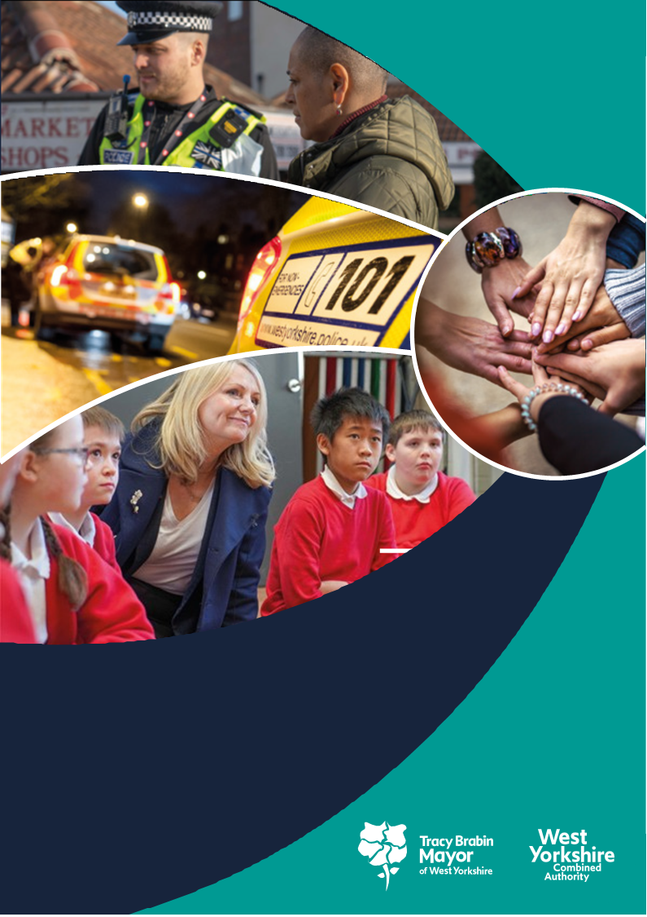

**West Yorkshire:**

**Safe. Just. Inclusive**

**Police and Crime Plan 2021-2024**

**1. Supporting Victims and Witnesses and Improving Criminal Justice Outcomes**

# 

# 2 Figures relate to 2021/22

# 3 Figures relate to 2022/23 (April-August)

**1.1 Victim Satisfaction**

1.1.1 The latest victim satisfaction rate stands at 70.9% for the 12 months to December 2022. The latest position is 3.7 percentage points lower than 12 months ago.



1.1.2 In comparison to the previous quarter the fall in satisfaction slowing with the reduction only 0.3% over the quarter, but still 3.7% above the same time last year. The district satisfaction only looks at crimes dealt with by the district. Those telephone investigations dealt with via the Force crime management unit (FCMU) are not included in the district ratings, but are included in the overall West Yorkshire rating

1.1.3 Over the last 12 months there has been a significant decline in the level of overall satisfaction of White victims and a smaller (not significant) decline of victims and callers from all other ethnic groups combined (down 4.2% and 1.6% respectively); levels now stand at 73.2% for white victims and 64.5% for victims from all other ethnic groups (a gap of 8.7%). Overall satisfaction for those victims with a disability is lower at 67.0% than for those without a disability 71.6%.

1.1.4 In comparison to overall Satisfaction, satisfaction for victims of Domestic Abuse is stable at 83.7% which is a 1.1% decrease on the same time last year.

1.1.5 Because there is not a standard framework for forces to provide satisfaction data, there have been moves by the government to again produce a satisfaction survey which will be comparable with other areas. Rather than mandate the way forces do their surveys, the government have decided to do a separate survey. Currently the provider for this service is being recruited and it is hoped that the survey process will start in the next few months. It is expected that the first results from this will be available in the autumn and these will be used in this document for comparison purposes when available.

## 1.2 Maintain high levels of calls answered on target

1.2.1 Over the last 12 months to Dec 2022 the number of total contacts into West Yorkshire Police have increased by 0.8% (11,677 additional contacts) however a larger increase in 999s has been reported in the latest 12 months to December 2022 (+7.1%, 33,424 more calls). Online contacts have also increased over the past 12 months (by 17.2%, 38,131 more contacts). The increase in 999 calls and online contacts offsets reductions in the number of 101 calls during the same period which have fallen by 8.8% (67,014 fewer calls)

1.2.2 The Force continues to locally report excellent call handling times for Emergency callers with 999 calls answered on average in seven seconds over the past year and performance in the latest quarter is similar.

1.2.3 For information – Police.uk produces statistics on 999 answering times, but these also contain transfer times from BT, which can be 4-6 seconds and can vary across Forces. The comparison data with other forces is available [here](https://www.police.uk/pu/your-area/west-yorkshire-police/performance/999-performance-data/?tc=BDT_BW)

1.2.4 The below chart looks at the answer time and compares with forces in our most similar group. All forces have a target to answer 90% of the 999 calls to the force in under 10 seconds. The excellent results from West Yorkshire Police can be seen here.

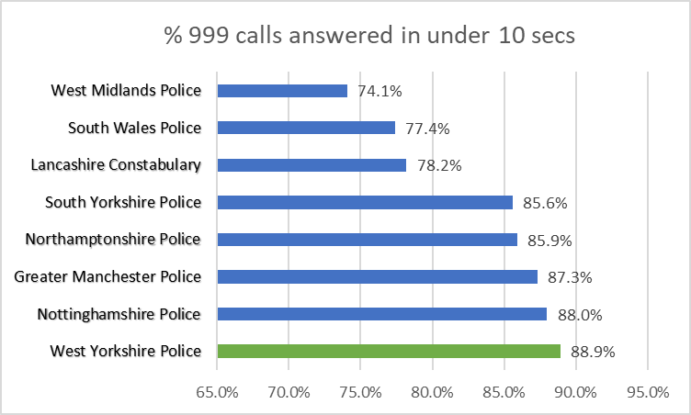

## 1.3 Improve Outcomes

**1.3.1 Rape and Serious Sexual Offences**



1.3.2 The above table shows the position so far this financial year in comparison to the same time last year. The numbers of rape offences has decreased in comparison to the same time last year and the outcome rate has risen with 20 more victims receiving a positive criminal justice outcome.

1.3.3 Nationally the most recent data available is to September 2022 (latest ONS statistics published on the 26th of January 2023). The data here looks at the number of Rape Crimes reported per 100,000 population. The baseline shown is to represent the typical rate of offences prior to the pandemic, as comparison to the previous 12 months is skewed by the lack of reporting during lockdowns and different parts of the country were subject to different periods of lockdown.



West Yorkshire has the same number of Crimes per 100,000 population as the West Midlands, but West Midlands saw a huge 58% rise in the number of offences in comparison to the baseline and the 9% rise in West Yorkshire against the baseline is the third lowest in the MSG.



1.3.4 Serious Sexual offence numbers have increased by 5.9% in comparison with the same time last year, but the positive outcome rate has risen by 1.2% with 91 more victims receiving a positive outcome.

1.3.5 Nationally the Serious Sexual Offence category is not reported on, as this category includes the rape offences above, but there is a category of ‘Other Sexual Offences’ which does not include the Rape offences. In a similar manner to the above Rape offences (with the baseline to March 2020) the below table gives an indication of the current position.



Lancashire has the most crimes in this category per 100.000 population, but this was after an above average rise of 16.5%. The increase in West Yorkshire was lower, but above the MSG average as there were big decreases in some areas such as South Yorkshire and Nottinghamshire. In contrast West Midlands and Greater Manchester have seen the numbers of these offences rising in similar proportions to the Rape offences.

**1.3.6 Domestic Abuse Outcomes**



1.3.7 The above looks at the data between April and December 2022 compared with the same time last year. The outcome rate has risen by 0.1% and the scale of the work required is shown here as this equates to nearly 300 more victims with a positive outcome.

1.3.8 Nationally only 32 forces report on Domestic Abuse offences in a comparative way. West Yorkshire is one of those forces and this shows that West Yorkshire has one of the highest numbers of DA offences per 100.000 population with only Northumbria as higher.

1.3.9 The above Police outcomes are only part of the picture of support for Domestic Abuse Surviviors. The Police and Crime plan discusses the need for more services to support victims with funding for these being prioritised along with working alongside the CSP as they fund DA services also

1.3.10 Recently the Domestic Abuse Commissioner has produced a survey, mapping this provision across England and Wales. The full report can be seen [‘A Patchwork of Provision’ - Domestic Abuse Commissioner](https://domesticabusecommissioner.uk/national-mapping-of-domestic-abuse-services/). Although this is only reporting to the regional level, as the largest police area in the Yorkshire and Humber (YatH) we can relate these figures to our area.

The survey shows that when looking at services provided to Domestic Abuse victims and survivors, YatH had the highest result with 51% for those finding it easy or very easy to find help compared with a 35% average in England and Wales (E&W)

Also we were the second highest in the category of parents whose children received support, with 38% result in YatH compared with 29% average in E&W. One thing to note was that YatH had a higher percentage of providers that had to cease some services due to lack of funding (35% compared to a 27% average), and this is to be addressed as part of the outcomes from the Survey.

The Policing and Crime Commissioning team is working closely with the DA commissioners office to provide evidence and understanding as thy press for more funding in this crucial area of service.

**1.4 Increase proportion of crime with victim initial needs assessment**

1.4.1 the Initial victims needs assessment is part of the Victims Code of Practice and is intended to

1. Determine if the victim needs support.

2. Establish the type of support needed.

3. Assess whether the victim is vulnerable or intimidated.

4. Consider whether the victim is entitled to enhanced rights

1.4.2 The guidance from the College of Policing shows that obtaining this at initial contact is important to the ongoing investigation as well as a key consideration towards effective communication and engagement with the victim

1.4.3 The continued increase in percentage for this area is therefore welcome and encouraged – this will become part of the Victims Code metrics and scrutinised by the Local Criminal Justice Board.

## 1.5 Criminal Justice Measures

**1.5.1 Decrease Ineffective trial rate (Magistrates Court)**

1.5.2 The Criminal Justice Scorecards (now called Delivery Data Dashboards) are a standing item at the Local Criminal Justice Board (LCJB) and some understanding of them is emerging along with priorities. As previously discussed, in the future these will form future measures for the Police and Crime plan, but currently the three previous measures used still stand.

1.5.3 The first of these is the ineffective trial rate, which looks at trials that do not go ahead due to action or inaction by one or more of the prosecution, the defence or the court and a further listing for trial is required. This is important as there is still a backlog in the courts after covid.

1.5.4 The figures here are shown for the whole of 2021/22 (25.4%) then for just the first two quarters of 2022/23 (19.8%). This indicates a good reduction so far for this measure and shows the hard work taking place locally to ensure trial effectiveness.

**1.5.5 Increase volume of early guilty pleas**

1.5.6 Similarly the increase of the number of early guilty pleas negates the need for a trial and frees up time which could be used elsewhere.

1.5.7 Again these figures are comparing the whole of 2021/22 with the most recent quarter, and this shows a slight decrease in both the Magistrates and Crown Courts.

**1.5.8 Decrease average time taken for cases to be brought to resolution**

1.5.9 This is the final measure, and the data is a quarter behind – so we can now compare the current rate with the same time last year. For the second quarter it shows that this time is decreasing and, in comparison to the same quarter last year, is down by 15.1 days.

1.5.11 There is to be a planning day for the LCJB in March 2023 and from this we will be able to provide details of the priorities for the LCJB going forward and look at which measures from the Delivery Dashboards will give an indication of these priorities and be the best way to assess progress in this area. These will then be communicated and agreed as measures for the Police and Crime plan.

**2 KEEPING PEOPLE SAFE AND BUILDING RESILIENCE**

# 

**2.1 Monitor the number of young persons flagged as at risk of Criminal Exploitation**

# 2.1.1 In February 2020 the government produced guidance about the criminal exploitation of children (and vulnerable adults) and as part of this guidance it was noted that *Criminal exploitation of children and vulnerable adults is a geographically widespread form of harm that is a typical feature of county lines activity. It is a harm which is relatively little known about or recognised by those best placed to spot its potential victims.*

# 2.1.2 The purpose of this measure is to gauge how well West Yorkshire Police officers spot this type of exploitation and ensure that these vulnerable victims get the support and help that they need

# 2.1.3 From the above figures we can see that there is an increase of 150 both victims and suspects flagged as at risk of Child Criminal Exploitation. Although we would want to see this number reducing eventually, it is expected that whilst this is still an unfolding area the numbers will continue to rise.

# 2.1.4 The Deputy Mayor spoke at a recent conference in Bradford entitled Bradford district police and partners serious organised crime event. It was clear from this event that all partners in the area are alive to the risk of Criminal Exploitation of young people and were putting processes in place to ensure that they are vigilant to address the harm that it causes.

**2.2 Monitor Indicators from Cyber Dashboard**

# 2.2.1 Action Fraud have created a database where the current picture for Cyber Crime in an area can be compared with other areas in England and Wales

# 2.2.2 The data at Appendix 2 shows the picture for West Yorkshire Police and looks at the picture for businesses in the area. As the database on contains 13months of data, it is not possible to do detailed comparisons, but as the data builds, we will be able to construct a better understanding of the current situation.

# 2.2.3 In West Yorkshire Police The Cyber team continues to support the new Action Fraud (AF) process, supporting each victim with in-person or telephone support together with pursuing live investigations.

# 2.2.4 Social Media Hacking continues to be the highest reported cyber incident. We have seen an increase in Cyber Domestic Abuse, with 18 cases reported through to AF as standalone cyber dependant crimes. This quarter, Cyber Protect are supporting the Domestic Abuse CPD Day, with awareness into Technology Facilitated Domestic Abuse with methods and consideration for victims to secure their personal digital data.

# 2.2.5 The Force Cyber team and ECU worked together on the lead up to Black Friday / Cyber Monday to warn shoppers of the online scams. Stalls were located in shopping centres across the district where there was a large amount of engagement with members of the public and cyber & fraud advice provided.

# 2.2.6 The team continues to assist in the upskilling of various departments across the districts with new developments in Cyber, crypto and Open-Source Research. It is recognised by the College of Policing that digital awareness training is required by specialist detectives and frontline officers

# 2.2.3 In the recent update to the Strategic Policing Requirement, Cyber threats continue but the area of Serious Organised Crime has been enhanced to include Fraud. A link to the 2023 Strategic Policing Requirement can be found at [www.gov.uk/government/publications/strategic-policing-requirement-2023](http://www.gov.uk/government/publications/strategic-policing-requirement-2023).

**2.3 Repeat Victims of Domestic Abuse and Hate Crimes**

# 

# 2.3.1 Domestic abuse incidents increased by 6% in comparison to the same quarters in the previous year. Over the same period, the number of repeat victims rose by 1.4%

# 2.3.2 Repeat victims of Domestic Abuse continues to be a priority as part of the Police and Crime plan. Currently in West Yorkshire there is work taking place to look at the risk assessment for victims.

# 2.3.3 The policing and crime office has put in a funding request for medium and high risk domestic abuse perpetrators programmes in response to the governments funding offer. This will compliment the successful CARA programme which currently deals with lower risk domestic abuse perpetrators.

# 2.3.4 The national CARA programme has recently produced their annual report where the success of this programme can be seen. Please see at <https://hamptontrust.org.uk/news/> In this report there is a quote from the Deputy Mayor which says:

# ‘*Tackling domestic abuse and sexual violence is a priority for the Mayor of West Yorkshire, Tracy Brabin, who has commissioned the CARA programme and is investing over £1m into the provision. Partnership working is crucial to achieving this and since the inception of the Mayor’s West Yorkshire Domestic Abuse Perpetrator service, that uses CARA, we are beginning to see the green shoots of this collaborative approach*.’

# 2.3.3 Hate Crime Repeat Victims

# 2.3.4 The number of Hate Crime incidents are on a current reducing trend. In comparison with the same quarter last year there was a 12.2% decrease in incidents

# 

# 2.3.5 Conversely the number of hate crime repeat victims is rising – this made up 33.1% of overall victims in Dec 22 compared with 26.1% in December 2021.

# 2.3.6 When looking at these figures it should be mentioned that the numbers being recorded can be due to many factors including the effectiveness of the force with regards to Crime Data Integrity (at which West Yorkshire was rated Outstanding) the willingness of the public to report the offence and what is hidden is the number that go unreported. The increase in Repeat victims could be seen as a positive in that victims are willing to contact the police after reporting a previous offence and shows that this has been a positive experience for them.

# 2.3.7 In November 2022 there was a report to Parliament about Hate Crime in the UK – this stated that for the different strands of hate crime, three forces were in the top 10 forces in the country for all strands. West Yorkshire was one of these 3 forces. The full briefing can be found at <https://commonslibrary.parliament.uk/research-briefings/cbp-8537/>.

# 

# 2.4 Increased Use of DVPN and DVPO

# 

# 2.4.1 The use of DVPN and DVPO was highlighted in the HMICFRS report A duty to protect: Police use of protective measures in cases involving violence against women and girls, which was released in August 2021. Here the investigation found that :there were good examples of the police using protective measures, and evidence of dedicated officers working to protect victims; but

# there was a lack of understanding within police forces over how and when to use protective measures, which means support for victims is sometimes not good enough; and

# better data collection on the use of protective measures is needed to help the police determine which measures are most effective in different scenarios

# 2.4.2 This performance measure is to show the progress in West Yorkshire and currently the number of DVPO’s and DVPN’s are increasing and particularly in the areas that had low numbers before. The performance measure is on the 12 months rolling data, but the table above shows the year so far compared to last year. We can see areas such as Wakefield and Calderdale are seeing large increases already.

**2.5 Use of Stalking Protection Orders**

# 2.5.1 The Home Office conducted a review of the use of SPOs in June 2021 and reported on the review the following month in the Tackling violence against women and girls’ strategy. The review concluded that they were working well but: “it also showed that there is more that can be done to increase their use, as well as to manage individuals who have an order imposed on them. The Home Office will therefore work with the police to ensure that all police forces make proper use of Stalking Protection Orders.”

# 2.5.2 The Ministry of Justice and the Home Office are planning to publish regular data on SPOs showing how many are being used and how their use varies from force to force

# 2.5.3 Since the SPO’s came into force in Jan 2020 WYP has issued 5 orders and 3 are currently live and there are there are currently 23 live cases where an SPO is either being actively considered or an application is already underway.

# 2.5.4 The Stalking Coordination Unit (SCU) went officially live on 9th January 2023. The unit comprises of a Sergeant and two Constables. A Stalking Action Plan covering the next twelve months of the pilot is now in place.

# 2.5.5 A daily review mechanism is now operational whereby any stalking and harassment crimes recorded within the last 24 hours are reviewed by SCU. Detailed reviews are undertaken on non-domestic stalking crimes and high-risk domestic stalking crimes; Harassment crimes are reviewed to ensure any stalking that has been incorrectly crimed is identified early and redirected appropriately

# 2.5.6 This has been a priority for the Mayor and this is further enhanced by the new Independent Stalking Advocacy Service in Victim Support which is funded from the office.

**3 Safer Places and Thriving Communities**

# 

## 3.1 Reduce Homicide

3.1.1 As a key measure for the Violence Reduction Unit, this was included in the Police and Crime plan. The overall measure shows the current position, but the VRU looks at non-domestic homicide and homicide for under 25’s, so the current position for those is shown below



3.1.2 Nationally, the most recent data for homicide shows that in the year ending September 2022 there were 33 offences which is a total of 14.07 per million residents

3.1.3 This puts West Yorkshire mid table when compared to its MSG.

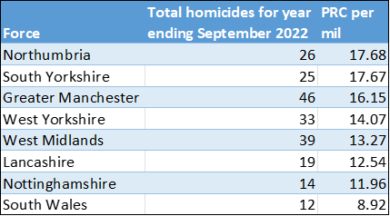

3.1.5 West Yorkshire was one of the forces nationally chosen by HMICFRS to be interviewed as part of its thematic report on Homicides. This took place during February and also involved an interview with the Mayor’s office and the Violence Reduction Unit.

**3.2 Reduce all hospital admission for assault with a sharp instrument**

3.2.1 Hospital Admissions has seen a decrease of 5 for both groups.



3.2.2 Of note the data for the last 12 months is provisional for April 21 to Nov 22 and this data does not include those months where there are less than 5 admissions in the month. This is more likely to affect the under 25 admissions than the overall total.

**3.3 Reduce Knife Crime**

3.3.1 Knife crime had been on an increasing trend after the pandemic, but in the last quarter we saw that this was levelling off and now we can see the reduction in knife crime.

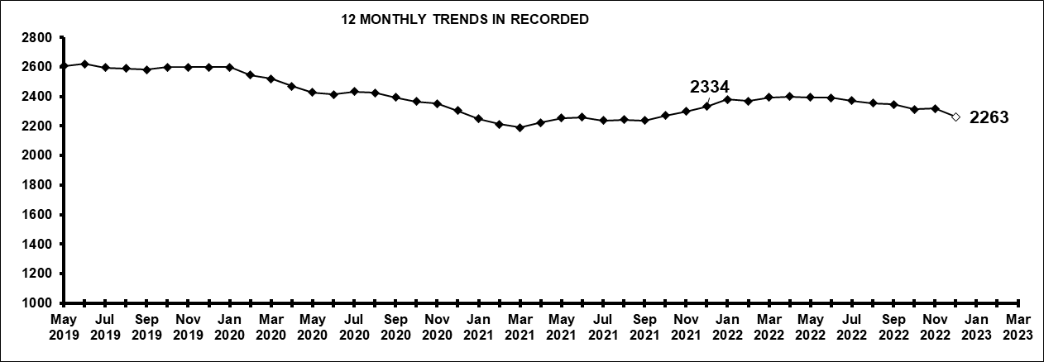

3.3.2 The most recent update nationally is to September 2022 – West Yorkshire are reporting a 4.8% increase (+107 offences to 2,353) in knife crime offences for the 12 months to September 2022. Nationally there is a 10.6% increase. In relation to knife offences per 1,000 population the Force has the 7th highest rate

3.3.3 It should be noted that West Yorkshire Police is one of 37 forces which uses a national methodology for recording knife crime. The remaining forces will be using the same methodology in the near future, but until then, national comparisons are problematic.

**3.4 Reduce number of ASB incidents**

3.4.1 The reductions in ASB incidents have been reported before to panel with the caveat that some of this reduction will be due to more of the incidents being crimed and therefore not included in these numbers

3.4.2 The chart below on the right highlights that whilst ASB logs have been falling the number of logs now opened as public order, harassment and criminal damage have increased.



3.4.3 The first graph shows the rolling 12 monthly trend for ASB incidents. Due to training within contact at West Yorkshire Police, the logs that would have previously been incoded as ASB are now immediately flagged as a crime and this is reflected by the blue line in comparison to orange line which shows the incodes for the crimes.

3.4.4 The Force continues to support and promote the five Principles of ASB and representatives from the Districts and HQ attended one of the NPCC’s Roadshows in November 2022 where the principles were promoted and discussed. The five principles of ASB can be found at [www.gov.uk/government/publications/anti-social-behaviour-principles/anti-social-behaviour-principles](http://www.gov.uk/government/publications/anti-social-behaviour-principles/anti-social-behaviour-principles)

**3.5 Keep Neighbourhood Crime below baseline**

3.5.1 Neighbourhood Crime includes Burglary, Robbery, Vehicle Crime and Theft from person. These crime types all plummeted during the pandemic and have not yet returned to pre-pandemic levels, hence the comparison with 12 months to June 2019 (as part of the national performance measures)

3.5.2 The below table looks at these crime types to break down the overall figures.



3.5.3 The one area that is different is Theft Of Motor Vehicle. This crime type continues to be the only one that is above the 12months to June 2019 baseline.

3.5.4 Neighbourhood Crime is included in the DCPP. Unlike other areas where the data is to Police force level only, the Neighbourhood Crime element breaks this down to CSP level so each CSP can see how they compare with their own similar areas (as per the most similar groups for forces, each CSP has its own most similar group)

3.5.5 The picture for West Yorkshire is as follows (data to end of Sept 2022)

3.5.6 Compared with our most similar group, West Yorkshire sits mid table (offences per 1000 population)



**3.6 Monitor cyber-attacks on businesses via WYCA survey**

3.6.1 This data is not available currently.

**3.7 Increase proportion of workforce from ethnic minorities**



3.7.1 Overall the proportion of the workforce from ethnic minorities is at 7.0% but officers are currently above this at 7.7%. Although staff numbers are lower at 5.7% this is still an increasing trend.

3.7.2 The Force continues to meet Status Level One rating for the joiner rate in relation to Ethnic Minority Officers meaning that the 12-month rolling joiner rate for Black, Asian, Mixed or Other officers is higher than the local population whilst the latest 12-month joiner rate for ethnic minority officers is also better than the rate in previous years.

**3.8 Increase proportion of female officers**



3.8.1 Due to the increased number of officers and staff compared to 2017 the percentage increases may look small, but these actually mask the increase in numbers. For female officers the nearly 5% increase equates to 624 more female officers (alongside an increase of 359 male officers )

For police staff there is a 1.1% rise in female staff (including PCSO’s) but this equates to 249 more. This compares to a fall in percentage of male staff members, but this fall is actually an increase of 103 male staff.

**3.9 Reduce numbers of KSI's on roads in W Yorkshire**

3.9.1 Numbers of KSI’s on the roads in West Yorkshire is currently increasing and this is the focus of the Vision Zero meetings in West Yorkshire

3.9.2 In January 2021, the Force started using CRASH (Collision Reporting and Sharing system) which is a Dept of Transport developed system to record collisions. Previously injuries were categorised subjectively based on the reporting officer’s assessment whereas CRASH is more prescriptive with injury descriptions being automatically categorised. It is acknowledged nationally that this has effectively increased the number of collisions where injuries are categorised as being serious.

3.9.3 Operation SNAP, (the on-line portal for submission of dangerous driving footage) goes from strength to strength in terms of numbers of submissions and resultant prosecutions. The Casualty Reduction Partnership also leads the way for enforcement and (outside of the Metropolitan Police Force area) is the highest performing unit in the country. ANPR technology generates intelligence tasking packages which lead the response against our highest risk drivers in West Yorkshire for which we currently have an 80% positive outcome rate, with numbers of offenders arrested and vehicles seized at consistently high levels.

3.9.3 In February 2023 the Vision Zero Policy manager and policy assistant started in the Policing and Crime team of the West Yorkshire Combined Authority.

3.9.3 A fuller update on the current position and the work of these officers is scheduled to come to panel in the April meeting.

**3.10 Increase number of additional officers and staff in comparison to April 2021 baseline**

3.10.1 The numbers here show that officer numbers are increasing as expected, with staff numbers also increasing even with the current budget constraints

3.10.2 The Mayor and Deputy Mayor receive a quarterly update for this measure to ensure that the Mayoral Pledge is met. This paper discusses the current situation and where there are any risks

3.10.3 Currently the projections are showing to surpass the pledge by the end of the Mayoral term for officers.

**4. Responding to Multiple and Complex Needs**



**4.1.1 Monitor VRU early intervention programme attendee figures**

4.1.2 As part of its monitoring information for the Home Office, the Violence Reduction Unit has to show the impact of its work by counting the number of young people (and others) that it reaches.

4.1.3 More information on these programmes is available on the VRU website (which can be seen at [www.westyorks-ca.gov.uk/policing-and-crime/west-yorkshire-violence-reduction-unit/](http://www.westyorks-ca.gov.uk/policing-and-crime/west-yorkshire-violence-reduction-unit/) ), so far this year 18,948 young people have been reached in West Yorkshire.

**4.2 Reduce number of repeat missing persons**

4.2.1 Number of Missing persons per 1000 population

Over the last 12 months there have been 11,164 missing persons (including repeats). These are broken down as follows

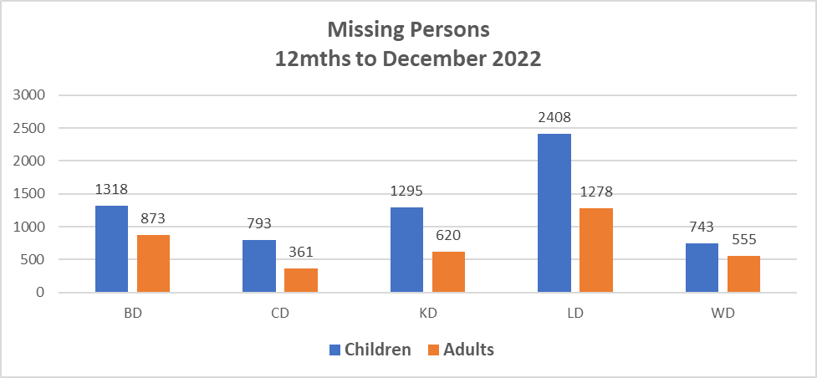

4.2.2 The following graph looks at the above missing persons and plots by 1,000 population.

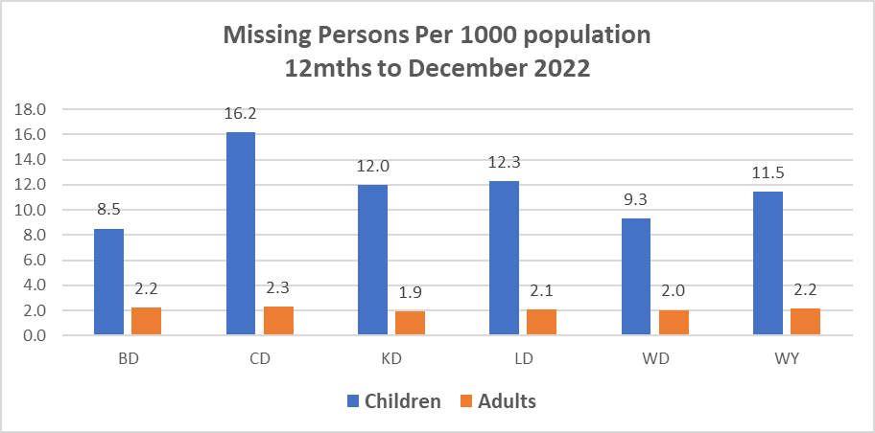

4.2.3 This indicates that in comparison to the resident population, Calderdale has the highest number of missing children with Kirklees and Leeds similar to the West Yorkshire average and Bradford lower. This could be due to the population differences in the area with Bradford having a high number of young persons compared to the national average.

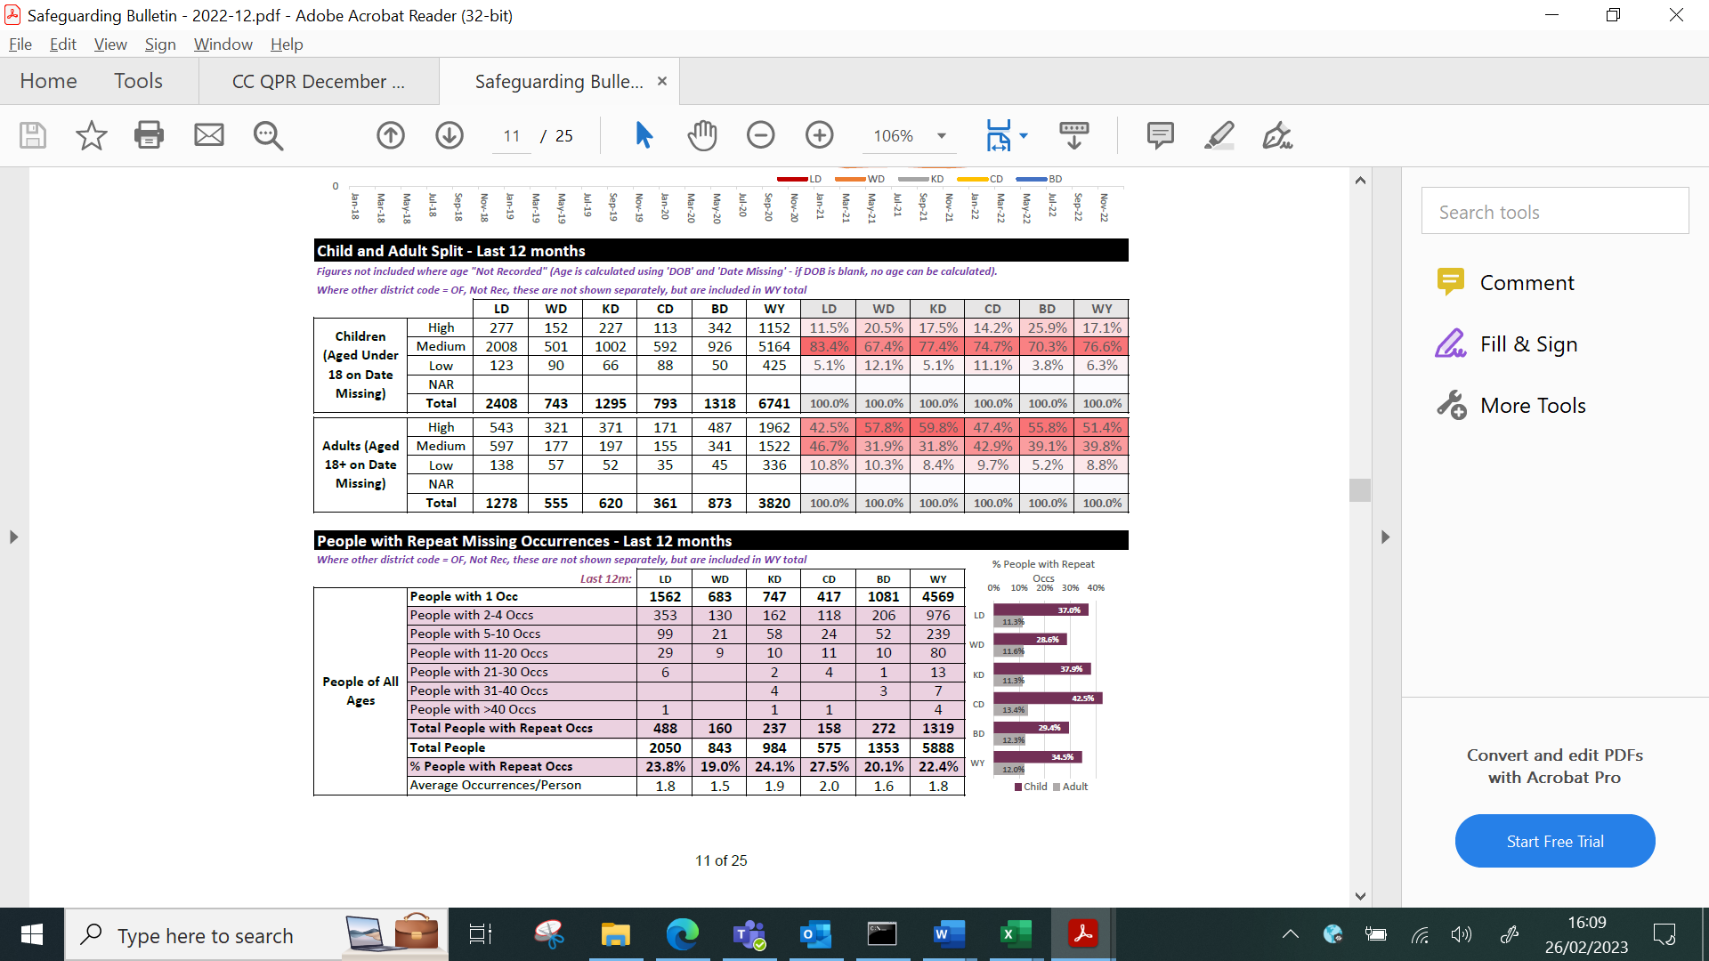

4.2.5 The number of repeat missing persons is detailed above. This stands at 34.5% for missing children and 12.0% for missing adults.

4.2.2 Although the numbers are slightly lower, the extent of the work can be seen above with 4 missing persons having greater than 40 occurrences throughout the year. This continues to be a drain on police resources.

**4.3. Reduce Re-offending Rate for Drug Related Crime**

4.3.1 Due to the time lapse required to ensure offences are taken into consideration, the re-offending rates are for offenders who were convicted 12 months ago.

4.3.2 The current figures show that there has been a 1.4% decrease in this rate in comparison to the same time 12 months ago.

4.3.3 Work is ongoing to understand the current picture for re-offending in west Yorkshire this features as part of the PCC review and Part Two of the PCC Review provides an opportunity to ensure that PCCs have the ability to work across the Criminal Justice System to cut crime, drugs misuse and antisocial behaviour, whilst continuing to strengthen their accountability to the public

4.3.4 Under the list of recommendations from Part two of the PCC review the Home office has agreed to:

1. Legislate to introduce a new reciprocal duty for PCCs and Regional Probation Directors to consult one another when developing priorities for their Policing and Crime Plans and Regional Reducing Reoffending Plans respectively, and to introduce a duty for them to collaborate, where appropriate
2. Work with the Association of Police and Crime Commissioners (APCC) and Her Majesty’s Prison and Probation Service (HMPPS) to develop guidance on the co-commissioning of services by Regional Probation Directors and PCCs.
3. Encourage HMPPS and the APCC develop a memorandum of understanding on the relevant data to support the reduction of reoffending, to provide confidence in local data sharing.
4. Work with the Ministry of Justice and HMPPS to produce guidance on the PCC role in unpaid work, including how they work with Community Safety Partnerships (CSPs) to canvass community views on opportunities for unpaid work. This builds on the new statutory duty being placed on the Probation Service through the Police, Crime, Sentencing and Courts Bill to consult PCCs when designing and delivering unpaid work schemes.

4.3.5 Work on this has started with the DMPC signing a memorandum of understanding with HMPPS (as per point 4 above)

**4.4 Reduce the number of First-time entrants to the CJS**

4.4.1 As the above there is a bit of a time lapse with this measure, as the Ministry of Justice data is based on offenders on PNC as having their 1st conviction, caution or youth caution. Figures reported relate to the 12 months to September in 2019, 2020 and the latest figures relate to 12 months to September in 2021

4.4.2 Currently there has been an increase in adult offenders, but the number for young people is decreasing.

**4.5 Increase number of offenders referred to drug treatment services via Liaison and Diversion**

4.5.1 Figures relate to referrals into drug services across the five districts. Figures provided by West Yorkshire All Age Liaison and Diversion Service

4.5.2 The tables below relate to the most recent quarter (Oct – Dec )

Adults

|  |  |  |  |  |  |  |
| --- | --- | --- | --- | --- | --- | --- |
|  | West Yorkshire | Bradford | Calderdale | Kirklees | Leeds | Wakefield |
| Referrals into L&D service Q3 2022-23 | 1204 | 246 | 150 | 160 | 321 | 327 |
| Formal pathway referrals made by L&D into support services | 379 | 50 | 35 | 37 | 128 | 129 |
| Other pathway contacts (eg already in in service, liaison with support services, no formal referral) | 183 | 26 | 24 | 33 | 61 | 39 |

Young People

|  |  |  |  |  |  |  |
| --- | --- | --- | --- | --- | --- | --- |
|  | West Yorkshire | Bradford | Calderdale | Kirklees | Leeds | Wakefield |
| Referrals into L&D service Q3 2022 -23 | 501 | 64 | 138 | 83 | 128 | 88 |
| Formal pathway referrals made by L&D into support services | 138 | 3 | 46 | 9 | 36 | 44 |
| Other pathway contacts (eg already in service, liaison with support services, no formal referral) | 44 | 3 | 7 | 20 | 2 | 12 |

4.5.3 This represents a slight decrease for both adults and children in comparison to the same quarter last year

4.5.4 These statistics and the work undertaken are discussed on the Liaison and Diversion Strategic Board – this is attended by the DMPC on a regular basis.

Appendix 2

**Cyber Crime**

**Reports, referrals, and outcomes for**

The below data is for Jan to Dec 2022 only

Cyber Crime reporting

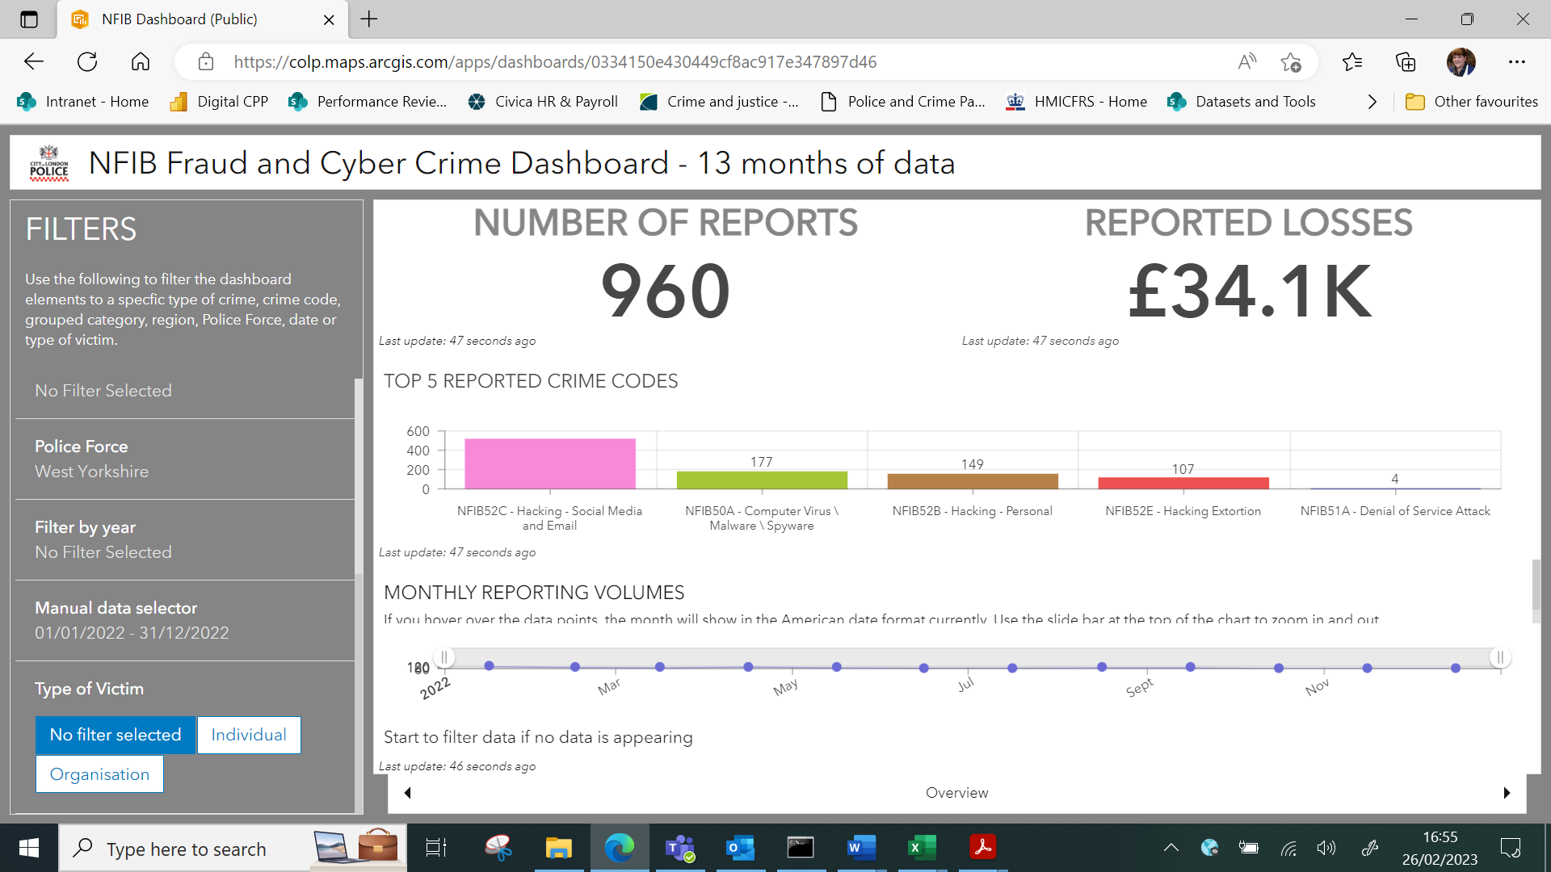

The above is for Cyber Crime only the picture for Fraud is as follows

For business Cyber Crime **only** the current picture is as follows:

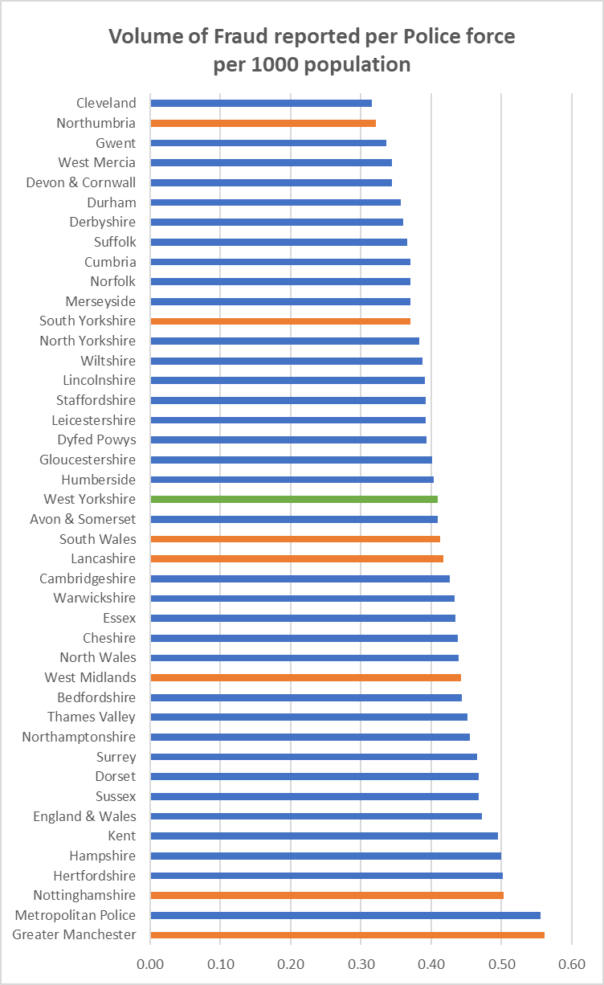

The above is for the period in question (i.e. 12 months to December 2022)

|  |  |
| --- | --- |
| **Acquisitive crime** | Acquisitive crime is defined as an offence where the offender derives material gain from the crime. Examples include shoplifting, burglary, theft, and robbery. |
| **BAME** | BAME stands for Black, Asian and Minority Ethnic and is used to describe people from any of these ethnicities. |
| **Child sexual exploitation and abuse** | Sexual exploitation of children and young people under 18 involves exploitative situations, contexts, and relationships where young people (or a third person or persons) receive 'something' (e.g., food, accommodation, drugs, alcohol, cigarettes, affection, gifts, money) because of them performing, and/or another or others performing on them, sexual activities. |
| **Community Safety Partner** | A number of different organisations have a role to play including local councils, fire and rescue service, health and probation services and housing providers etc. These are often referred to as local community safety partners. |
| **Conviction rate** | This measure is calculated by dividing the number of defendants convicted, by the total number of defendants prosecuted in the court during the period in question. The total number of defendants prosecuted in the court includes those charged by the police and Crown Prosecution Service but whose cases were dropped. |
| **Crime rate** | The crime rate used in this document refers to the number of offences committed per 1000 people in the population. |
| **Cyber crime** | Can be seen in two parts: cyber-enabled crime, where crimes that may be committed without computers are instead committed using computer networks (for example fraud and bullying); and pure cyber-crime where the offence can only be committed using computers (for example computer hacking or use of malicious software). |
| **GAP**  **Human trafficking** | Anticipated Guilty Plea  Human trafficking is the trade of humans, most commonly for the purpose of forced labour or commercial sexual exploitation by the trafficker or others. |
| **IOM** | Integrated Offender Management (IOM) is an overarching framework that allows local and partner agencies to come together to ensure that the offenders whose crimes cause most damage and harm locally are managed in a coordinated way. |
| **Ineffective trial** | An ineffective trial occurs when the trial does not go ahead on the date planned due to action or inaction by one or more of the prosecution, the defence or the court and a further listing for a trial is required. |
| **Most similar police groups/family/forces**  **NGAP** | Most Similar Groups (MSGs) are groups of police force areas that have been found to be the similar to each other based on an analysis of demographic, social and economic characteristics which relate to crime. Each police area has its own group of up to seven police areas to which it is ‘most similar’. MSGs are designed to help make fair and meaningful comparisons between police areas which share similar characteristics, rather than, for example, comparison with a neighbouring police area.  Anticipated Not Guilty Plea |
| **Operational functions** | Operational functions include things like patrolling neighbourhoods, responding to 999 calls, roads policing and protecting vulnerable people. |
| **Outcomes/detections** | Outcomes/detections are used by the Home Office to describe the result of a police investigation following the recording of a crime. They can include cautions, charges, fixed penalty notices, cannabis warnings etc. There are 21 categories of outcomes. |
| **PEEL**  **Positive Outcomes** | HMICFRS carry out several thematic annual inspections throughout the year, these are drawn together into a wider PEEL assessment which stands for Police Effectiveness, Efficiency and Legitimacy. The aim of the PEEL assessment is to judge each police force in a cross-topic way based on criteria which considers the full breadth and complexity of what the police do.  Outcomes which fall into the first 8 categories for Police outcomes, these include mostly charges, cautions and community resolutions. |

**Find out more**

westyorks-ca.gov.uk

@WestYorkshireCA

enquiries@westyorks-ca.gov.uk

+44 (0)113 251 7272

All information correct at time of print (March 24)