**Appendix 1.**

PERFORMANCE MONITORING REPORT

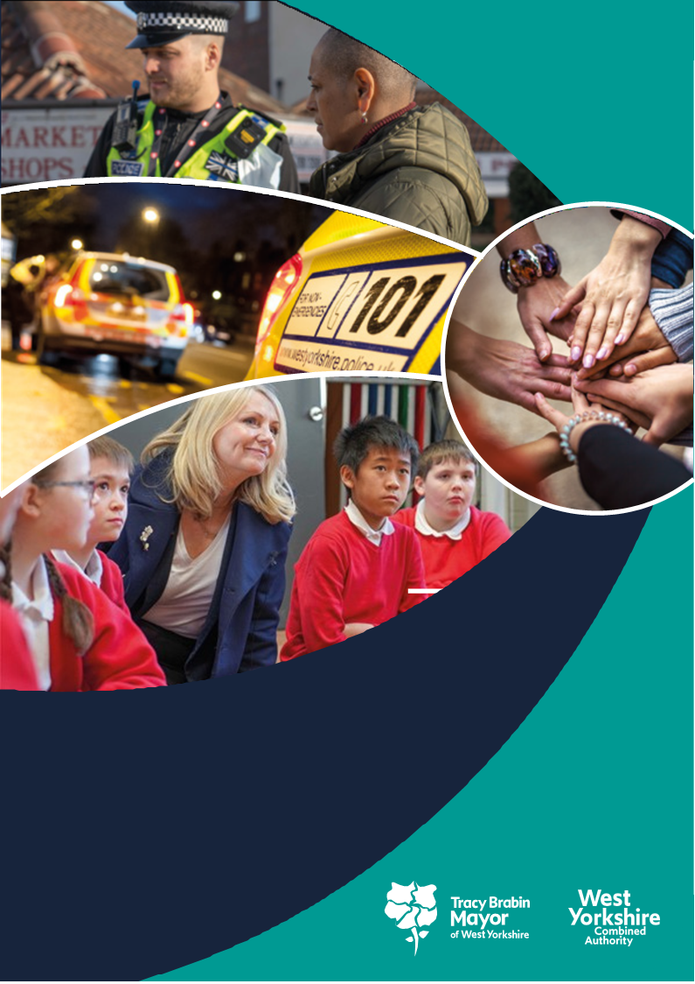

**West Yorkshire:**

**Safe. Just. Inclusive**

**Police and Crime Plan 2021-2024**

**1. Supporting Victims and Witnesses and Improving Criminal Justice Outcomes**

# 

# 2 Figures relate to 2021/22

# 3 Figures relate to 2022/23 (April-February)

**1.1 Victim Satisfaction**

1.1.1 The latest victim satisfaction rate stands at 71.8% for the 12 months to March 2023. The latest position is 0.8 percentage points lower than 12 months ago.



1.1.2 In comparison to the previous quarter the fall in satisfaction has now reversed with a 0.9% increase in the last quarter. The only areas showing decreases are Leeds and Bradford. The district satisfaction score only looks at crimes dealt with by the district. Those telephone investigations dealt with via the Force Crime Management Unit (FCMU) are not included in the district ratings but are included in the overall West Yorkshire rating.

1.1.3 Victims of Hate incidents, ASB and Arson and Criminal Damage offences have the lowest level of satisfaction at around 65%, whereas Safety and Welfare callers and Domestic Abuse victims are the most satisfied, with levels around 85%. There is a significant difference between overall satisfaction of White victims (73.5%) and for victims and callers from all other ethnic groups combined (66.7%), leading to a satisfaction gap of 6.8%, down from 11.4% a year ago. The gap varies from 1.5% at Calderdale to 11.1% at Leeds.

1.1.4 Satisfaction for victims of Domestic Abuse is stable at 83.5%, which is a 1.6% decrease on the same time last year.

1.1.5 West Yorkshire Police have added stalking to the list of offences that are included in this survey. Up to present there have been 262 victims of stalking surveyed and this has given a 79.5% satisfaction rate. As with other crime types, there is a lower satisfaction rating for ‘keeping informed of progress’ (66.4%), but this crime type has a higher satisfaction for the outcome (68.8% for attended crime, but 83.2% for stalking).

## 1.2 Maintain high levels of calls answered on target.

1.2.1 In the latest 12 months to March 2023 the number of total contacts into West Yorkshire Police have increased by 3.4% (50,676 additional contacts), however a slightly larger increase in 999s has been reported in the latest 12 months to March 2023 (+3.9%, 19,082 more calls). Online contacts have also increased over the past 12 months (by 24.4%, 54,418 more contacts). The increase in 999 calls and online contacts offsets reductions in the number of 101 calls during the same period, which have fallen by 4.2% (31,366 fewer calls).

1.2.2 West Yorkshire Police continues to report excellent call handling times for Emergency callers with 999 calls answered on average in just five seconds over the past quarter.

1.2.3 For information – Police.uk produces statistics on 999 answering times, but these also include transfer times from BT, which can be 4-6 seconds and can vary across police forces. The comparison data with other forces is available [here](https://www.police.uk/pu/your-area/west-yorkshire-police/performance/999-performance-data/?tc=BDT_BW).

## 1.3 Improve Outcomes

**1.3.1 Rape and Serious Sexual Offences**



1.3.2 The above table shows the position at the end of the financial year in comparison to the same time last year. The numbers of rape offences have decreased in comparison to the same time last year, and the outcome rate has dipped slightly.

1.3.3 Nationally the most recent data available is to December 2022. The data here looks at the number of Rape Crimes reported per 100,000 population. The baseline shown is to represent the typical rate of offences prior to the pandemic.

The above table is ordered by the difference from the baseline. Although the numbers in West Yorkshire have increased, this is overshadowed by the increases in both West Midlands and Greater Manchester.



1.3.4 Serious Sexual offence numbers have increased by 4.1% in comparison with the same time last year, but the positive outcome rate has risen by 0.4% with 62 more victims receiving a positive outcome.

1.3.5 Nationally the Serious Sexual Offence category is not reported on, as this category includes the rape offences above, but there is a category of ‘Other Sexual Offences’ which does not include the Rape offences. In a similar manner to the above Rape offences (with the baseline Jan – Dec 2019) the table below gives an indication of the current position.



Many in West Yorkshire Police’s most similar group of police forces (MSG) have seen decreases in this area, but both West Yorkshire and the West Midlands have seen increases.

**1.3.6 Domestic Abuse Outcomes**



1.3.7 The above looks at the data between April 22 to March 23 compared with the same time last year. The outcome rate has risen by 0.2% and the scale of the work required is shown here as this equates to 374 more victims with a positive outcome.

1.3.8 Nationally only 25 forces report on Domestic Abuse offences in a comparative way. West Yorkshire is one of those forces and this shows that West Yorkshire has the highest numbers of DA offences per 100,000 population.

1.3.9 The above Police outcomes are only part of the picture of support for Domestic Abuse Survivors. The Police and Crime Plan discusses the need for more services to support victims, with funding for these being prioritised along with working alongside the CSP as they fund DA services also.

**1.4 Increase proportion of crimes with victim initial needs assessment**

1.4.1 The Initial Victim Needs Assessment (IVNA) is part of the Victims Code of Practice and is intended to:

1. Determine if the victim needs support.

2. Establish the type of support needed.

3. Assess whether the victim is vulnerable or intimidated.

4. Consider whether the victim is entitled to enhanced rights.

1.4.2 The guidance from the College of Policing shows that obtaining this at initial contact is important to the ongoing investigation, as well as a key consideration towards effective communication and engagement with the victim.

1.4.3 The continued increase in the proportion of cases with an IVNA for this area is therefore welcome and encouraged – this will become part of the Victims Code metrics and scrutinised by the Local Criminal Justice Board.

## 1.5 Criminal Justice Measures

**1.5.1 Decrease ineffective trial rate (Magistrates Court)**

1.5.2 The work with the Local Criminal Justice board continues at pace with a face-to-face meeting of strategic partners to agree the priorities of the board going forward. One of the first pieces of work is an overview of the governance framework alongside a review of the various work groups under the board. This will ensure a join-up of the priorities across all the criminal justice agencies.

1.5.3 The transforming summary justice work continues with the priorities still in scope. The first of these is the ineffective trial rate, which looks at trials that do not go ahead due to action or inaction by one or more of the prosecution, the defence, or the court, and a further listing for trial is required. This is important as there is still a backlog in the courts after Covid and other complications.

1.5.4 The figures here are shown for the whole of 2021/22 (25.4%) then for just the first three quarters (+2 months) of 2022/23 (20.3%). This indicates a good reduction so far for this measure and shows the hard work taking place locally to ensure trial effectiveness.

**1.5.5 Increase volume of early guilty pleas**

1.5.6 Similarly the increase of the number of early guilty pleas negates the need for a trial and frees up time which could be used elsewhere.

1.5.7 Again these figures compare the same timescales as the above and this shows a slight decrease in both the Magistrates and Crown Courts. This is subject to current scrutiny to understand the reasons why people do not plead guilty at first hearing.

**1.5.8 Decrease average time taken for cases to be brought to resolution.**

1.5.9 This is the final measure, and the data is a quarter behind – so we can now compare the current rate with the same time last year. For the second quarter it shows that time taken is decreasing and, in comparison to the same quarter last year, is down by 15.1 days, and for the most recent quarter reported the reduction is 32.1 days in comparison to the same quarter last year.

1.5.11 The measures from the Delivery Dashboards give the opportunity to compare current performance with national performance and going forward this report will be able to give these comparisons against the agreed priorities.

**2 KEEPING PEOPLE SAFE AND BUILDING RESILIENCE**

# 

**2.1 Monitor the number of young persons flagged as at risk of Criminal Exploitation**

# 2.1.1 In February 2020 the government produced guidance about the criminal exploitation of children (and vulnerable adults) and as part of this guidance it was noted that *Criminal exploitation of children and vulnerable adults is a geographically widespread form of harm that is a typical feature of county lines activity. It is a harm which is relatively little known about or recognised by those best placed to spot its potential victims.*

# 2.1.2 The purpose of this measure is to gauge how well West Yorkshire Police officers spot this type of exploitation and ensure that these vulnerable victims get the support and help that they need.

# 2.1.3 From the above figures we can see that there is an increase of 25 victims or suspects flagged as at risk of Child Criminal Exploitation. Although we would want to see this number reducing eventually, it is expected that whilst this is still a developing area the numbers will continue to rise.

# 

**2.2 Monitor Indicators from Cyber Dashboard**

# 2.2.1 As Fraud has now been included in the Strategic Policing Requirement, updates about Cyber-crime will now also include updates about action against fraud.

# 2.2.2 The data at Appendix 2 shows the picture for West Yorkshire and includes both Fraud and Cyber offences with a comparison to most similar force areas (MSG).

# 2.2.3 The Stalking Coordination Unit (SCU) has developed links with West Yorkshire Police Digital Teams to ensure that investigations that involve a digital element and/or have digital forensic potential are referred promptly for bespoke advice. SCU is also promoting the use of the Digital Safeguarding e-Book, a national resource recommended by the Cyber Protect Team for victims to safeguard themselves from online stalking.

# 2.2.4 In the Economic Crime Unit, the operational teams are managing 30+ serious and complex investigations, principally relating to fraud, money laundering and suspected corruption offences involving professional enablers. An increasing feature is digital assets and crypto currency.

# The Financial Investigation Unit have obtained 182 confiscation orders / civil forfeiture orders this financial year totalling £10.75m (Year End).

# 2.2.5 Fraud Prevention: Ongoing collaboration with external stakeholders to drive prevention work, includes a Fraud Networking Meeting and several face-to-face awareness events / presentations across the Force, including a Romance Fraud Event hosted by White Rose Shopping Centre. Supported by a local media campaign, the event was a remarkable success, engaging with 500+ members of the public, raising awareness of romance fraud and other high harm fraud offences.

**2.3 Repeat Victims of Domestic Abuse and Hate Crimes**

# 

# 2.3.1 Domestic abuse incidents increased by 4.0% in comparison to the last 12 months. The repeat victim rate rose by 1.1% in comparison.

# 2.3.2 The force is currently undergoing training sessions with ‘Domestic Abuse Matters’. This is a bespoke cultural change programme for police officers and staff in England and Wales. It has been designed to transform the response to domestic abuse, ensuring the voice of the victim is placed at the centre, and controlling and coercive behaviour is better understood. The programme is designed to have a long-term impact: changing and challenging the attitudes, culture and behaviour of the police when responding to domestic abuse. More information on this can be found at <https://safelives.org.uk/training/police>

# 2.3.3 Also there are some online training sessions taking place with Dr Jane Monckton-Smith which looks at how and why risk may be escalating and identifying appropriate interventions to safeguard victims of domestic abuse. For more information on this, please see <https://www.glos.ac.uk/content/the-homicide-timeline/>

# 2.3.3 Hate Crime Repeat Victims

# 2.3.4 Hate Incidents have fallen by 1.4% (156 fewer incidents) in the latest 12 months to March 2023 when compared with the 12 months to March 2022.

# 2.3.5 Conversely the number of hate crime repeat victims is rising – the increase of 2.9% is a significant increase in comparison to last year, although the current rate is on a reducing trend.

# 2.3.6 When looking at these figures it should be mentioned that the numbers being recorded can be due to many factors, including the effectiveness of the force with regards to Crime Data Integrity (at which West Yorkshire was rated Outstanding), and the willingness of the public to report the offence. What is hidden is the number of incidents that go unreported. The increase in repeat victims could be seen as a positive in that victims are willing to contact the police after reporting a previous offence and shows that this has been a positive experience for them.

# 2.3.7 West Yorkshire Police have recently approved an uplift of ten extra Hate crime coordinators across the force. The NPCC lead for Hate Crime has agreed to provide initial training for our new Hate Crime Co-ordinators which will be a first nationally. This will increase provision to 19 coordinators and will enable continued victim focus.

# 2.4 Increased Use of DVPN and DVPO

# 2.4.1 The use of DVPN and DVPO was highlighted in the HMICFRS report A duty to protect: Police use of protective measures in cases involving violence against women and girls, which was released in August 2021. The investigation found that there were good examples of the police using protective measures, and evidence of dedicated officers working to protect victims, but:

# there was a lack of understanding within police forces over how and when to use protective measures, which means support for victims is sometimes not good enough; and

# better data collection on the use of protective measures is needed to help the police determine which measures are most effective in different scenarios.

# 2.4.2 Now that DVPN and DVPO statistics have been collected over a few years, going forward we will be able to see the longer-term trends for these orders. This will be part of the reporting in the next Performance Monitoring Report.

**2.5 Use of Stalking Protection Orders (SPOs)**

# 2.5.1 The Home Office conducted a review of the use of SPOs in June 2021 and reported on the review the following month in the ‘Tackling violence against women and girls strategy’. The review concluded that they were working well but: “it also showed that there is more that can be done to increase their use, as well as to manage individuals who have an order imposed on them. The Home Office will therefore work with the police to ensure that all police forces make proper use of Stalking Protection Orders.”

# 2.5.2 The Ministry of Justice and the Home Office are planning to publish regular data on SPOs showing how many are being used and how their use varies from force to force.

# 2.5.3 Since the SPOs came into force in Jan 2020, WYP has issued 5 orders and 3 are currently live and there are there are currently 29 live cases where an SPO is either being actively considered or an application is already underway.

# 2.5.4 In the last Performance Monitoring Report we reported on the new Stalking Coordination Unit in West Yorkshire Police and the stalking advocacy service (ISAC) that is funded by the Combined Authority. The county-wide Stalking Advocacy Service for victims of domestic stalking sits with Victim Support, and victims will be allocated a specialist case worker, who will provide one on one practical and emotional support.

# • Since the ISAC service went live, Victim Support has received over 500 referrals from Police and other organisations.

**3 Safer Places and Thriving Communities**

# 

## 3.1 Reduce Homicide

3.1.1 As a key measure for the Violence Reduction Unit, this was included in the Police and Crime Plan. The overall measure shows the current position, but the VRU looks at non-domestic homicide and homicide for under 25s, so the current position for those is shown below.



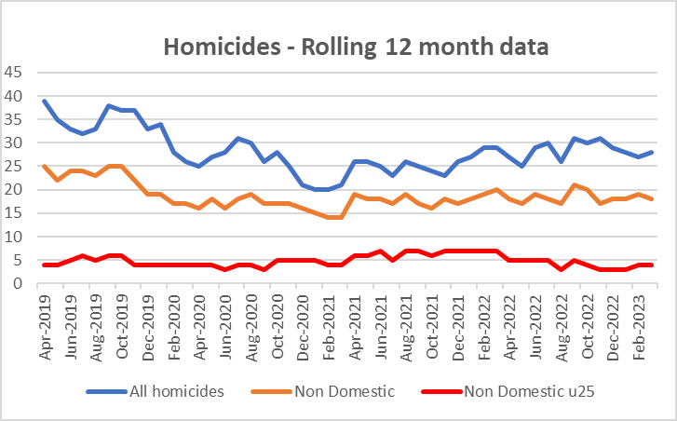

3.1.2 The above data shows the trends for all three crime types for the last 4 years. This is now an improving trend for Non-Domestic under 25s and a stabilization for all homicides including non-domestic.

3.1.3 When looking at the trends in the age of victims of homicides the following pattern can be seen with homicides above the relative proportion of the population, starting at age 16 to age 45.

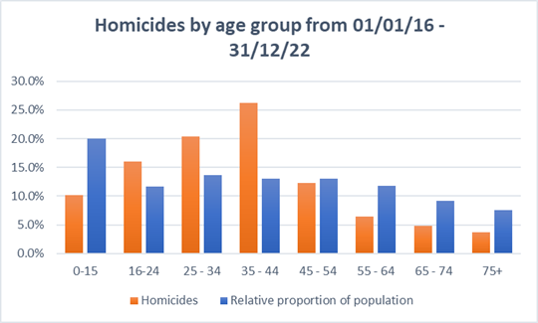

3.1.5 In comparison to the population, homicides for those aged 16-24 are 4% overrepresented in West Yorkshire – this compares to 20% in the Met and 8% in the West Midlands, but in GMP this is currently only 2% points.

**3.2 Reduce all hospital admissions for assault with a sharp instrument.**

3.2.1 Hospital admissions has seen a decrease of 5 for both groups.



3.2.2 Note: the data for the last 12 months is provisional for April 21 to Nov 22, and this data does not include those months where there are less than 5 admissions in the month. This is more likely to affect the under 25 admissions than the overall total.

**3.3 Reduce Knife Crime**

3.3.1 The decreasing trend over the pandemic can be seen culminating in the lowest figures recorded in March 2021.

Knife Crime then increased to closer to pre pandemic levels, but since April 2022 there has been a decreasing trend.

The most recent two months have seen a slight increase in these crimes, but the numbers are still below those seen in the same months last year.

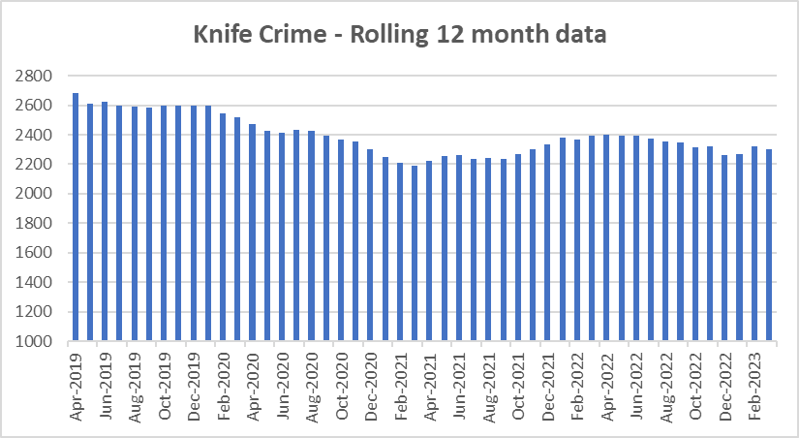

3.3.2 The most recent update nationally is to December 2022 – West Yorkshire is reporting a 3% decrease (-80 offences to 2,262) in knife crime offences for the 12 months to December 2022. Nationally there is a 6% increase.



3.3.3 It should be noted that West Yorkshire Police is one of 37 forces which uses a national methodology for recording knife crime. The remaining forces will be using the same methodology soon, but until then, national comparisons are problematic.

**3.4 Reduce number of ASB incidents.**

3.4.1 The reductions in ASB incidents have been reported before to Panel with the caveat that some of this reduction will be due to more of the incidents being crimed and therefore not included in these numbers.

3.4.2 The chart below on the right highlights that whilst ASB logs have been falling the number of logs now opened as public order, harassment and criminal damage have increased.

3.4.3 The left-hand graph shows the rolling 12 monthly trend for ASB incidents. Due to training within contact at West Yorkshire Police, the logs that would have previously been in coded as ASB are now immediately flagged as a crime and this is reflected (right graph) by the blue line in comparison to orange line which shows the in-codes for the crimes.

3.4.4 In line with this change of recording, the force includes these crime types in the analysis for their multi agency meeting to ensure the ASB felt by residents is reflected in the analysis of not just ASB incidents, but also those crimes linked to ASB. For more information on this please see the latest Community Outcome Meeting paper on Neighbourhood Policing and ASB at <https://www.westyorks-ca.gov.uk/policing-and-crime/holding-the-chief-constable-to-account/community-outcomes-meetings/community-outcomes-meeting-18-april-2023/>

**3.5 Keep Neighbourhood Crime below baseline.**

3.5.1 West Yorkshire Police continues to make significant reductions in Neighbourhood Crime. Figures for 2022/23 report that Neighbourhood Crime offences have fallen by 23% when compared to the year prior to the pandemic (2019/20) equating to over 10,000 fewer victims. Notable reductions are residential burglary (down 34%), personal robbery (down 9%), theft from person (down 23%), and theft from vehicle (down 39%).

3.5.2 The below table looks at these crime types to break down the overall figures.



3.5.3 The one area that is different is Theft Of Motor Vehicle. This crime type continues to be the only one that is above the 12months to June 2019 baseline.

3.5.6 Compared with our most similar group, West Yorkshire sits mid-table (offences per 100,000 population).



**3.6 Monitor cyber-attacks on businesses via WYCA survey**

3.6.1 This data is not available currently.

**3.7 Increase proportion of workforce from ethnic minorities**



3.7.1 Overall the proportion of the total WYP workforce from ethnic minorities is at 7.4% but officers are currently above this at 8.2%. Although staff numbers are lower at 5.7% this is still an increasing trend.

3.7.2 As reported nationally, West Yorkshire Police exceeded its target for recruitment of officers and although the overall proportion of officers and staff from ethnic minorities continues to be below that of the West Yorkshire population, during recruitment this proportion was much higher and nearer to the target.

**3.8 Increase proportion of female officers**

3.8.1 Due to the increased number of officers and staff compared to 2017 the percentage increases may look small, but these mask the increase in numbers. For female officers, the 5.5% increase equates to 719 more female officers. At the same time, the number of male officers has increased by 416.

**3.9 Reduce numbers of KSIs on roads in West Yorkshire**

3.9.1 Numbers of KSIs on the roads in West Yorkshire is currently increasing and this is the focus of the Vision Zero meetings in West Yorkshire

3.9.2 In January 2021, the Force started using CRASH (Collision Reporting and Sharing system) which is a Dept of Transport developed system to record collisions. Previously injuries were categorised subjectively based on the reporting officer’s assessment whereas CRASH is more prescriptive with injury descriptions being automatically categorised. It is acknowledged nationally that this has effectively increased the number of collisions where injuries are categorised as being serious.

3.9.3 Operation SNAP, (the on-line portal for submission of dangerous driving footage) goes from strength to strength in terms of numbers of submissions and resultant prosecutions. The Casualty Reduction Partnership also leads the way for enforcement and (outside of the Metropolitan Police Force area) is the highest performing unit in the country. ANPR technology generates intelligence tasking packages which lead the response against our highest risk drivers in West Yorkshire for which we currently have an 80% positive outcome rate, with numbers of offenders arrested and vehicles seized at consistently high levels.

3.9.3 For more information on the work of Vision Zero, please see the panel paper that came to the meeting in April 2023.

**3.10 Increase number of additional officers and staff in comparison to April 2021 baseline**

3.10.1 The numbers here show that officer numbers are increasing as expected, with staff numbers also increasing even with the current budget constraints.

3.10.2 The Mayor and Deputy Mayor receive a quarterly update for this measure to ensure that the Mayoral Pledge is met. This paper discusses the current situation and where there are any risks.

3.10.3 Currently the projections are showing to surpass the pledge by the end of the Mayoral term for officers.

**4. Responding to Multiple and Complex Needs**



**4.1.1 Monitor VRU early intervention programme attendee figures**

4.1.2 As part of its monitoring information for the Home Office, the Violence Reduction Unit must show the impact of its work by counting the number of young people (and others) that it reaches.

4.1.3 The VRU have outlined the current initiatives in the Safer Places and Thriving Communities paper which is being presented at the same meeting as this paper. Please see this paper for more detail on this metric.

**4.2 Reduce number of repeat missing persons.**

4.2.1 Number of Missing persons per 1000 population

Over the last 12 months there have been 11,164 missing persons (including repeats). The trends for this are as follows.

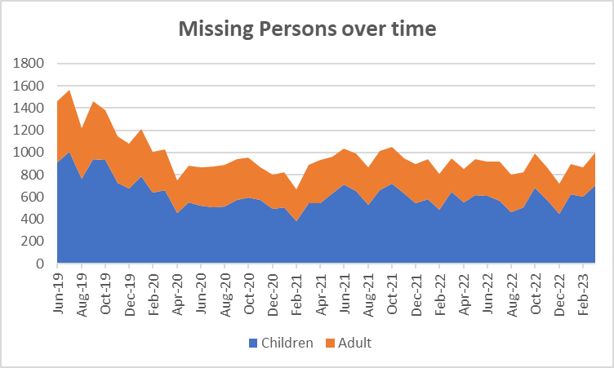

4.2.2 The reason for including missing persons under the Multiple and Complex Needs priority was due to the proportion of those that go missing which fall into this priority. This is reflected in the risk level assigned to each case when the call is received by WYP. The below graphs show this risk level.

4.2.3 In the last 12 months the risk level for both High and Medium has increased and the number categorized as low has fallen. This gives an indication of the complexity of the work in this area and the need for all partners to be involved.

4.2.3 The next table looks at the numbers of repeat missing occurrences.

4.2.5 The number of repeat missing persons is detailed above. This stands at 35.6% for missing children and 11.8% for missing adults.

4.2.2 Although the numbers are slightly lower, the extent of the work can be seen above with 5 missing persons having greater than 40 occurrences throughout the year. This continues to be a drain on police resources.

**4.3. Reduce Re-offending Rate for Drug Related Crime**

4.3.1 Due to the time lapse required to ensure offences are taken into consideration, the re-offending rates are for offenders who were convicted 12 months ago.

4.3.2 The current figures show that there has been a 0.2% increase in this rate in comparison to the same time 12 months ago.

4.3.3 Work is ongoing with the Senior Responsible Officers for the Combatting Drugs WY partnership with the first meeting taking place in February. Terms of reference for the group are being written following feedback and discussions took place with updates from each area.

**4.4 Reduce the number of First-time entrants to the CJS**

4.4.1 As the above there is a bit of a time lapse with this measure, as the Ministry of Justice data is based on offenders on PNC as having their 1st conviction, caution or youth caution. This now compares 12 months to Sept 2021 to 12 months to Sept 22 (which is the latest data available).

4.4.2 Both Adult and youth offenders are seeing a decrease in this measure currently.

**4.5 Increase number of offenders referred to drug treatment services via Liaison and Diversion**

4.5.1 Figures relate to referrals to drug services across the five districts. Figures provided by West Yorkshire All Age Liaison and Diversion Service.

4.5.2 The figures relate to the most recent quarter (Oct – Dec) available and are the same as reported in the last iteration as the most recent quarter is not available.

4.5.4 These statistics and the work undertaken are discussed on the Liaison and Diversion Strategic Board – this is attended by the DMPC on a regular basis.

Appendix 2

**Cyber Crime**

**Reports, referrals, and outcomes for**

The below data is for April 2022 to March 2023

Cyber Crime reporting

The above is for Cyber Crime only the picture for Fraud is as follows.

For business Cyber Crime **only** the current picture is as follows:

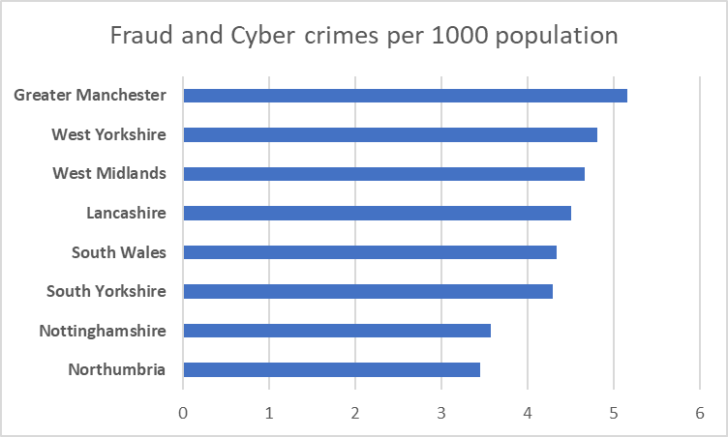

|  |  |
| --- | --- |
| **Acquisitive crime** | Acquisitive crime is defined as an offence where the offender derives material gain from the crime. Examples include shoplifting, burglary, theft, and robbery. |
| **BAME** | BAME stands for Black, Asian and Minority Ethnic and is used to describe people from any of these ethnicities. |
| **Child sexual exploitation and abuse** | Sexual exploitation of children and young people under 18 involves exploitative situations, contexts, and relationships where young people (or a third person or persons) receive 'something' (e.g., food, accommodation, drugs, alcohol, cigarettes, affection, gifts, money) because of them performing, and/or another or others performing on them, sexual activities. |
| **Community Safety Partner** | Several different organisations have a role to play including local councils, fire and rescue service, health and probation services and housing providers etc. These are often referred to as local community safety partners. |
| **Conviction rate** | This measure is calculated by dividing the number of defendants convicted by the total number of defendants prosecuted in the court during the period in question. The total number of defendants prosecuted in the court includes those charged by the police and Crown Prosecution Service but whose cases were dropped. |
| **Crime rate** | The crime rate used in this document refers to the number of offences committed per 1000 people in the population. |
| **Cyber crime** | Can be seen in two parts: cyber-enabled crime, where crimes that may be committed without computers are instead committed using computer networks (for example fraud and bullying); and pure cyber-crime where the offence can only be committed using computers (for example computer hacking or use of malicious software). |
| **GAP**  **Human trafficking** | Anticipated Guilty Plea  Human trafficking is the trade of humans, most commonly for the purpose of forced labour or commercial sexual exploitation by the trafficker or others. |
| **IOM** | Integrated Offender Management (IOM) is an overarching framework that allows local and partner agencies to come together to ensure that the offenders whose crimes cause most damage and harm locally are managed in a coordinated way. |
| **Ineffective trial** | An ineffective trial occurs when the trial does not go ahead on the date planned due to action or inaction by one or more of the prosecution, the defence or the court and a further listing for a trial is required. |
| **Most similar police groups/family/forces**  **NGAP** | Most Similar Groups (MSGs) are groups of police force areas that have been found to be the like each other based on an analysis of demographic, social and economic characteristics which relate to crime. Each police area has its own group of up to seven police areas to which it is ‘most similar’. MSGs are designed to help make fair and meaningful comparisons between police areas which share similar characteristics, rather than, for example, comparisons with a neighbouring police area.  Anticipated Not Guilty Plea |
| **Operational functions** | Operational functions include things like patrolling neighbourhoods, responding to 999 calls, roads policing and protecting vulnerable people. |
| **Outcomes/detections** | Outcomes/detections are used by the Home Office to describe the result of a police investigation following the recording of a crime. They can include cautions, charges, fixed penalty notices, cannabis warnings etc. There are 21 categories of outcomes. |
| **PEEL**  **Positive Outcomes** | HMICFRS carry out several thematic annual inspections throughout the year, these are drawn together into a wider PEEL assessment which stands for Police Effectiveness, Efficiency and Legitimacy. The aim of the PEEL assessment is to judge each police force in a cross-topic way based on criteria which consider the full breadth and complexity of what the police do.  Outcomes which fall into the first 8 categories for Police outcomes, these include mostly charges, cautions and community resolutions. |

**Find out more.**

westyorks-ca.gov.uk

@WestYorkshireCA

enquiries@westyorks-ca.gov.uk

+44 (0)113 251 7272

All information correct at time of print (March 24)