**Appendix 1.**

PERFORMANCE MONITORING REPORT

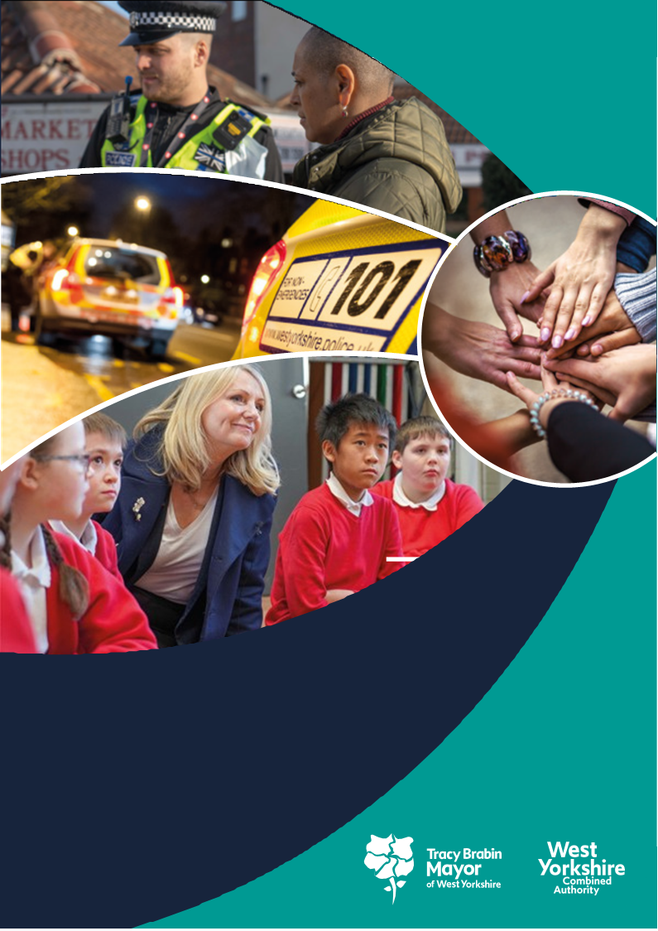

**West Yorkshire:**

**Safe. Just. Inclusive**

**Police and Crime Plan 2021-2024**

**1. Supporting Victims and Witnesses and Improving Criminal Justice Outcomes**



# 2 Figures relate to 2022/23

# 3 Figures relate to 12 months to November 2023

**1.1 Victim Satisfaction**

1.1.1 The latest victim satisfaction rate stands at 71.9% for the 12 months to December 2023. The latest position is 1 percentage point higher than 12 months ago.



1.1.2 Performance levels range from 71.7% at Leeds to 76.4% at Calderdale. Kirklees and Wakefield have seen improvement over the last 12 months whereas in contrast Leeds has seen reductions. The district satisfaction score only looks at crimes dealt with by the district. Those telephone investigations dealt with via the Force Crime Management Unit (FCMU) are not included in the district ratings but are included in the overall West Yorkshire rating.

1.1.3 Safety and Welfare continues to be the highest performing category at 83.8% but the biggest increase in the last 12 months has been with ASB and the largest decrease in Robbery. Arson and Criminal Damage currently has the lowest rate at 63.8%.

1.1.4 Satisfaction for victims of Domestic Abuse is at 83.2%, which is higher than the all crime satisfaction rate of 71.9% (as shown above) and victims of stalking gave a satisfaction rate of 76.0%.

## 1.2 Maintain high levels of calls answered on target.

1.2.1 In the latest 12 months to December 2023 the number of total contacts into West Yorkshire Police have increased by 4.6% (73k additional contacts). During the same period 999s have increased by 3.7% (19k more calls), 101 calls have increased by 3.2% (23k more calls), Other calls have increased by 11.6% (8k more calls) and online contacts have increased by 7.9% (22k more contacts). The very latest quarter is reporting a downturn in demand with overall contacts falling by 8.8% and all contact types reporting a reduction in the last three months to December 2023..



1.2.2 The above trends have had an impact on 999 answering times – the below graph shows the comparison with the MSG. Previously WYP were 2nd in the table and are now 3rd.

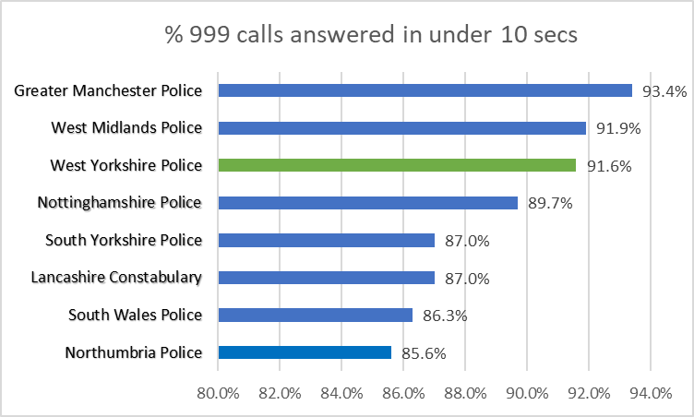

1.2.3 For information – The above is from Police.uk who produce statistics on 999 answering times, but these also include transfer times from BT, which can be 4-6 seconds and can vary across police forces. The comparison data with other forces is available [here](https://www.police.uk/pu/your-area/west-yorkshire-police/performance/999-performance-data/?tc=BDT_BW).

## 1.3 Improve Outcomes

**1.3.1 Rape and Serious Sexual Offences**



1.3.2 The above table shows the position in December 2023 in comparison to the same time last year. The numbers of rape offences are 109 offences higher than the same time last year, and the outcome rate has decreased by 0.6%.

1.3.3 The most recent data that is available nationally is up to November 2023, so not a direct comparison with the above. This data compares forces by looking at crimes per 100,000 population. Previously other areas were not close in number to West Yorkshire, but now we see large increases in some areas which bring them to similar numbers – whereas the effect of CDI is getting slower in WYP.



**Serious Sexual Offences**



1.3.4 Serious Sexual offence numbers have decreased by 0.6% in comparison with the same time last year, and the positive outcome rate has risen by 0.5% with 39 more victims receiving a positive outcome.



1.3.5 Nationally the Serious Sexual Offence category is not reported on, as this category includes the rape offences above, but there is a category of ‘Other Sexual Offences’ which does not include the Rape offences. In a similar manner to the above Rape offences (with the baseline Jan – Dec 2019) the table below gives an indication of the current position.



Most forces have seen an increase in these crime types and now have similar rates to WYP.

**1.3.6 Domestic Abuse Crime Outcomes**



1.3.7 The above looks at the data for the last 12 months compared to the previous 12 months. The number of Domestic Abuse Crimes has fallen by over 5000 in the last 12 months which is an 8.6% decrease. The outcome rate has risen by 0.7% although the actual numbers of positive outcomes have fallen slightly.

1.3.8 In the most recent national comparison (up to March 2023) West Yorkshire still has a high number of police recorded domestic abuse crimes per 1000 population. Currently we have a rate of 27 per 1000. The rate for Yorkshire and the Humber is 21 and England and Wales is 15.

1.3.9 The data also shows that 20% of all crime in West Yorkshire is domestic related, compared to 18% in the YaTH and 16 in E&W. For more detail see <https://www.ons.gov.uk/peoplepopulationandcommunity/crimeandjustice/datasets/domesticabuseinenglandandwalesdatatool>

**1.4 Increase proportion of crimes with victim initial needs assessment**

1.4.1 The Initial Victim Needs Assessment (IVNA) is part of the Victims Code of Practice and is intended to:

1. Determine if the victim needs support.

2. Establish the type of support needed.

3. Assess whether the victim is vulnerable or intimidated.

4. Consider whether the victim is entitled to enhanced rights.

1.4.2 The guidance from the College of Policing shows that obtaining this at initial contact is important to the ongoing investigation, as well as a key consideration towards effective communication and engagement with the victim.

## 1.5 Criminal Justice Measures

1.5.1 It has been agreed that the LCJB will scrutinise a written report on the Delivery Data Dashboards at each Executive Board meeting going forward, providing the dataset has been delivered nationally. These delivery dashboards include the transforming summary justice target data, but also include a number of other data sets. The measures from the Delivery Dashboards give us the opportunity to compare current performance with national performance and this report will be able to give these comparisons against the agreed priorities.

1.5.2 The most recent data to the Local Criminal Justice Board gave the data up to the end of Q1 2023 (June 2023)

A link to the Delivery Data Dashboards is here - [Home - CJS Dashboard (justice.gov.uk)](https://criminal-justice-delivery-data-dashboards.justice.gov.uk/)

The following looks at the last qtr. (Apr-Jun 2023) against the average for the last 12 months and concentrates on exceptions rather than the whole data set.

The number of victim based recorded offences has increased in this quarter, but the number of cases referred to CPS for advice has fallen slightly as has the number authorised to be charged.

WYorks has a high percentage of cases accepted by CPS at first triage (78.3% compared with a national average of 59.2% in the last qtr.).

The average days from police referring a case to the CPS and the CPS authorising a charge has fallen slightly but is still above the national average (47.4 vs 44.1)

Early guilty plea rates at Magistrates is slightly lower than the national rate, but the actual guilty plea rate and the conviction after trial at Magistrates is similar to the national rate.

Early guilty plea rates at Crown Court is higher than the national rate, but the actual guilty plea rate and the conviction after trial at Crown is significantly higher than the national rate.

Non-conviction due to victim issues is slightly lower for Magistrates court, but significantly higher for Crown Court.

There are currently over 3,600 cases outstanding at Magistrates court and over 3200 cases outstanding at Crown Court. 586 cases have been outstanding for a year or more at Crown Court and there are over 7,000 defendants with a case outstanding in either/both courts.

**1.5.4 Decrease ineffective trial rate (Magistrates Court)**

1.5.5 The figures here are shown for 2022/23 and then for up to November 2023, This shows an increase (5.9%) and is reflective of the increases in the number of trials taken forward.

**1.5.6 Increase volume of early guilty pleas**

1.5.7 The increase of the number of early guilty pleas negates the need for a trial and frees up time which could be used elsewhere.

1.5.8 Again these figures compare the same timescales as the above and this shows an increase in both the Magistrates and Crown Courts.

**1.5.9 Decrease average time taken for cases to be brought to resolution.**

1.5.10 “Average Days from First Listing to Completion” has changed definition in the new TSJ National Results. The new measure is still Average Days from First Listing to Completion, but completion now refers only to ‘Not Guilty or No Plea”. This means that results from Q3 2023 onwards are not comparable with previous quarters.

**2 KEEPING PEOPLE SAFE AND BUILDING RESILIENCE**

# 

**2.1 Monitor the number of young persons flagged as at risk of Criminal Exploitation**

# 2.1.1 In February 2020 the government produced guidance about the criminal exploitation of children (and vulnerable adults) and as part of this guidance it was noted that *Criminal exploitation of children and vulnerable adults is a geographically widespread form of harm that is a typical feature of county lines activity. It is a harm which is relatively little known about or recognised by those best placed to spot its potential victims.*

# 2.1.2 The purpose of this measure is to gauge how well West Yorkshire Police officers spot this type of exploitation and ensure that these vulnerable victims get the support and help that they need.

# 2.1.3 From the above figures we can see that there is a decrease in numbers and whilst numbers are down in the past 12 months the long term trend is upward..

# 

**2.2 Monitor Indicators from Cyber Dashboard**

# 2.2.1 As Fraud has now been included in the Strategic Policing Requirement, updates about Cyber-crime will now also include updates about action against fraud.

# 2.2.2 The data at Appendix 2 shows the picture for West Yorkshire and includes both Fraud and Cyber offences with a comparison to most similar force areas (MSG).

# 2.2.3 The Economic Crime Unit Team have been involved in a number of initiatives to contribute to Cyber Threat reduction including:

# On Tuesday 21st November, officers and staff from the Economic Crime Unit were on hand at shopping centres across the county offering help and advice ahead of Black Friday and Cyber Monday. The Force’s fraud experts were at shopping centres in Bradford, Halifax, Huddersfield, Leeds and Wakefield and engaged with over 1000 people warning them to be extra vigilant on the run up to the festive period.

# The cyber operations team identified a male in Bradford, who the FBI believe is part of a cyber organised crime group. A proactive operation conducted by YHROCU Cyber Crime Unit, identifying UK based criminality in relation to Computer Misuse Act (CMA) offences. An individual was arrested and interviewed and bailed for those matters but charged & remanded (as well as recalled to prison) for previous Computer Misuse Act offences.

# The YHROCU Cyber Crime Unit have launched the first Cyber Blue Line Community Engagement Vehicle. Cyber Blue Line (CBL) is a community engagement vehicle that is fully mobile and digitally equipped resource that enables the Cyber Prevent & Protect messaging to be disseminated to a wide and varied audience in an immersive, engaging, and interactive way.

The Cyber Blue Line vehicle is equipped with three gaming stations for both educational games and traditional games. Cyber Blue Line also has a fully equipped Virtual Reality (VR) experience scenario.

**2.3 Repeat Victims of Domestic Abuse and Hate Crimes**

# 

# 2.3.1 Domestic abuse incidents have reduced by 5.8% in comparison to the last 12 months. The repeat victim rate reduced by 0.6% in comparison.

# 2.3.2 Safeguarding Governance and Corporate Communications worked together to support the 16 days of action from 25th November to 10th December 2023. External messaging included the refresh and relaunch of the third-party reporting campaign and promotion of White Ribbon UK. Internally, key messages were shared to promote White Ribbon UK (to encourage officers and staff to sign up to the White Ribbon promise, or as an ambassador or champion,) the promotion of Clare’s Law and the unwanted prisoner contact scheme and highlighting again the importance of checking on children at DA incidents and the impact that DA has on children. Comms also included raising the awareness of the DA Champions and their role in districts and departments.

# 2.3.3 Hate Crime Repeat Victims

# 2.3.4 Hate Incidents have fallen by 9.2% (987 fewer incidents) in the latest 12 months to December 2023..

# 2.3.5 The only strand to see an increase was faith hate crimes – this formed part of the Performance Scrutiny Meeting with West Yorkshire Police where the increases were discussed. This was as a direct result of the Israel/Gaza conflict, and although the numbers spiked at the start of the conflict, they soon returned to near normal levels.

# 2.3.6 In the same period, the number of hate crime repeat victims also fell.

# 2.3.7 Almost nine out of 10 hate crimes recorded relate to public order, stalking/harassment and violence without injury. 4.8% of hate incidents in the past 12 months are violence with injury offences and this is 70 less than the same time last year.

# 2.4 Increased Use of DVPN and DVPO

# 2.4.1 As discussed in the last Performance Monitoring Report, we can now look at the trends in DVPN and DVPO’s. We will also note Claire’s laws occurrences as this is another intervention which protects victims of Domestic Abuse. (for more information on Claire’s law please see the WYP website: <https://www.westyorkshire.police.uk/ClaresLaw>

# 2.4.2 DVPN and DVPO’s are interventions used after a Domestic Abuse incident has taken place, but Clare’s Law is an early intervention to stop these occurrences taking place and could be argued to be a better intervention. The numbers are as follows:

**2.5 Use of Stalking Protection Orders (SPOs)**

# 2.5.1 Stalking Protection Orders (SPOs) are being increasingly considered as an option to safeguard victims and manage risks posed by perpetrators. There are currently five full SPOs (including one Out of Force) and seven interim SPOs (including two OoF)

# 2.5.2 The latest victim satisfaction results for the 12 months to December report overall victim satisfaction (for all crime types) at 71.9% whereas satisfaction reported by stalking victims is higher at 76.0% and 81% are satisfied with the outcome.

*.”*

**3 Safer Places and Thriving Communities**

# 

## 3.1 Reduce Homicide

3.1.1 Homicide continues to be a key measure for the Violence Reduction Partnership (VRP), The overall measure shows the current position, but the VRP looks at non-domestic homicide and homicide for under 25s, so the current position for those is shown below.



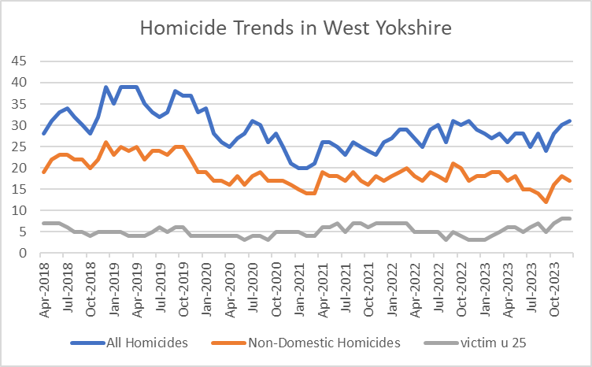

3.1.2 The above data shows the trends for all three crime types for the since 2018. This is now showing a rolling 12 month increase for all homicides including non-domestic homicides.

3.1.3

The long-term trends for Homicide rates (as shown in the map) evidence that West Yorkshire (13.2 per mil) has a similar rate to many in our MSG including GMP (12.4), West Mids. (14.8) and South Yorkshire (14.6)

**3.2 Reduce all hospital admissions for assault with a sharp instrument.**

3.2.1 Hospital admissions are up to September 2023 and show a decrease for both groups.



**3.3 Reduce Knife Crime**

3.3.1 The undulating picture with knife crime can be seen in the below graph. There was a reduction during the pandemic and then a rise back to normal levels which reached its peak a year ago. This then decreased again, but since the beginning of the year there has been an increase in knife crime and figures are now above the same time last year. The most recent two months have seen a slight increase in these crimes. These are still well below the baseline figures.

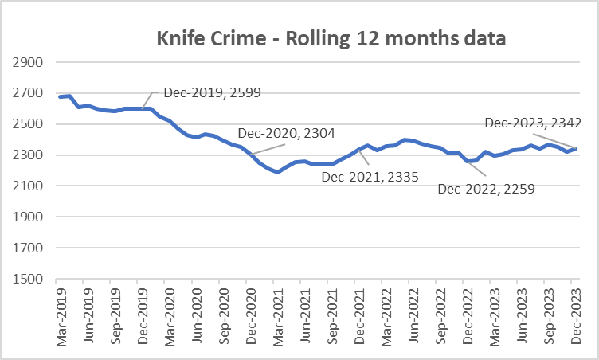

3.3.2 The most recent update nationally is to September – The below table looks at knife crime per million residents when compared to the Jan-Dec 2019 baseline. The below table compares with others in our most similar group.



3.3.3 It should be noted that West Yorkshire Police is one of 40 forces which uses a national methodology for recording knife crime. The remaining forces will be using the same methodology soon, but until then, national comparisons are problematic. Also, data for West Midlands is provisional due to a move to a new computer system.

**3.4 Reduce the number of ASB incidents.**

3.4.1 ASB incidents have fallen by -2.3% (-637 incidents) when comparing the latest 12 months to December 2023 with the previous 12-month period.

3.4.2 The number of ASB incidents was significantly impacted by crime recording improvement activity. But now that difference is starting to slow as can be seen in the below graph.



3.4.3 West Yorkshire has been monies from round Five of the Safer Streets Fund to tackle neighbourhood crime, violence against women and girls (VAWG) and anti-social behaviour (ASB). Three proposals were approved and run from 1st October 2023 to 31st March 2025 in the Leeds, Bradford and Wakefield areas of the force. This is led by Local authorities and supported by West Yorkshire Police. Operational Support has supported districts in tackling criminal and anti-social use of motorcycles financed by the funding.

**3.5 Keep Neighbourhood Crime below baseline.**

3.5.1 In previous iterations of this document we have looked at the baseline of June 2019. More recent iterations of figures from the government look at this baseline as the 12 months to December 2019, so we have now changed to fall into line with this comparison.

3.5.2 Figures for the latest 12 months to December 2023 report that Neighbourhood Crime offences have fallen by 26% when compared to the national baseline period (Jan-Dec 2019) equating to over 12,000 fewer victims. Notable reductions for residential burglary (down 36%), personal robbery (down 12%), theft from person (down 20%) and vehicle crime (down 22%) have been reported. Encouragingly, more recent reductions are also being recorded with a 2% reduction being reported in the latest quarter.

3.5.2 The below table looks at these crime types to break down the overall figures.



3.5.3 The one area that is different is Theft Of Motor Vehicle. This crime type continues to be the only one that is above the 12months to Dec 2019 baseline.

3.5.6 Compared with our most similar group, West Yorkshire has one of the largest % change in comparison to the baseline. (offences per 100,000 population).



**3.6 Monitor cyber-attacks on businesses via WYCA survey**

3.6.1 This data is not available currently.

**3.7 Increase proportion of workforce from ethnic minorities**

3.7.1 Overall the proportion of the total WYP workforce from ethnic minorities is at 8.2% but officers are currently above this at 9.2%. Although staff numbers are lower at 6.5% this is still an increasing trend.

3.7.2 As reported nationally, West Yorkshire Police exceeded its target for recruitment of officers and although the overall proportion of officers and staff from ethnic minorities continues to be below that of the West Yorkshire population, during recruitment this proportion was much higher and nearer to the target.

**3.8 Increase proportion of female officers**

3.8.1 West Yorkshire continues with high numbers of female officers - this has increased from 34% in 2018 to nearly 40% currently. Police staff continue to have a high number of female members, with that percentage not changing over the years.

3.8.2 Police workforce Statistics are available on the Gov.uk website – the most recent are to September 2023. These statistics do not give the overall breakdowns regarding ethnicity and gender, but just include the full-time equivalent numbers.

3.8.3 When looking at PCSO numbers, it tells us the following:

* In September 2023 West Yorkshire was showing to have a **deficit of 3.1%** in comparison to 12 months before – which equates to a **fall of 17** persons.
* We **compare favourably** with the England average which is a fall of **8.8%** and out of 8 forces in our **MSG** only **two** have **smaller drops** than us.
* **Three** of these forces are in the **top 5** for drops in PCSO numbers – with **Northumbria** as the highest at **43.3%** but **West Midlands** as the highest actual numbers with a **deficit of 114** staff members – a fall of **26.5%.**
* **Most interestingly** – when looking at the numbers of PCSO per 1000 population, the **only forces** with **more** than West Yorkshire are the **4 Welsh forces**, of which one is in our Most Similar Group and these increases were paid for by the Welsh government.

**3.9 Reduce numbers of KSIs on roads in West Yorkshire**

3.9.1 Numbers of KSIs on the roads in West Yorkshire is currently increasing and this is the focus of the Vision Zero meetings in West Yorkshire

3.9.2 awaiting discussion at Performance Scrutiny meeting.

**3.10 Increase number of additional officers and staff in comparison to April 2021 baseline**

3.10.1 The numbers here show that officer numbers are increasing as expected, with staff numbers also increasing even with the current budget constraints.

3.10.2 The Mayor and Deputy Mayor receive a quarterly update for this measure to ensure that the Mayoral Pledge is met. This paper discusses the current situation and where there are any risks. Currently the projections are showing to surpass the pledge by the end of the Mayoral term for officers.

**4. Responding to Multiple and Complex Needs**



**4.1.1 Monitor VRU early intervention programme attendee figures**

4.1.2 As part of its monitoring information for the Home Office, the Violence Reduction Partnership must show the impact of its work by counting the number of young people (and others) that it reaches.

4.1.3 The VRP sends these figures quarterly to the Home office to show the impact of its interventions. These interventions have been detailed in previous papers to the panel and will continue to be part of the impact of the Police and Crime plan.

**4.2 Reduce the number of repeat missing persons.**

4.2.1 Number of Missing persons per 1000 population

Over the last 12 months there have been 10,575 missing persons (including repeats). The trends for this are as follows.

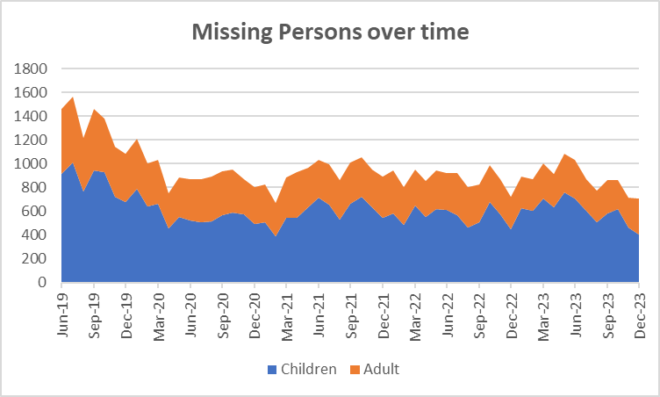

4.2.2 The next table looks at the numbers of repeat missing occurrences.

4.2.5 The number of repeat missing persons is detailed above. This stands at 36.6% for missing children and 12.3% for missing adults.

4.2.2 Although the numbers are slightly lower, the extent of the work can be seen above with 14 missing children having greater than 30 occurrences throughout the year. This continues to be a drain on police resources.

**4.3. Reduce Re-offending Rate for Drug Related Crime**

4.3.1 Due to the time lapse required to ensure offences are taken into consideration, the re-offending rates are for offenders who were convicted 12 months ago.

4.3.2 The current figures show that there has been a 0.1% reduction in this rate in comparison to the same time 12 months ago.

4.3.3 Work is ongoing with the Senior Responsible Officers for the Combatting Drugs WY partnership with the Deputy Mayor bringing all 5 districts together to discuss common problems and share best practice.

4.3.4 West Yorkshire Reducing Reoffending Partnership Board: This is the current iteration of the board convened by the Mayor and chaired initially by the Criminal Justice Policy Manager. The intention of this board is to add value to existing Reducing Reoffending Partnerships within districts and their work with Criminal Justice partners including Youth Justice.

**4.4 Reduce the number of First-time entrants to the CJS.**

4.4.1 Following a user consultation published in February 2023, the MOJ have concluded first time entrants’ statistics will only be published annually as part of the First-time entrants (FTE) into the Criminal Justice System and Offender Histories publication.). The stats are those which are currently published with the next iteration due in May 2024.

**4.5 Increase number of offenders referred to drug treatment services via Liaison and Diversion**



4.5.1 Figures relate to referrals to drug services across the five districts. Figures provided by West Yorkshire All Age Liaison and Diversion Service.

4.5.6 Referrals are up for both adults and young people, but there has been a reduction in formal pathway referrals and other pathway contacts. Areas are looking at other pathway contacts to enhance this data from partners.

Appendix 2

**Cyber Crime**

**Reports, referrals, and outcomes for**

The below data is for Jan – Dec 2023

Cyber Crime reporting

The above is for Cyber Crime only the picture for Fraud is as follows.

For business Cyber Crime **only** the current picture is as follows:

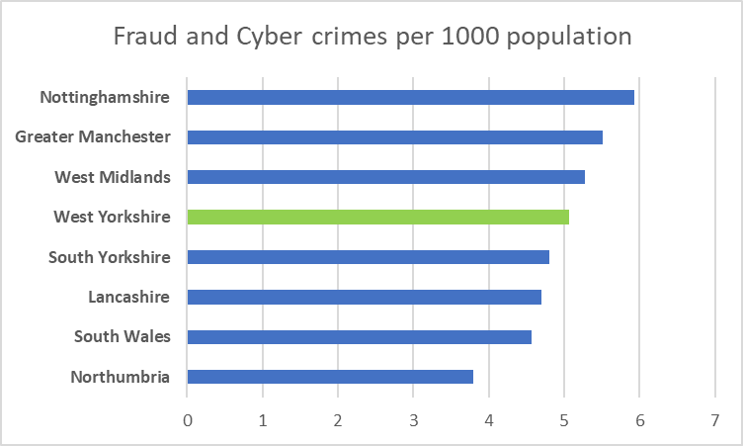

|  |  |
| --- | --- |
| **Acquisitive crime** | Acquisitive crime is defined as an offence where the offender derives material gain from the crime. Examples include shoplifting, burglary, theft, and robbery. |
| **BAME** | BAME stands for Black, Asian and Minority Ethnic and is used to describe people from any of these ethnicities. |
| **Child sexual exploitation and abuse** | Sexual exploitation of children and young people under 18 involves exploitative situations, contexts, and relationships where young people (or a third person or persons) receive 'something' (e.g., food, accommodation, drugs, alcohol, cigarettes, affection, gifts, money) because of them performing, and/or another or others performing on them, sexual activities. |
| **Community Safety Partner** | Several different organisations have a role to play including local councils, fire and rescue service, health and probation services and housing providers etc. These are often referred to as local community safety partners. |
| **Conviction rate** | This measure is calculated by dividing the number of defendants convicted by the total number of defendants prosecuted in the court during the period in question. The total number of defendants prosecuted in the court includes those charged by the police and Crown Prosecution Service but whose cases were dropped. |
| **Crime rate** | The crime rate used in this document refers to the number of offences committed per 1000 people in the population. |
| **Cyber crime** | Can be seen in two parts: cyber-enabled crime, where crimes that may be committed without computers are instead committed using computer networks (for example fraud and bullying); and pure cyber-crime where the offence can only be committed using computers (for example computer hacking or use of malicious software). |
| **GAP**  **Human trafficking** | Anticipated Guilty Plea  Human trafficking is the trade of humans, most commonly for the purpose of forced labour or commercial sexual exploitation by the trafficker or others. |
| **IOM** | Integrated Offender Management (IOM) is an overarching framework that allows local and partner agencies to come together to ensure that the offenders whose crimes cause most damage and harm locally are managed in a coordinated way. |
| **Ineffective trial** | An ineffective trial occurs when the trial does not go ahead on the date planned due to action or inaction by one or more of the prosecution, the defence or the court and a further listing for a trial is required. |
| **Most similar police groups/family/forces**  **NGAP** | Most Similar Groups (MSGs) are groups of police force areas that have been found to be the like each other based on an analysis of demographic, social and economic characteristics which relate to crime. Each police area has its own group of up to seven police areas to which it is ‘most similar’. MSGs are designed to help make fair and meaningful comparisons between police areas which share similar characteristics, rather than, for example, comparisons with a neighbouring police area.  Anticipated Not Guilty Plea |
| **Operational functions** | Operational functions include things like patrolling neighbourhoods, responding to 999 calls, roads policing and protecting vulnerable people. |
| **Outcomes/detections** | Outcomes/detections are used by the Home Office to describe the result of a police investigation following the recording of a crime. They can include cautions, charges, fixed penalty notices, cannabis warnings etc. There are 21 categories of outcomes. |
| **PEEL**  **Positive Outcomes** | HMICFRS carry out several thematic annual inspections throughout the year, these are drawn together into a wider PEEL assessment which stands for Police Effectiveness, Efficiency and Legitimacy. The aim of the PEEL assessment is to judge each police force in a cross-topic way based on criteria which consider the full breadth and complexity of what the police do.  Outcomes which fall into the first 8 categories for Police outcomes, these include mostly charges, cautions and community resolutions. |

**Find out more.**

westyorks-ca.gov.uk

@WestYorkshireCA

enquiries@westyorks-ca.gov.uk

+44 (0)113 251 7272

All information correct at time of print (March 24)