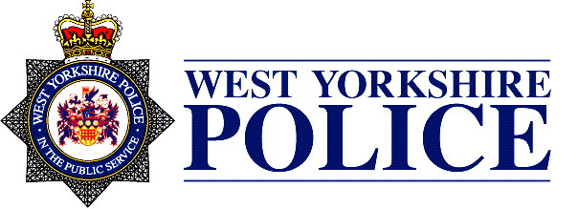

JOINT INDEPENDENT AUDIT COMMITTEE
(WEST YORKSHIRE COMBINED AUTHORITY AND WEST YORKSHIRE POLICE)

DATE: | WEDNESDAY 21 FEBRUARY 2023
TIME: | 09:30 – Member pre-meet with Internal and External Audit  10:00 – Audit Committee  13:00 – Close  This meeting is 30 minutes longer to reflect the agenda.
LOCATION: | Meeting Room 1, Wellington House, 40-50 Wellington Street, Leeds, LS1 2DE
MEMBERS: | Mike Ford, Chair  Jeff Colley, Member  Helen Kemp, Member
OFFICERS: | Joanne Campbell, Internal Audit Manager, WYP  Gary Dowson, Head of Finance, WYCA  Alastair Newall, Director, Public and Social Sector, Mazars  Julie Edwards, Head of Accountancy, WYP  Sarah Fraser, Superintendent, Corporate Services, WYP  Nicola Hallas, Manager, Mazars  Katherine Johnson, Assistant Chief Officer, WYP  Julie Reid, Head of Policing and Crime, WYCA  Neil Rickwood, Head of Audit, Risk and Assurance, WYP  Angela Taylor, Director of Corporate Services, WYCA
CONTACT OFFICERS: | Carol Beanland, Business Manager, WYCA  Carol.beanland@westyorks-ca.gov.uk  and;  Joanne Colley, Business Manager, WYCA  Joanne.Colley@westyorks-ca.gov.uk

AGENDA

Item |  | Officer
- Apologies | To note | Joanne Colley
- Declaration of Interests | To note | Mike Ford
- Record of Attendance | To note | Joanne Colley
- Minutes of the meeting on 6 December 2023 | To approve | Mike Ford
- Matters Arising | To note | Mike Ford
- Chair’s Update (verbal report) | To note | Mike Ford
Address agenda items 10, 11 and 12
- West Yorkshire Police Reports  - Business Update (verbal report)  - Programme of Change (verbal report)  - WYP Risk Management Update  - Tender Exceptions Report  - Internal Audit Progress Report  - Internal Audit Follow Up Report  - Internal Audit Draft Directional Plan  - Anti-fraud and Anti-corruption strategies  - Review of Draft Accounting Policies | To note  To note  To note  To note  To note  To note  To note  To note  To note | Katherine Johnson  Katherine Johnson  Katherine Johnson  Katherine Johnson  Neil Rickwood  Neil Rickwood  Neil Rickwood  Neil Rickwood  Julie Edwards
- External Audit Reports  8.1 External Audit Annual Report 2023/24 | To note | Alastair Newall
Break
- West Yorkshire Combined Authority Reports  9.1 Business Update (verbal report)  9.2 WYCA Risk Management Update  9.3 Draft Annual Accounts including the Annual Governance Statement  9.4 Commissioning Update Report | To note  To note  To note  To note | Julie Reid  Julie Reid  Angela Taylor  Julia Clough
- Committee Annual Report and Self-Assessment | To agree | Mike Ford
- Review of Committee Terms of Reference | To agree | Mike Ford
- JIAC Workplan | To note | Mike Ford
- AOB |  | All

Date of next meeting: Wednesday 24 April 2024 at West Yorkshire Police HQ, Wakefield

