**Appendix 1.**

PERFORMANCE MONITORING REPORT

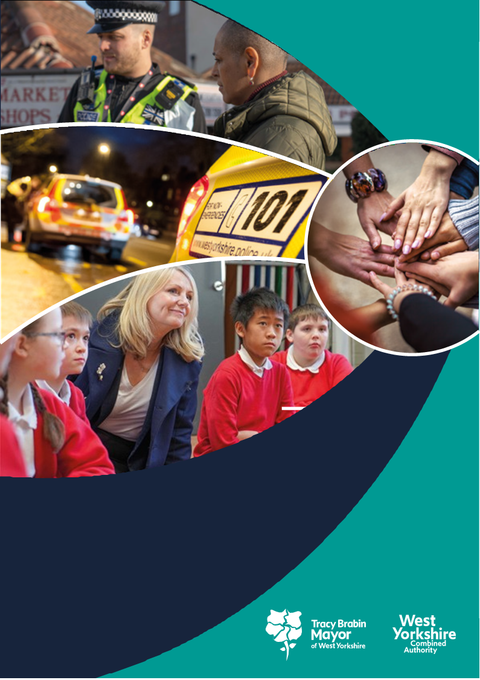

**West Yorkshire:**

**Safe. Just. Inclusive**

**Police and Crime Plan 2021-2024**

**1. Supporting Victims and Witnesses and Improving Criminal Justice Outcomes**



# 2 Figures relate to 2021

# 3 Figures relate to 2022

**1.1 Victim Satisfaction**

1.1.1 The latest victim satisfaction rate stands at 71.5% for the 12 months to June 2023. The latest position is 0.1 percentage points lower than 12 months ago.



1.1.2 Performance levels range from 71% at Wakefield to 77% at Calderdale. Bradford have seen a significant improvement over the last 12 months whereas in contrast Leeds and Wakefield have seen reductions. The district satisfaction score only looks at crimes dealt with by the district. Those telephone investigations dealt with via the Force Crime Management Unit (FCMU) are not included in the district ratings but are included in the overall West Yorkshire rating.

1.1.3 Over the last 12 months there has been a significant decline in the level of overall satisfaction of White victims (down 1.4%) and a significant increase for victims and callers from all other ethnic groups combined (up 3.4%); levels now stand at 73.0% for white victims and 66.8% for victims from all other ethnic groups (this has reduced the gap from 11.0% a year ago to 6.2%).

1.1.4 Satisfaction for victims of Domestic Abuse is stable at 83.0%, which is higher than the all crime satisfaction rate of 71.8% (as shown above)

1.1.5 West Yorkshire Police have added stalking to the list of offences that are included in this survey. Up to present there have been 262 victims of stalking surveyed and this has given a 78.8% satisfaction rate. As with other crime types, there is a lower satisfaction rating for ‘keeping informed of progress’ (66.3%), but this crime type has a higher satisfaction for the outcome (67.3% for attended crime, but 82.4% for stalking).

## 1.2 Maintain high levels of calls answered on target.

1.2.1 In the latest 12 months to June 2023 the number of total contacts into West Yorkshire Police have increased by 8.3% (124k additional contacts). During the same period 999s have increased by 6.0% (29,500 more calls), 101 calls have increased by 2.9% (21,000 more calls), Other calls have increased by 21.2% (11,800 more calls) and online contacts have increased significantly by 26.2% (62,000 more contacts). The very latest quarter is reporting further and more significant increases with overall contacts increasing by 16.2% between April-June 2023 with all calls and online contacts increasing considerably.



1.2.2 The above trends have had an impact on 999 answering times – the below graph shows the comparison with the MSG

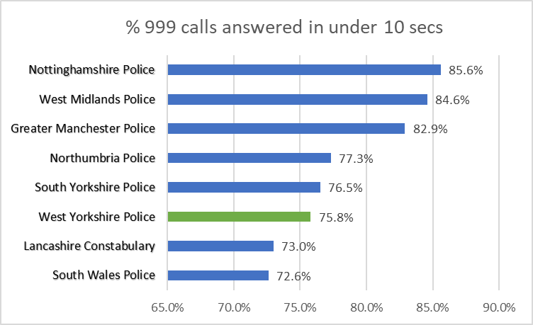

1.2.3 For information – The above is from Police.uk who produce statistics on 999 answering times, but these also include transfer times from BT, which can be 4-6 seconds and can vary across police forces. The comparison data with other forces is available [here](https://www.police.uk/pu/your-area/west-yorkshire-police/performance/999-performance-data/?tc=BDT_BW).

## 1.3 Improve Outcomes

**1.3.1 Rape and Serious Sexual Offences**



1.3.2 The above table shows the position at the end of the financial year in comparison to the same time last year. The numbers of rape offences have decreased by 113 offences in comparison to the same time last year, but the outcome rate has increased by 0.7% to 8.2%. .

1.3.3 The most recent data that is available nationally is up to May 2023, so not a direct comparison with the above. This data compares to a baseline similar to that for Neighbourhood Crime (i.e. Jan – Dec 2019) and shows that in comparison Rape offences have continued to rise over the pandemic and are 2.9% above the 2019 figure – but this is much lower than some areas (as seen in the below table).



The most recent levelling off of data indicates that we now seem to have reached an even footing with these offences although the number of historic offences (i.e. those reported more than 12 months after the crime event) continues.



1.3.4 Serious Sexual offence numbers have increased by 0.2% in comparison with the same time last year, but the positive outcome rate has risen by 1.1% with 85 more victims receiving a positive outcome.



1.3.5 Nationally the Serious Sexual Offence category is not reported on, as this category includes the rape offences above, but there is a category of ‘Other Sexual Offences’ which does not include the Rape offences. In a similar manner to the above Rape offences (with the baseline Jan – Dec 2019) the table below gives an indication of the current position.



Many in West Yorkshire Police’s most similar group of police forces (MSG) have seen decreases in this area, but as well as West Mids and West Yorkshire, Greater Manchester has also increased to above the baseline.

**1.3.6 Domestic Abuse Crime Outcomes**



1.3.7 The above looks at the data between April 22 to March 23 compared with the same time last year. The outcome rate has risen by 0.4% and the scale of the work required is shown here as this equates to 404 more victims with a positive outcome.

1.3.8 Nationally only 25 forces report on Domestic Abuse offences in a comparative way. West Yorkshire is one of those forces and this shows that West Yorkshire has the highest numbers of DA offences per 100,000 population.

1.3.9 The above Police outcomes are only part of the picture of support for Domestic Abuse Survivors. This area is being prioritized in Local Criminal Justice Board meetings and continues to be a focus for policing teams.

**1.4 Increase proportion of crimes with victim initial needs assessment**

1.4.1 The Initial Victim Needs Assessment (IVNA) is part of the Victims Code of Practice and is intended to:

1. Determine if the victim needs support.

2. Establish the type of support needed.

3. Assess whether the victim is vulnerable or intimidated.

4. Consider whether the victim is entitled to enhanced rights.

1.4.2 The guidance from the College of Policing shows that obtaining this at initial contact is important to the ongoing investigation, as well as a key consideration towards effective communication and engagement with the victim.

1.4.3 The continued increase in the proportion of cases with an IVNA for this area is therefore welcome and encouraged – this will become part of the Victims Code metrics and scrutinised by the Local Criminal Justice Board.

## 1.5 Criminal Justice Measures

1.5.1 It has been agreed that the LCJB will scrutinise a written report on the Delivery Data Dashboards at each Executive Board meeting going forward, providing the dataset has been delivered nationally. These delivery dashboards include the transforming summary justice target data, but also include a number of other data sets. The measures from the Delivery Dashboards give the opportunity to compare current performance with national performance and this report will be able to give these comparisons against the agreed priorities.

1.5.2 The most recent data to the Local Criminal Justice Board gave the data up to the end of Q4 2022 (to Dec 22)

1.5.3 In the final quarter of 2022 total volumes decreased by 5871 offences to 75120 offences a fall of 7.2% over the previous quarter. An annual figure of 310937 is up from 279818 in 2021.

The number of defendants with current live proceedings in both Magistrates and Crown Courts has reduced every quarter since Q3 2021. In Q4 2022 it rose 4% to 6669 defendants. This is a reduction of 616 on the same point in time a year ago when there were 7285 defendants with live proceedings. Outstanding cases in the Crown Court reduced by 27 cases in Q4 to 3118 and is an increase on the year from 2990 at Q4 2021.

**1.5.4 Decrease ineffective trial rate (Magistrates Court)**

1.5.5 The figures here are shown for the whole of 2021 (25.4%) then for the whole of 2022 (28.5%). This is a slight increase (3.1%) and is reflective of the increases in the number of trials taken forward.

**1.5.6 Increase volume of early guilty pleas**

1.5.7 The increase of the number of early guilty pleas negates the need for a trial and frees up time which could be used elsewhere.

1.5.8 Again these figures compare the same timescales as the above and this shows an increase in both the Magistrates and Crown Courts for the last quarter. Although lower than a year ago, this compares to a 68% average nationally.

**1.5.9 Decrease average time taken for cases to be brought to resolution.**

1.5.10 In Q4 it took, on average, 59.3 days from first police referral to CPS making a decision to charge, up 10.3 days on the previous quarter. The annual average is 50.2 days and nationally the figure is 45.5 days..

**2 KEEPING PEOPLE SAFE AND BUILDING RESILIENCE**

# 

**2.1 Monitor the number of young persons flagged as at risk of Criminal Exploitation**

# 2.1.1 In February 2020 the government produced guidance about the criminal exploitation of children (and vulnerable adults) and as part of this guidance it was noted that *Criminal exploitation of children and vulnerable adults is a geographically widespread form of harm that is a typical feature of county lines activity. It is a harm which is relatively little known about or recognised by those best placed to spot its potential victims.*

# 2.1.2 The purpose of this measure is to gauge how well West Yorkshire Police officers spot this type of exploitation and ensure that these vulnerable victims get the support and help that they need.

# 2.1.3 From the above figures we can see that there is a decrease in numbers and whilst numbers are down in the past 12 months the long term trend is significantly upward..

# 

**2.2 Monitor Indicators from Cyber Dashboard**

# 2.2.1 As Fraud has now been included in the Strategic Policing Requirement, updates about Cyber-crime will now also include updates about action against fraud.

# 2.2.2 The data at Appendix 2 shows the picture for West Yorkshire and includes both Fraud and Cyber offences with a comparison to most similar force areas (MSG).

# 2.2.3 The Cyber Prevent Team have been involved in a number of initiatives to contribute to Cyber Threat reduction including:

# • Working with a major bank on staff training day including exercises around Cyber Escape Rooms.

# • Presentations to Leeds Teaching Hospitals about cyber awareness. We aim to cover 20k staff.

# • Workshops with the Football Association and their Youth Engagement Officers to deliver cyber awareness training.

# 2.2.4 Cyber Protect work has been undertaken with a number of educational establishments and businesses. This involved raising awareness and training, but also advice on specific measures they need to take to protect themselves.

# 2.2.5 The Cyber Pursue Team are working with industry to understand the emergence Crypto ATM machines. They have already had one ground-breaking, successful operation which resulted in the removal of devices from the streets of West Yorkshire.

**2.3 Repeat Victims of Domestic Abuse and Hate Crimes**

# 

# 2.3.1 Domestic abuse incidents increased by 1.5% in comparison to the last 12 months. The repeat victim rate rose by 0.7% in comparison.

# 2.3.2 Working with SafeLives, the Force has recently delivered Domestic Abuse Matters training to 3,250 officers and staff across the Force. Initial feedback has highlighted significant improvements in officer and staff knowledge following the training. The DA Matters Champions courses commenced in early July. DA Champions will play a key role in recognising and sharing best practice in relation to domestic abuse across the Force.

# 2.3.3 The College of Policing is rolling out the new Domestic Abuse Risk Assessment (DARA) Tool, requesting that Police Forces implement this over the next 12 months. The DARA is the new risk assessment for Police Forces, whilst partners will still continue to use the DASH. Training materials have been received in Force and reviewed by SCGU. Further work is required nationally to ensure we have any IT requirements built into our existing systems prior to roll out.

# 2.3.4 The revised domestic abuse Force policy, which now includes the police perpetrated abuse procedures was approved at the JNCC in February 2023. The review of this policy ensures that it meets the recommendations within the super complaint and provides support and reassurance for victims of domestic abuse within the Force. The Professional Standards Department hosted a partnership symposium in June 2023 to share the work the Force is doing to tackle police perpetrators of abuse of position for a sexual purpose, sexual misconduct and domestic abuse.

# 2.3.5 Hate Crime Repeat Victims

# 2.3.6 Hate Incidents have fallen by 7.3% (788 fewer incidents) in the latest 12 months to June 2023 when compared with the 12 months to June 2022.

# 2.3.5 Conversely the number of hate crime repeat victims is rising – the increase of 2.9% is a significant increase in comparison to last year, although the current rate is closer to a year ago.

# 2.3.6 When looking at these figures it should be mentioned that the numbers being recorded can be due to many factors, including the effectiveness of the force with regards to Crime Data Integrity (at which West Yorkshire was rated Outstanding), and the willingness of the public to report the offence. What is hidden is the number of incidents that go unreported. The increase in repeat victims could be seen as a positive in that victims are willing to contact the police after reporting a previous offence and shows that this has been a positive experience for them.

# 2.3.7 Almost nine out of 10 hate crimes recorded relate to public order, stalking/harassment and violence without injury. 4.8% of hate incidents in the past 12 months are violence with injury offences and this is 9.7%(52 offences) less than the same time last year.

# 2.4 Increased Use of DVPN and DVPO

# 2.4.1 As discussed in the last Performance Monitoring Report, we can now look at the trends in DVPN and DVPO’s. We will also note the Claire’s laws occurrences as this is another intervention which protects victims of Domestic Abuse. (for more information on Claire’s law please see the WYP website: <https://www.westyorkshire.police.uk/ClaresLaw>

# 2.4.2 After a peak in September 2022, both DVPN and DVPO numbers have been on a falling trajectory although both a much higher than the numbers seen in 2021 when HMICFRS highlighted them

# 2.4.3 DVPN and DVPO’s are interventions used after a Domestic Abuse incident has taken place, but Clare’s Law is an early intervention to stop these occurrences taking place and could be argued as a better intervention. The numbers are as follows

# 2.4.4 As part of the Performance Scrutiny Meetings with the Police the DMPC has raised the issue of Claire’s Law and discussed the innovative ways that West Yorkshire are using to inform possible victims of Domestic Abuse.

**2.5 Use of Stalking Protection Orders (SPOs)**

# 2.5.1 The Force continues to be inspected in key areas. The recently carried out HMICFRS Thematic into Homicide Prevention led by Protective Services Crime is yet to be published and at the time of writing, the Force is being inspected in relation to the Super Complaint on the Police Response to Stalking. This inspection is being carried out by HMICFRS Inspectors and West Yorkshire Police is one of six Forces chosen to be visited. We welcome their assessment of our Stalking Coordination Unit Pilot and focus on stalking victims via the stalking advocacy service. We do not expect the report (which will reflect on the national police response only) until Spring 2024.

# 2.5.2 Stalking Protection Orders (SPOs) are being increasingly considered as an option to safeguard victims and manage risks posed by perpetrators. There are currently five active SPO cases with a further two cases currently within the court process. A new interim SPO was granted in May and we hope many will follow as the rest progress.

# 2.5.3 The Police Stalking Coordination Unit (SCU) continues to build links regionally and nationally with other Forces to share and develop best practice; this includes participation in the Regional and National Stalking Working Groups. Importantly, strong links are being made with key partner agencies such as Victim Support and Paladin National Stalking Advocacy Services. Paladin have recently provided some formal feedback regarding the SCU.

# *“[SCU] has elevated the management of stalking crimes in West Yorkshire - we at Paladin are a national service working with all Police Forces covering England and Wales. West Yorkshire have actively taken steps to identify and respond to stalking crimes by setting up the Stalking Coordination Unit.*

*This alone has allowed victims to have their safety increased and be validated of the high-risk behaviours they are experiencing. This is unique and the only police Force who are actively engaged with charities like ourselves to ensure and increase the safety of high-risk victims of stalking.*

*The care and dedication is clear and victim focussed. This unit has demonstrated to us as an organisation how successful police intervention can be and how it should be nationwide - an exemplary team.”*

**3 Safer Places and Thriving Communities**

# 

## 3.1 Reduce Homicide

# 3.1.1 On 17th July 2023 there was a showcase event in Bradford which marked the change from the Violence Reduction Unit to the Violence Reduction Partnership.

# The Violence Reduction Unit or VRU, which is hosted by our Mayor, takes a pioneering ‘public health’ approach, which means focusing on prevention, rather than simply the cure.

# During 2022/23 they spent over £3.3m on interventions, worked with 46 organisations supporting around 900 young people aged over 25 years and over 14,000 young people under 25 years.

# While this is all helping to turn the tide on serious violence, there must be a much wider and concerted effort to change current culture.

# The Serious Violence Duty’ was recently announced which places a legal expectation on key partners, such as local authorities, to focus on addressing serious violent crime.

# This is another important step in the right direction, but to achieve the Mayor’s ambition of safer places, thriving communities and delivering upon the Police and Crime Plan, we must collectively still do more.

# A recent national assessment showed that West Yorkshire is recognised as having one of the most mature partnerships.

# So the unit is now taking the next step in their evolution, by becoming a ‘Violence Reduction Partnership’ or VRP.

3.1.2 Homicide continues to be a key measure for the Violence Reduction Partnership (VRP), The overall measure shows the current position, but the VRP looks at non-domestic homicide and homicide for under 25s, so the current position for those is shown below.



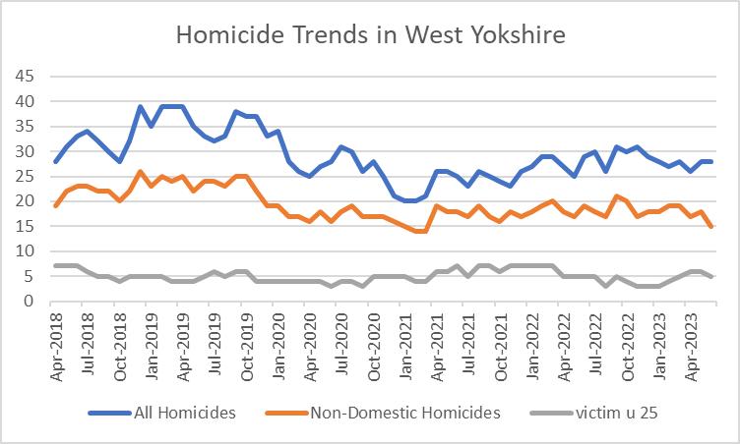

3.1.2 The above data shows the trends for all three crime types for the since 2018. This is now a stabilization for all homicides including non-domestic.

3.1.3 The below table compares some of the attributes of Homicides to see where West Yorkshire sits in comparison to other areas (data from the national homicide index)



3.1.4 In comparison to other areas, West Yorkshire has a comparable number of homicides per million (South Yorkshire stands out here), similarly for female victims (Greater Manchester the outlier here) For drugs involved is slightly lower (West Midlands and GMP higher here and also slightly lower for alcohol involved (similar to drugs)

**3.2 Reduce all hospital admissions for assault with a sharp instrument.**

3.2.1 Hospital admissions has seen a decrease of 5 for both groups.



3.2.2 Note: the data for the last 12 months is up to March 2023, and this data is provided by NHS digital and is subject to change

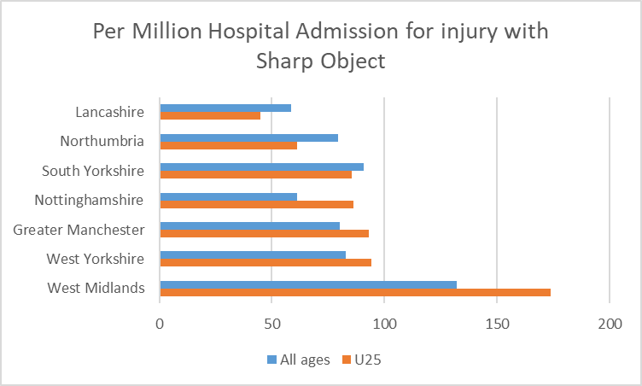

3.2.3 Many of the most similar forces are seeing higher numbers of u25 admission in comparison to all admissions (see table above) but for West Yorkshire that difference is reducing.

**3.3 Reduce Knife Crime**

3.3.1 The decreasing trend over the pandemic can be seen culminating in the lowest figures recorded in March 2021.

Knife Crime then increased to closer to pre pandemic levels, but since April 2022 there has been a decreasing trend.

The most recent two months have seen a slight increase in these crimes, but the numbers are still below those seen in the same months last year.

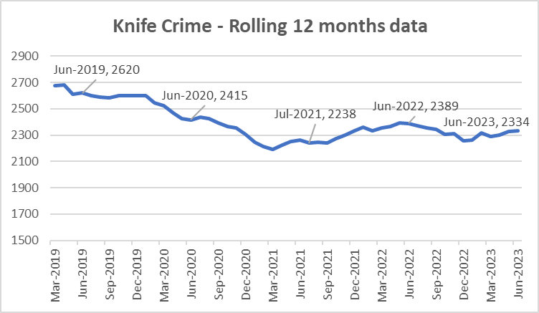

3.3.2 The most recent update nationally is to March 2023 – The below table looks at knife crime per 100,000 residents. West Yorkshire is reporting a 4.3% decrease in knife crime offences, nationally there is a 4.9% increase.



3.3.3 It should be noted that West Yorkshire Police is one of 40 forces which uses a national methodology for recording knife crime. The remaining forces will be using the same methodology soon, but until then, national comparisons are problematic. Also data for West Midlands is provisional due to a move to a new computer system.

**3.4 Reduce number of ASB incidents.**

3.4.1 ASB incidents have fallen by 10.6% (-3,308 incidents) when comparing the latest 12 months to June 2023 with the previous 12-month period.

3.4.2 The fall in ASB is significantly impacted by crime recording improvement activity. HMICFRS crime recording inspections across a number of Forces has highlighted that some ASB logs (and particularly ASB personal logs) should be considered for a crime being recorded. The chart below shows this change



3.4.3 The left-hand graph shows the rolling 12 monthly trend for ASB incidents. Due to training within contact at West Yorkshire Police, the logs that would have previously been in coded as ASB are now immediately flagged as a crime and this is reflected (right graph) by the blue line in comparison to orange line which shows the in-codes for the crimes.

3.4.4 In line with this change of recording, the force includes these crime types in the analysis for their multi agency meeting to ensure the ASB felt by residents is reflected in the analysis of not just ASB incidents, but also those crimes linked to ASB. For more information on this please see the latest Community Outcome Meeting paper on Neighbourhood Policing and ASB at <https://www.westyorks-ca.gov.uk/policing-and-crime/holding-the-chief-constable-to-account/community-outcomes-meetings/community-outcomes-meeting-18-april-2023/>

**3.5 Keep Neighbourhood Crime below baseline.**

3.5.1 West Yorkshire Police continues to show significant reductions in Neighbourhood Crime against the nationally recognised baseline of June 2019. In some tables this baseline is to December 2019, but is supposed to reflect offending before the pandemic. Figures for 2022/23 report that Neighbourhood Crime offences have fallen by 35.4% when compared to the 12 mths to June 2019 baseline equating to over 18,000 fewer victims. Notable reductions are residential burglary (down 42%), personal robbery (down 19%), theft from person (down 20.1%), and theft from vehicle (down 42%).

3.5.2 The below table looks at these crime types to break down the overall figures.



3.5.3 The one area that is different is Theft Of Motor Vehicle. This crime type continues to be the only one that is above the 12months to June 2019 baseline.

3.5.6 Compared with our most similar group, West Yorkshire has one of the largest % change in comparison to the baseline.(offences per 100,000 population).



**3.6 Monitor cyber-attacks on businesses via WYCA survey**

3.6.1 This data is not available currently.

**3.7 Increase proportion of workforce from ethnic minorities**

3.7.1 Overall the proportion of the total WYP workforce from ethnic minorities is at 7.7% but officers are currently above this at 8.6%. Although staff numbers are lower at 6.0% this is still an increasing trend.

3.7.2 As reported nationally, West Yorkshire Police exceeded its target for recruitment of officers and although the overall proportion of officers and staff from ethnic minorities continues to be below that of the West Yorkshire population, during recruitment this proportion was much higher and nearer to the target.

**3.8 Increase proportion of female officers**

3.8.1 Due to the increased number of officers and staff compared to 2018 the percentage increases may look small, but these mask the increase in numbers. For female officers, the 4.9% increase equates to 620 more female officers. At the same time, the number of male officers has increased by 314

**3.9 Reduce numbers of KSIs on roads in West Yorkshire**

3.9.1 Numbers of KSIs on the roads in West Yorkshire is currently increasing and this is the focus of the Vision Zero meetings in West Yorkshire

3.9.2 From a Road Safety perspective, West Yorkshire operates a partnership approach to reduce KSI’s with an overall aim of Vision Zero by 2040. The partnership sees the Combined Authority and West Yorkshire Police working with all five district authorities, West Yorkshire Fire and Rescue Service and National Highways. The partnership supports West Yorkshire Police enforcement operations and provides some funding to support initiatives

3.9.3 For more information on the work of Vision Zero, please see the panel paper that came to the meeting in April 2023.

**3.10 Increase number of additional officers and staff in comparison to April 2021 baseline**

3.10.1 The numbers here show that officer numbers are increasing as expected, with staff numbers also increasing even with the current budget constraints.

3.10.2 The Mayor and Deputy Mayor receive a quarterly update for this measure to ensure that the Mayoral Pledge is met. This paper discusses the current situation and where there are any risks.

3.10.3 Currently the projections are showing to surpass the pledge by the end of the Mayoral term for officers.

**4. Responding to Multiple and Complex Needs**



**4.1.1 Monitor VRU early intervention programme attendee figures**

4.1.2 As part of its monitoring information for the Home Office, the Violence Reduction Unit must show the impact of its work by counting the number of young people (and others) that it reaches.

4.1.3 The VRU have outlined the current initiatives in the Safer Places and Thriving Communities paper which is being presented at the same meeting as this paper. Please see this paper for more detail on this metric.

**4.2 Reduce number of repeat missing persons.**

4.2.1 Number of Missing persons per 1000 population

Over the last 12 months there have been 10,919 missing persons (including repeats). The trends for this are as follows.

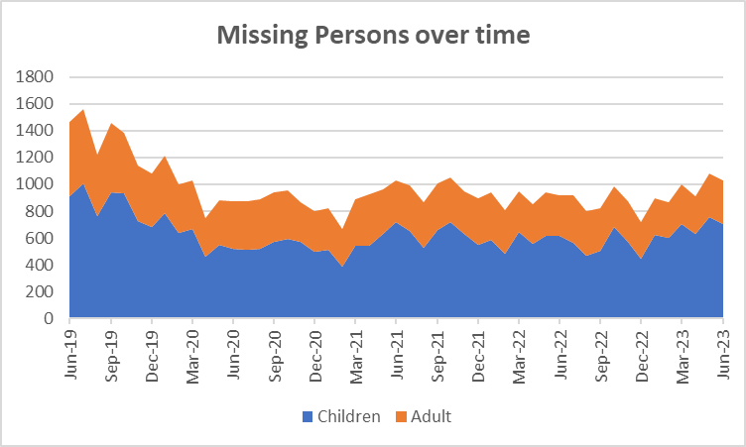

4.2.2 In the last PMR we stated that the reason for including missing persons under the Multiple and Complex Needs priority was due to the proportion of those that go missing which fall into this priority. In this report we look at the difference in risk level between Adults and Children occurrences.

4.2.3 Although the numbers of children missing is higher than adults, we find that many are in the medium category of risk, whereas the risk level for adults is much higher.

4.2.3 The next table looks at the numbers of repeat missing occurrences.



4.2.5 The number of repeat missing persons is detailed above. This stands at 37.3% for missing children and 12.2% for missing adults.

4.2.2 Although the numbers are slightly lower, the extent of the work can be seen above with 15 missing children having greater than 30 occurrences throughout the year. This continues to be a drain on police resources.

**4.3. Reduce Re-offending Rate for Drug Related Crime**

4.3.1 Due to the time lapse required to ensure offences are taken into consideration, the re-offending rates are for offenders who were convicted 12 months ago.

4.3.2 The current figures show that there has been a 0.5% increase in this rate in comparison to the same time 12 months ago.

4.3.3 Work is ongoing with the Senior Responsible Officers for the Combatting Drugs WY partnership with the first meeting taking place in February. This is discussed in the Keeping people safe and building resilience paper in this meeting.

4.3.4 West Yorkshire Reducing Reoffending Partnership Board: This is the current iteration of the board convened by the Mayor and chaired initially by the Criminal Justice Policy Manager. The intention of this board is to add value to existing Reducing Reoffending Partnerships within districts and their work with Criminal Justice partners including Youth Justice across these areas of focus.

* Accommodation
* Employability, Training and Skills
* Drugs and Alcohol dependency
* Womens’ whole system approaches

The first meeting of this board is on the 20th September 2023. It will meet monthly until the new year and thereafter bi-monthly or quarterly (To be confirmed)

The West Yorkshire meeting will develop a West Yorkshire Reducing Reoffending Strategy, that will share some key priorities with the Yorkshire and the Humber Rehabilitation Partnership Board, derived from His Majesty’s Prison and Probation service resettlement targets. There are key strategic benefits to sharing priorities, particularly in terms of the PCC part 2 review on the duty to collaborate and a similar duty under the Victims and Prisoners Bill currently progressing through Parliament and the Lords.

**4.4 Reduce the number of First-time entrants to the CJS**

4.4.1 There is a bit of a time lapse with this measure with this measure, as we rely on the Ministry of Justice data which is based on offenders on PNC as having their 1st conviction, caution or youth caution. This now compares 12 months to Sept 2021 to 12 months to Sept 22 (which is the latest data available).

4.4.2 Both Adult and youth offenders are seeing a decrease in this measure currently.

**4.5 Increase number of offenders referred to drug treatment services via Liaison and Diversion**



4.5.1 Figures relate to referrals to drug services across the five districts. Figures provided by West Yorkshire All Age Liaison and Diversion Service.

4.5.2 The figures relate to the most recent quarter (April - June)

4.5.4 These statistics and the work undertaken are discussed on the Liaison and Diversion Strategic Board – this is attended by the DMPC on a regular basis.

Appendix 2

**Cyber Crime**

**Reports, referrals, and outcomes for**

The below data is for July 2022 to June 2023

Cyber Crime reporting

The above is for Cyber Crime only the picture for Fraud is as follows.

For business Cyber Crime **only** the current picture is as follows:

|  |  |
| --- | --- |
| **Acquisitive crime** | Acquisitive crime is defined as an offence where the offender derives material gain from the crime. Examples include shoplifting, burglary, theft, and robbery. |
| **BAME** | BAME stands for Black, Asian and Minority Ethnic and is used to describe people from any of these ethnicities. |
| **Child sexual exploitation and abuse** | Sexual exploitation of children and young people under 18 involves exploitative situations, contexts, and relationships where young people (or a third person or persons) receive 'something' (e.g., food, accommodation, drugs, alcohol, cigarettes, affection, gifts, money) because of them performing, and/or another or others performing on them, sexual activities. |
| **Community Safety Partner** | Several different organisations have a role to play including local councils, fire and rescue service, health and probation services and housing providers etc. These are often referred to as local community safety partners. |
| **Conviction rate** | This measure is calculated by dividing the number of defendants convicted by the total number of defendants prosecuted in the court during the period in question. The total number of defendants prosecuted in the court includes those charged by the police and Crown Prosecution Service but whose cases were dropped. |
| **Crime rate** | The crime rate used in this document refers to the number of offences committed per 1000 people in the population. |
| **Cyber crime** | Can be seen in two parts: cyber-enabled crime, where crimes that may be committed without computers are instead committed using computer networks (for example fraud and bullying); and pure cyber-crime where the offence can only be committed using computers (for example computer hacking or use of malicious software). |
| **GAP**  **Human trafficking** | Anticipated Guilty Plea  Human trafficking is the trade of humans, most commonly for the purpose of forced labour or commercial sexual exploitation by the trafficker or others. |
| **IOM** | Integrated Offender Management (IOM) is an overarching framework that allows local and partner agencies to come together to ensure that the offenders whose crimes cause most damage and harm locally are managed in a coordinated way. |
| **Ineffective trial** | An ineffective trial occurs when the trial does not go ahead on the date planned due to action or inaction by one or more of the prosecution, the defence or the court and a further listing for a trial is required. |
| **Most similar police groups/family/forces**  **NGAP** | Most Similar Groups (MSGs) are groups of police force areas that have been found to be the like each other based on an analysis of demographic, social and economic characteristics which relate to crime. Each police area has its own group of up to seven police areas to which it is ‘most similar’. MSGs are designed to help make fair and meaningful comparisons between police areas which share similar characteristics, rather than, for example, comparisons with a neighbouring police area.  Anticipated Not Guilty Plea |
| **Operational functions** | Operational functions include things like patrolling neighbourhoods, responding to 999 calls, roads policing and protecting vulnerable people. |
| **Outcomes/detections** | Outcomes/detections are used by the Home Office to describe the result of a police investigation following the recording of a crime. They can include cautions, charges, fixed penalty notices, cannabis warnings etc. There are 21 categories of outcomes. |
| **PEEL**  **Positive Outcomes** | HMICFRS carry out several thematic annual inspections throughout the year, these are drawn together into a wider PEEL assessment which stands for Police Effectiveness, Efficiency and Legitimacy. The aim of the PEEL assessment is to judge each police force in a cross-topic way based on criteria which consider the full breadth and complexity of what the police do.  Outcomes which fall into the first 8 categories for Police outcomes, these include mostly charges, cautions and community resolutions. |

**Find out more.**

westyorks-ca.gov.uk

@WestYorkshireCA

enquiries@westyorks-ca.gov.uk

+44 (0)113 251 7272

All information correct at time of print (March 24)