STATE AID

PUBLIC CONSULTATION -

CLOSURE NOTE
SUPERFAST WEST YORKSHIRE & YORK
CONTRACT 3 PROJECT

Name: John Bullivent
Date: 18 December 2018

STATE AID PUBLIC CONSULTATION – CLOSURE NOTE

SUPERFAST WEST YORKSHIRE & YORK
CONTRACT 3 PROJECT

New procurement to further extend coverage of Next Generation Access (NGA) Broadband across the 5 West Yorkshire local authorities (Leeds, Bradford, Wakefield, Calderdale and Kirklees) and the city of York.

1. OUTCOME OF THE PUBLIC CONSULTATION

  - The Public Consultation to determine the State Aid classifications for the Superfast West Yorkshire and York project closed on 3 September 2018. The Public Consultation followed an Open Market Review with the telecoms market to which suppliers responded with information on their existing infrastructure and commercial plans in the project area.

  - Following this process, the eligible Intervention Area for the project will be determined; the ‘White NGA’ areas. The final State Aid maps for Next Generation Access (NGA) Broadband and Basic Broadband area shown below and are available on the Project Website: https://westyorks-ca.gov.uk/economy/superfast-west-yorkshire-and-york-broadband/

  - The Combined Authority intends to procure coverage to target the remaining ‘White NGA’ areas by conducting a new procurement under the 2016 NBS (and in accordance with the Public Contracts Regulations 2015);

- TIMESCALES

  - The following table summarises the timescales of the next stages of the procurement:

Activity | Date
Issue of Contract Notice | 21 December 2018
Closing date for Expressions of Interest | 17 January 2019
Bidders sign up to Code of Conduct | 17 January 2019
Bidder access to the Data Room | Up to 14 March 2019
Clarification Question process | Up to 04 March 2019
Bidders prepare responses | Up to 14 March 2019
Bidders response evaluation and clarification | 15 March to 03 April 2019
Local body initial governance – sign off evaluation and preferred bidder | 04 April 2019
Bidders notified of evaluation outcome | 22 April 2019
Standstill period | 23 April to 02 May 2019
Contract finalisation/Due Dilligence | Up to 02 May 2019
DCMS Approvals including State Aid and Funding | 03 May to 16 May 2019
Local body final governance and Contract award | 12 April to 16 May 2019
Contract signature | 17 May 2019

- REVISED STATE AID MAPS

  - The following criteria have been used by the project team to determine the classification of areas in basic Broadband and NGA White/Grey/Black areas respectively:

  - For basic broadband,

  - A postcode is turned grey if there is only one broadband infrastructure operator providing basic broadband services (with speeds greater than 2 Mbps) to that postcode.
  - A postcode is turned black if there are at least two broadband infrastructure operators providing basic broadband services (with speeds greater than 2Mbps) to that postcode.
  - All other postcodes remain white.

  - For NGA,

  - A postcode is turned grey if there is only one broadband infrastructure operator providing NGA services (with speeds greater than 30Mbps) to that postcode.
  - A postcode is turned black if there are at least two broadband infrastructure operators providing NGA services (with speeds greater than 30Mbps) to that postcode.
  - All other postcodes remain white.

  - In addition, the proposed intervention area includes a number of “under review” areas (coloured blue on the map). These areas have previously been indicated to have planned commercial coverage for NGA broadband (i.e. mapped as grey or black NGA), but those plans have been reported through the OMR as being ‘at risk’ of not being completed. These areas will be subject to continued monitoring and verification of supplier plans within the three year period by the Combined Authority and in the event that these commercial plans fall away these premises will be mapped as white NGA and form part of the proposed intervention area and eligible for intervention via this aid measure.

  - The mapping analysis of existing and concretely planned coverage (within the next three years) has identified significant remaining ‘white NGA’ areas. The outcome of the OMR is summarised in terms of NGA White, Grey, Black and ‘Under Review’ premises below.

Table 1: Number of premises by postcode and type of premise
Postcode Status | Number of Postcodes | Number of Black Premises | Number of Grey Premises | Number of White Premises | Number of ‘under review’ premises
NGA White | 7,974 | 0 | 38,953 | 38,428 | 43
NGA Grey | 20,677 | 0 | 271,672 | 0 | 0
NGA Black | 25,436 | 499,375 | 0 | 0 | 0
‘Under Review’ | 8,446 | 96,919 | 1,878 | 0 | 90,436
Total | 62,533 | 596,294 | 312,503 | 38,428 | 90,479

  - The project Intervention Area includes 38,428 NGA White premises, however there are an additional 90,479 Under Review premises that could potentially be brought into scope of the procurement if plans are not completed and confirmed by the monitoring team.

  - All premises in the overall project area are believed to have access to a Basic Broadband served through existing commercial operators. The following table summarises the outcome of the Open market Review in terms of White, Grey and Black postcodes and premises for Basic Broadband:

Postcode Status | Number of Postcodes | Number of Black Premises | Number of Grey Premises | Number of White Premises | Number of ‘under review’ premises
White | - | - | - | - | -
Grey | 62,533 | - | 1,037,704 | - | -
Black | - | - | - | - | -
Total | 62,533 | - | 1,037,704 | - | -

- REVISED STATE AID MAPS

  - The State Aid maps for the Intervention Area are shown below for NGA Broadband and Basic Broadband respectively.

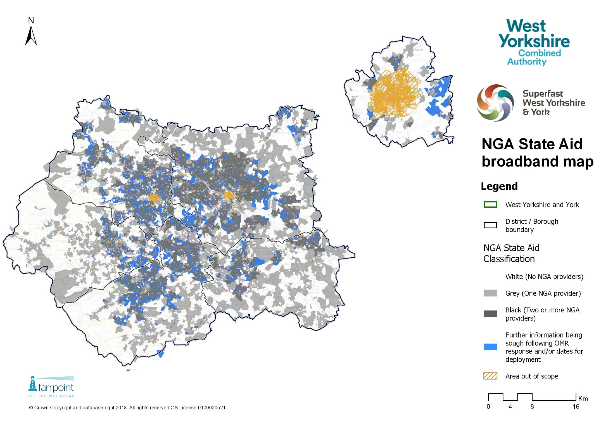
NGA BROADBAND MAP

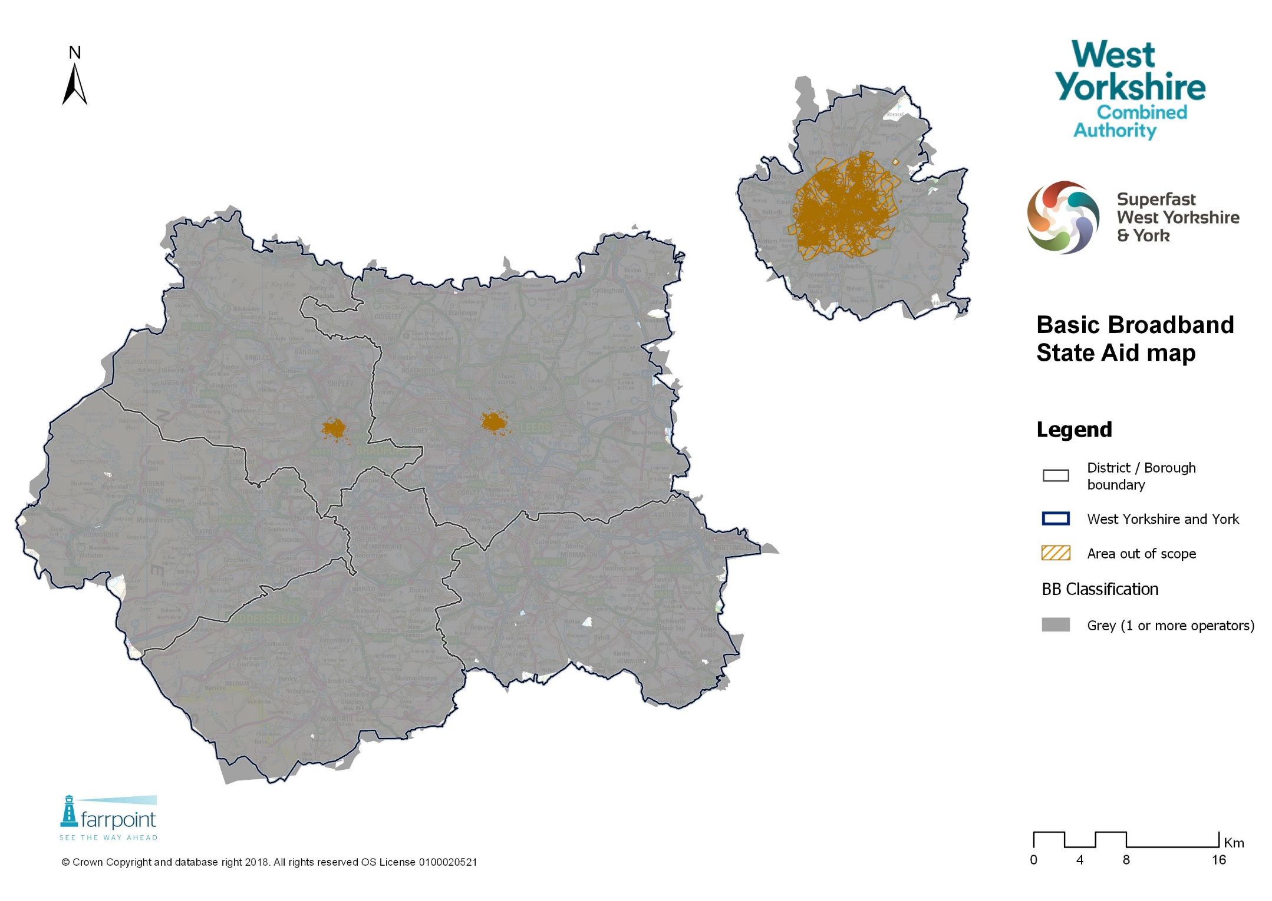
BASIC BROADBAND MAP

- STATUS OF THE INTERVENTION AREA

  - The State Aid Public Consultation is now closed. The Combined Authority has submitted its State Aid (Part 1) notification to the National Competence Centres (part of the Department for Culture Media and Sport) which oversees the UK National Broadband Scheme. A decision on the eligibility of the proposed Intervention Areas is expected in December 2018. If clearance is granted, the Intervention Areas mapped above will be confirmed as eligible for public sector intervention for the next stage of the Superfast West Yorkshire and York project.

- CONTACT DETAILS
  - If you have any questions about any of the above, please contact:

John Bullivent
C/O: SFWY@leeds.gov.uk

The white premises in these postcodes will be subject to monitoring and review as explained above.

