

**West Yorkshire Authorities**

**Governance Review**

Undertaken in accordance with Section 111 of the Local Democracy Economic Development and Construction Act 2009

Contents

Executive Summary 5

Purpose of Review 7

Methodology for the Governance Review 8

Ambition 9

West Yorkshire Context 10

West Yorkshire Economy 11

A functional economic market area 14

Economic Profile 16

(a) Structure 16

(b) Employment 18

(c) The role of public transport 18

Challenges 19

1. Growth 19

2. Productivity 20

3. Diversity and Inclusion 21

4. Innovation 21

5. Trade 22

6. Place 22

7. People 23

8. Infrastructure 24

Understanding current governance arrangements 26

Combined Authorities, LEPs and PCCs 26

(a) Combined Authorities 26

(b) LEPs 26

(c) Police and Crime Commissioners 27

West Yorkshire Combined Authority 27

Supporting structures 28

Functions 28

Leeds City Region LEP 29

West Yorkshire PCC 30

Case for change 31

The ’minded-to’ West Yorkshire devolution deal 31

Governance 31

Functions 33

Criteria 40

Local requirements 40

Statutory tests 40

Governance options 41

Option 1 - Do nothing / business as usual 41

Option 2 – Strengthen existing arrangements 42

Option 3 - A Mayoral Combined Authority 42

Conclusions 44

Find out more 45

Appendix A – Draft Scheme………………………………………………………....

# Executive Summary

**On 11 March 2020, a ‘minded-to' Devolution Deal was agreed between government and local authority Leaders of West Yorkshire, comprising Bradford, Calderdale, Kirklees, Leeds, and Wakefield Councils, and West Yorkshire Combined Authority (‘the Combined Authority’). The deal agrees a significant shift of powers, funding and responsibility from Whitehall to the region in return for establishing the role of a directly elected Mayor for the area of West Yorkshire.**

The additional powers and funding afforded through the deal, including £1.14 billion of additional investment over 30 years, would help to drive productivity by enabling additional investment in our towns, cities and rural areas in their infrastructure, skills, business, housing & regeneration, and in cultural and heritage assets, and by boosting trade, innovation, and inward investment.

The purpose of this governance review, undertaken in accordance with Section 111 of the Local Democracy, Economic Development and Construction Act 2009 (the 2009 Act) is to look at the exercise of statutory functions in West Yorkshire with a view to deciding whether to prepare and publish a scheme with new functions and changed constitutional arrangements, including a directly elected mayor. A public consultation would then be carried out on the proposals set out in the scheme. The Secretary of State would be provided with a summary of consultation responses and would need to consider whether an order should be made under the 2009 Act to establish a Mayoral Combined Authority (MCA) for the area.

Under section 112 of the 2009 Act, the review needs to conclude that the exercise of the power to make an order to establish an MCA for the West Yorkshire area would be likely to improve the exercise of statutory functions in relation to the West Yorkshire area.

The review has found that the economic evidence provides a rationale to continue to work across the West Yorkshire area, recognising that it operates as a coherent functional geography. It has a strong and diverse sectoral mix with significant growth potential, underpinned by notable economic assets and infrastructure, and through its links with the wider Leeds City Region, Yorkshire and the Northern Powerhouse.

Despite its economic successes, West Yorkshire is still a net spender of UK tax revenues, and there are significant challenges in relation to securing its ambitions to promote faster and more inclusive growth, tackle the climate emergency and deliver a 21st century transport system for the area. And there is not enough local control over the policies that affect our economy.

The idea of West Yorkshire authorities working together on a range of transport and economic activities is not new. Leeds City Region was a pilot forerunner city region, the City Deal was secured in 2012 and £1 billion Growth Deal was agreed in July 2014. This success has enabled the Combined Authority (established in 2014), the five West Yorkshire councils, and the Leeds City Region Enterprise Partnership (‘the LEP’) to make a strong start.

The ‘minded-to’ devolution deal represents a significant step forward in delivering more and better jobs to the area. It delivers significant new responsibilities and investment that will benefit our communities and businesses across the region. It means that decisions previously taken centrally can now be taken closer to the people affected and gives the area greater financial freedom and flexibility to manage our investment choices according to local priorities. Establishing an MCA for the area will promote local democracy through direct democratic accountability in exercising locally more of the levers of change that will drive economic growth. The review notes that the devolution deal is dependent on the adoption of an MCA model of governance and finds that this is the most appropriate mechanism by which the powers and funding proposed can be devolved to West Yorkshire.

The review concludes that:

* current regional governance arrangements - based on a non-mayoral West Yorkshire Combined Authority - do not represent the best model in terms of delivering the long-term ambitions of the authorities within the area for economic growth and delivery of public services;
* there is limited practical scope for the existing governance arrangements to be meaningfully strengthened, short of adopting an MCA model of governance;
* a change is required to enable the West Yorkshire authorities to pursue their economic policy agenda at greater pace, while continuing to collaborate with the wider Leeds City Region, Yorkshire and the North in pursuit of shared economic objectives;
* the statutory criteria for preparing and publishing a scheme are met, i.e., the making of an order under S104 and S105 to enable the adoption of an MCA model of governance for the area of West Yorkshire will likely **improve the exercise of statutory functions in that area;**
* **in addition, establishing an MCA model of governance for West Yorkshire will:** 
  + **have a positive impact on the interests and identities of local communities** – these proposals build on established regional governance arrangements which cover a coherent functional economic area and which represent the views and interests of local communities; and
  + **secure more effective and convenient local government** by reducing complexity and streamlining the delivery of public services within the area.

It is therefore proposed that a scheme is published (a draft scheme is included at Appendix A) that confirms:

* an MCA should cover the area of West Yorkshire;
* a West Yorkshire Mayor would be elected in May 2021;
* the mayor would become a member of the Combined Authority, and Chair meetings of the authority.
* each council will continue to appoint a member to the new MCA, along with political representatives from opposition groups, and non-constituent members from the LEP and City of York Council would continue to be appointed; and
* the Mayor and MCA will exercise specific statutory functions, and hold some powers concurrently with West Yorkshire local authorities. No functions are being removed from those councils. Where existing functions currently held by West Yorkshire local authorities are to be shared with the Mayor or the MCA, this must be agreed by the constituent councils.

# Purpose of Review

West Yorkshire Leaders have agreed with Government that fulfilling the local economic priorities and drawing down significant additional powers and funding through the West Yorkshire Devolution Deal raises the question about the on-going appropriateness of regional governance arrangements which are currently based on the (non-Mayoral) Combined Authority, the LEP, and West Yorkshire’s Police and Crime Commissioner (PCC). As part of the Deal, Leaders have therefore committed to consider the creation of a new, directly elected West Yorkshire Mayor, acting as Chair to West Yorkshire Combined Authority by May 2021 (and in addition ex officio PCC by 2024).

West Yorkshire’s councils, along with the Combined Authority, have therefore commissioned this review to look at whether strengthening existing collaboration arrangements by adopting an MCA model of governance would be the best way of improving delivery of a 21st century transport system, and more inclusive and cleaner growth across the City Region, and exercising PCC functions. Because the PCC elections have subsequently been delayed until May 2021, there is now an opportunity for any Mayor to exercise PCC functions from May 2021, rather than from May 2024 (as originally proposed in the West Yorkshire Devolution Deal).

To ensure compliance with the relevant legislation contained in the 2009 Act, the Review considers whether an MCA is the best governance model and would be likely to:

* Improve the **exercise of statutory functions** in the area of West Yorkshire;
* Secure **more effective and convenient local government** for the area; and
* have a positive or neutral impact on the **identities and interests of our local communities**

# Methodology for the Governance Review

The governance review has comprised the following:

* West Yorkshire’s ambition and context, covering the area’s devolution journey and the devolution deal
* Economic assessment of:

1. the existence of a Functional Economic Market Area across West Yorkshire; and
2. the region’s economic strengths, challenges and opportunities

* Assessment of the current governance arrangements across West Yorkshire
* The case for change
* The devolved functions in scope
* An options appraisal that considers the alternative governance structures which could be pursued in the light of the above evidence
* Consideration of whether the preferred option meets the statutory tests
* Conclusions

# Ambition

West Yorkshire local authorities, the Combined Authority and the LEP want our region to be recognised globally as a place with a strong, successful economy where everyone can build great businesses, careers and lives supported by world-class transport, housing and digital connectivity.

Securing more devolved powers and funding is a central enabler and we will deliver our ambitions by:

* Tackling the climate emergency
* Boosting productivity
* Enabling inclusive growth; and
* Delivering 21st century transport

West Yorkshire, a core part of the wider Leeds City Region, and located at the heart of the Northern Powerhouse, is an internationally significant economy in its own right comprising the five metropolitan areas of Bradford, Calderdale, Kirklees, Leeds and Wakefield, and which has:

* a £55.4 billion economy – bigger than 9 EU countries
* 2.3 million people
* 1.1 million jobs and nearly 92,000 businesses – West Yorkshire is the second largest LEP area by employment outside of the South East
* 1.6% of the land area of England
* a predominantly urban character but with 9% of the population living in the 38% of the geography defined as a DEFRA Rural Area.

Whilst overall, West Yorkshire - and the wider Leeds City Region - has been relatively successful in making the transition from a predominantly industrial to a more diverse economy there remain significant challenges, including in terms of labour market participation, skills and levels of economic activity. Well-co-ordinated, targeted, and locally determined investment and interventions are needed to address these issues.

West Yorkshire authorities are of the view that a radical devolution of powers and funding to local areas is needed to respond to our opportunities and address these challenges. Greater local control of the levers of growth, productivity and inclusion would enable West Yorkshire communities and businesses to be better served.

# West Yorkshire Context

West Yorkshire has been on a considerable devolution journey to date and the following significant steps have already been taken in securing devolved powers and funding to the area:

* 2004 to 2009: Leeds City Region Concordat, expressing the shared local commitment to working together differently in the interests of the economy of the whole city region and all its diverse communities; establishment of the Leeds City Region Leaders Board, empowered to discharge, on behalf of the member Councils, the promotion and improvement of the economic wellbeing and competitiveness of the City Region; and the adoption of a City Region Development Plan to deliver Leeds City Region Leaders’ shared ambition.
* Multi-Area Agreement (2008) – Leeds City Region was one of the first wave partnerships to agree freedoms and flexibilities with government around transport and skills.
* City Region Forerunner Pilot status (2009) - recognised the importance of the Leeds City Region economy to the North and that, without an ambitious package of devolution and local governance reform with particular reference to transport, skills and economic development, its full potential would not be realised.
* 2012 Leeds City Region City Deal – was a step change for the devolution of powers and funding from Government to the City Region, including initial funding and freedoms to build, manage and sustain a local £1 billion West Yorkshire Plus Transport Fund, and Leeds City Region to deliver a ‘NEET free’ City Region.
* 2014 - Following the establishment of the Combined Authority (a key condition of the City Deal), the first Leeds City Region Growth Deal - the largest secured in the country - which fully capitalised the £1 billion West Yorkshire Plus Transport Fund.
* 2015 – an initial, first stage Leeds City Region and West Yorkshire devolution deal with a focus on flexibilities including around skills, transport, employment and business support.

Building on these achievements, the 2020 West Yorkshire Devolution Deal provides the region with the opportunity to accelerate the delivery of local ambitions for a 21st century transport system and for faster, cleaner and more inclusive economic growth, provided it can be shown that the way it is all managed is fit for purpose.

# West Yorkshire Economy

This section provides an assessment of:

* the existence of a Functional Economic Market Area across West Yorkshire; and
* the region’s economic strengths, challenges and opportunities

Like all areas, the West Yorkshire economy also faces significant challenges as well as strengths in terms of achieving our full growth potential.

The following economic assessment is drawn from a broad survey of available data and intelligence, primarily analysis of published data from the Office for National Statistics and other official sources to provide an understanding of economic performance on a range of indicators.

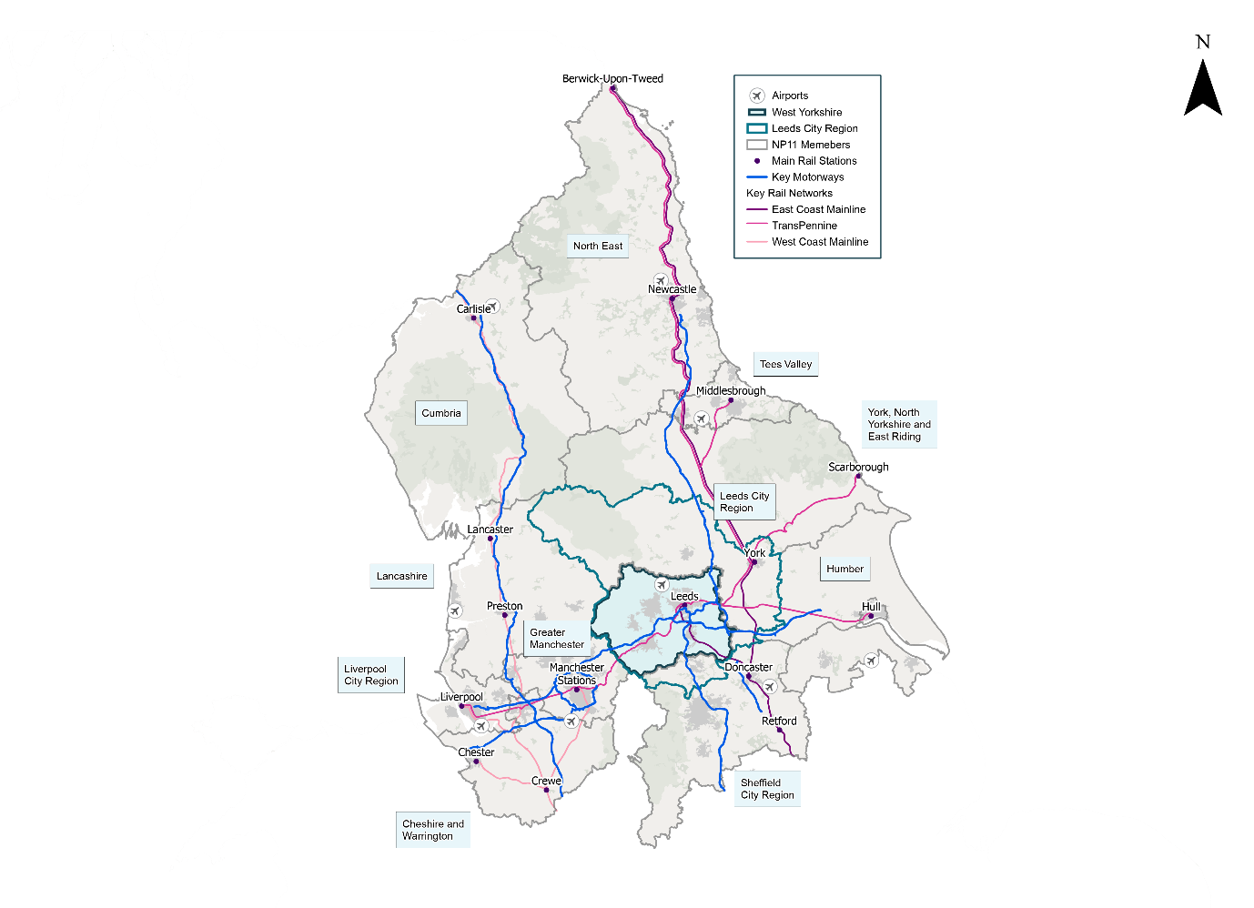

#### A coherent, diverse and resilient region

West Yorkshire has an economically coherent, diverse and resilient economy that possesses a unique combination of economic strengths, assets and opportunities, including the following:

* An economy that values diversity, talent, and youth as the key to our future, exemplified by:
  + these distinctive strengths cited as a key reason for Channel 4 choosing Leeds as its new home;
  + Kirklees’ Outstanding rated Huddersfield New College, which is ranked number one in England for Equality and Diversity; and
  + the University of Bradford, which has been identified as the best in the country for Social Inclusion.
* Home to substantial renewable and low-carbon energy capacity in on-shore wind, biomass, energy-from-waste and micro-generation; leading manufacturers in the low-carbon supply chain and strong environmental consultancy expertise, which will contribute towards our ambition to become a net-zero carbon city region by 2038, with significant progress by 2030, in order to play our part in limiting average global temperature rise to between 1.5 and 2.0 degrees Celsius.
* A thriving digital and tech hub cluster - employment in the digital sector in West Yorkshire has increased by 48% between 2015-18, faster than any other LEP area and six times the rate of growth seen in London since 2015 (8%). The cluster has the capability and potential to pioneer the next generation of technological change to transform outcomes for society, business and individuals across the region, including to become the most digitally connected and inclusive region in country.
* An economy that is focused on the future – for example the city of Bradford is the youngest city in the UK, with almost a quarter of the population under the age of 18. The City Region has the highest concentration of Higher Education institutions outside of London with some 7 universities, producing 30,000 graduates annually, of which 13,000 are in STEAM subjects.
* Leading business clusters e.g. Health-Tech, Fin-Tech and Digital Health. Also, in terms of sectors, the UK’s largest regional finance centre, 140,000 jobs in the health economy, and more manufacturing jobs than anywhere in the North (with 13.5% of output vs 10.1% nationally ), notably in textiles, food & drink, aerospace components, automotive engineering, printing & publishing and construction fabrication, and based on a core of precision engineering.
* Associated key assets that will enable the formation of the next wave of leading knowledge-based industries, clusters and businesses, including:
  + Leeds University’s NEXUS;
  + Huddersfield University’s 3M Buckley Innovation Centre;
  + the Wolfson Institute for Applied Health Research at Bradford Royal Infirmary; and
* At the centre of the UK, within one hour’s drive of 7 million people, and at the heart of national railway and motorway networks, which provides easy access to global markets and means that Leeds City Region is ideally placed as a location for the logistics industry. Moreover, the City Region is a major connectivity hub for the Northern Powerhouse, with Leeds alone typically having more train passengers than anywhere else in the North (100,000 per day), equivalent to London Kings Cross.
* Outstanding historic and cultural assets enhancing both quality of life and economic growth (by £565m p.a.), including:
  + the Sculpture Triangle which includes the internationally renowned Hepworth in Wakefield;
  + Calderdale’s historic, recently restored Halifax Piece Hall, which attracted 5 million visitors since reopening in 2017;
  + Bradford’s bid for 2025 City of Culture status, and Leeds 2023; and
  + the role of sport and heritage across the region as distinctive economic drivers and the key to the identity of the place.

# A functional economic market area

To improve productivity and jobs in those urban areas with several centres, such as West Yorkshire, and the wider Northern Powerhouse, there is a well-established evidence base which demonstrates the need to better connect the key towns and cities to reduce congestion, reduce journey times (shrink distances) between places, and improve freight transfer[1].

Although Leeds City Region is the area’s recognised functional economic market area, West Yorkshire represents its core, and in its own right evidences strong elements of economic self-containment but with clear linkages and interdependency with the wider City Region economic footprint in terms of a wider labour and housing market area.

The map below reveals the economic context of West Yorkshire and the wider City Region via commuter flows. It highlights the top 2,000 travel to work-flows originating and terminating within the City Region (with colour, from blue to purple, representing strength of the flow) against a background of ‘urban’ areas. Flows are based on 2011 Census data and include all modes of transport.

The table below shows that a large proportion (70%) of West Yorkshire residents in work live and work in their home district, and that over 90% of West Yorkshire residents in work live and work in West Yorkshire. Only 5% of West Yorkshire commuters work outside the City Region compared to 17% of commuters in the remaining Leeds City Region Districts.

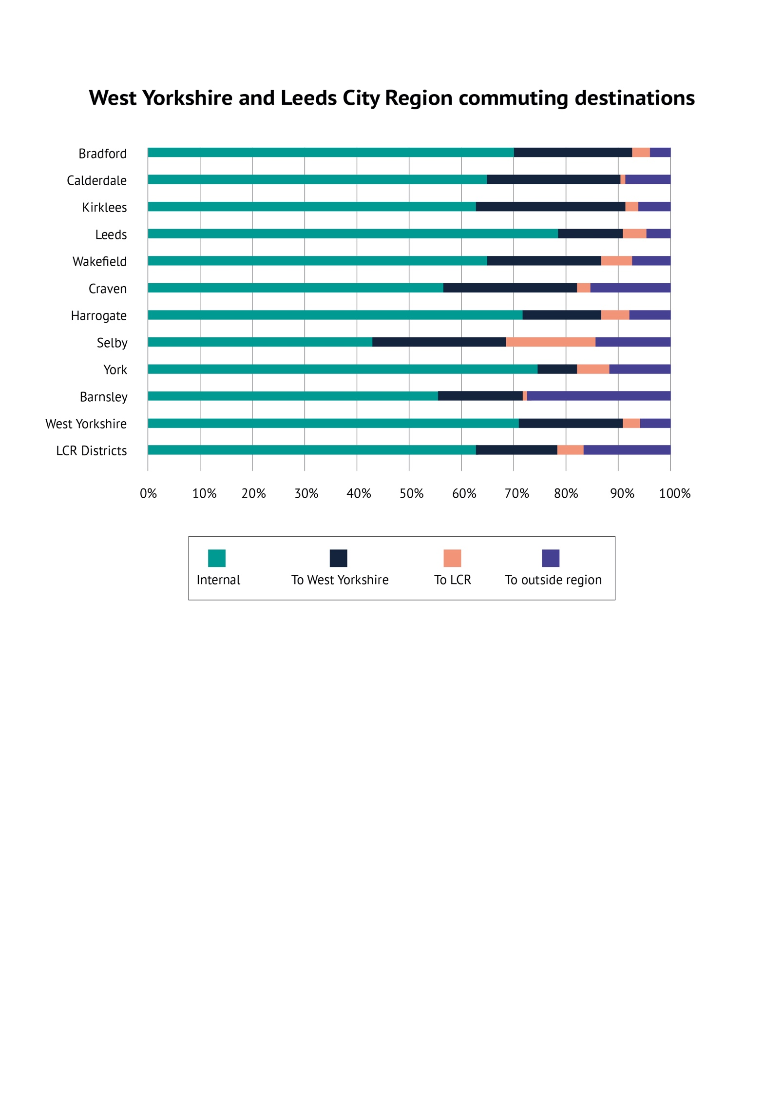

# Economic Profile

### (a) Structure

West Yorkshire’s diverse economic structure closely resembles that of the UK:

However, this masks a broad range of specialisms across districts as illustrated by the table below. The prevalence of machinery & transport component manufacturers in multiple districts emphasises the region’s importance in supply chains. In many districts, this often higher-value activity sits alongside sectors where lower skilled jobs often dominate such as food production and more basic manufacturing industries. Knowledge intensive services are more prevalent in Leeds, though Bradford and Calderdale have at least some degree of specialism here.

**Top 5 location quotients for West Yorkshire districts (district employment share >0.9%)**

#### Source: Business Register & Employment Survey, Office for National Statistics, 2019

West Yorkshire is home to almost 92,000 businesses. In line with the UK as a whole, 99.5% of these are SMEs.

However, the area has relatively fewer micro businesses and more small and medium size firms. Businesses with 10-249 staff constitute 16.9% of our business base, compared to 15.2% nationally. This pattern is more pronounced among the manufacturing base. 30% of 5,800 manufacturers employ 10-249 staff, compared to 22% nationally.

The number of businesses in West Yorkshire has increased by 18.5% since 2014, ahead of national growth (17%). Transport & storage has increased from 3,000 in 2014 to 5,000 in 2018, an increase of 69%, compared to a 44% increase nationally. Both the UK and our region have seen a substantial increase in businesses in the energy sector in recent years, though the number of businesses in the sector remains small in absolute terms (200 in West Yorkshire as of 2019).

The area’s business base is relatively stable with the combined business birth and failure rate, (or churn rate) at 23.6% in West Yorkshire and 24.4% in the UK. (A higher churn rate can indicate a more dynamic business base).

Within West Yorkshire, Leeds is the only district where the churn rate is higher than the national rate, albeit only marginally, at 24.9%, suggesting a relatively high degree of dynamism in the economy despite low net growth in the business base. Away from Leeds, business failures were generally below the UK average in most districts suggesting a relatively stable business base.

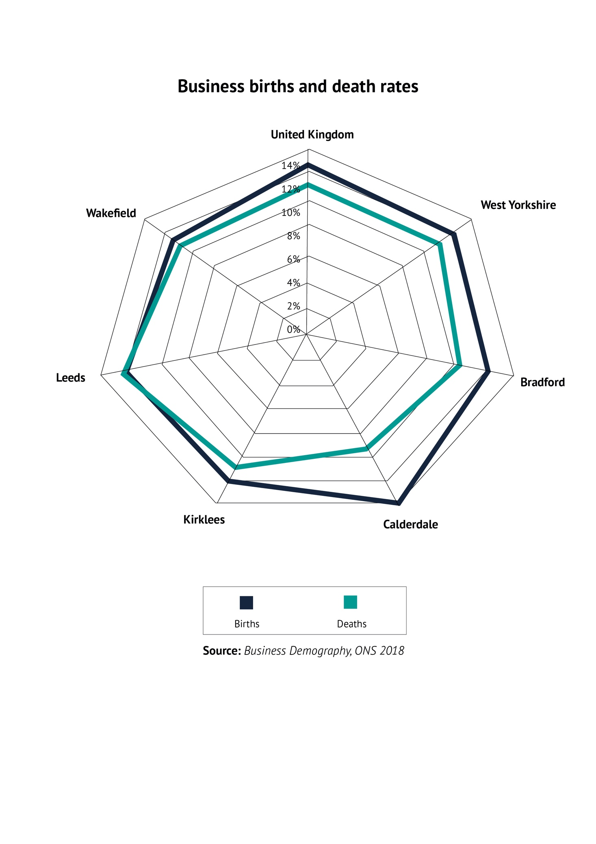

### (b) Employment

The number of jobs in West Yorkshire rose to 1.1 million in 2018, an increase of 40,000 (3.8%) on 2015. This is faster than the 3.5% growth across England and 3.3% across Great Britain over this period. Within West Yorkshire, Leeds (8%) and Wakefield (5%) have seen the strongest growth with a more mixed picture elsewhere.

### (c) The role of public transport

Within this area, the quality of public transport, and in particular local bus networks, have multiple impacts on the regional economy, amongst them:

* They join up our towns, cities and rural areas and allow people to access jobs, services and learning and leisure opportunities across the area, therefore affecting productive activities. In metropolitan areas, bus networks are estimated to generate £2.5 billion in economic benefits against public funding of £0.50 billion. More than 50% of this benefit is attributable to user benefits from access to jobs, training, shopping and leisure activities[2].
* They can increase participation in economic activity by providing affordable access to jobs and education. This is particularly important for our most deprived areas.
* Conversely, the effect of service cuts may have dramatic consequences in terms of labour market participation; research suggest that 11% of those who use bus as their means of travel to work would either change jobs or leave the labour market if there was no bus service available.

In addition the rail network offers the following economic benefits:

* Labour market mobility;
* Facilitating housing development;
* Social mobility; and
* Easing road congestion.

## Challenges

The headline economic data summarised below indicates that for a sub region of its scale and demographic composition, and despite its strengths and assets, West Yorkshire is not punching at its weight and is falling behind.

### Growth

In recent years, West Yorkshire’s economic growth has outpaced that seen in all other core city LEP areas, with the exception of Greater Birmingham & Solihull, at an average of 3.5%. Despite this, average annual growth has remained below UK levels since 2012. In the years preceding the recession, its GVA growth rate of 4.6% was below the national average, and lower than other northern core city LEP areas.

Within the area, GVA growth was at, or above, national levels in only Leeds and Calderdale prior to the financial crisis of 2008, though across West Yorkshire as a whole growth was a little below the national average. This gap has widened since the recession, with growth averaging 2.8% per year since 2009 compared to 3.3% nationally. Wakefield has seen growth outpace UK levels over that period, however.

### Productivity

Whilst UK productivity growth has been below trend since the recession, local productivity has persistently lagged behind UK levels. In 2008, output per hour in West Yorkshire was £25.65, about 89.6% of UK output. In 2017, output per hour in West Yorkshire had risen to £29.29, though is just 87% of UK levels. In value added terms, if productivity in West Yorkshire matched UK levels the economy would be £7.9 billion larger.

Although in absolute terms productivity is increasing in all parts of West Yorkshire, all areas have productivity levels below the UK average. In Leeds and Bradford it is now close to 90% of the UK average, but this falls to around 83% elsewhere in the area.

A range of factors influence this relative productivity underperformance. ONS research suggests that West Yorkshire has a higher proportion of firms with relatively low productivity compared to the country as a whole, and London in particular. This creates a long tail of underproductive firms.

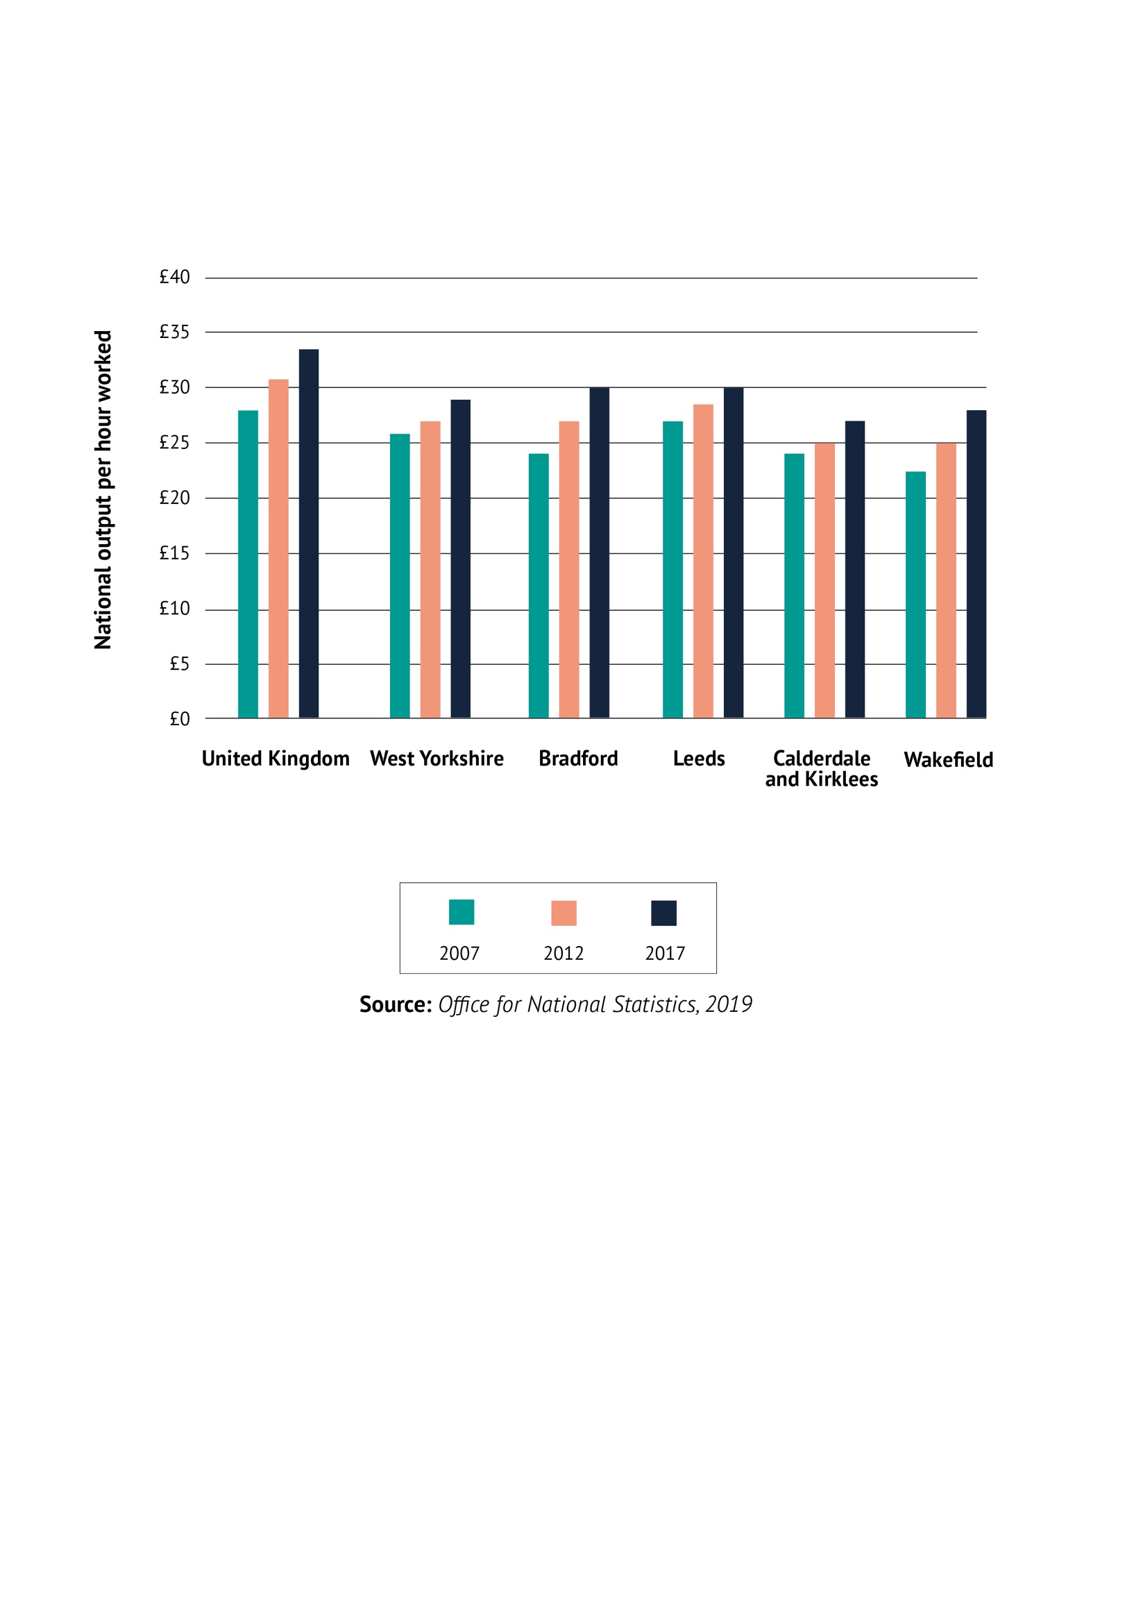

### Diversity and Inclusion

18.2% of the population are Black, Asian, Minority Ethnic (BAME), compared to 14.6% in England. One in nine (11%) business owners/directors is from a minority background in West Yorkshire. Whilst this is similar to England as a whole, the region has a higher share of business leaders from Asian backgrounds (8.7% compared to 6.8%). This is particularly true in Bradford and Kirklees, where 17% and 10% respectively of businesses owners are Asian.

The proportion of business leaders from ethnic minority backgrounds is therefore lower than the share of all workers from those backgrounds. Whilst this is true in most similar LEP areas, it does suggest that people from such backgrounds are under-represented in senior business positions.

A number of additional inclusion and deprivation related issues are identified in the Place challenge below.

### Innovation

The national industrial strategy sets out the ambition for the UK to spend 2.4% of GDP on research and development (R&D). Although the 2014 Research Excellence Framework (REF) identified 23% of West Yorkshire HEI research as world leading, and 42% as internationally excellent, Yorkshire & Humber as a whole spends only 1.4% of GVA on R&D - less than any other English region. This is economically significant, and the chart below shows the generally positive correlation between R&D spend and productivity, though London is an outlier in this regard.

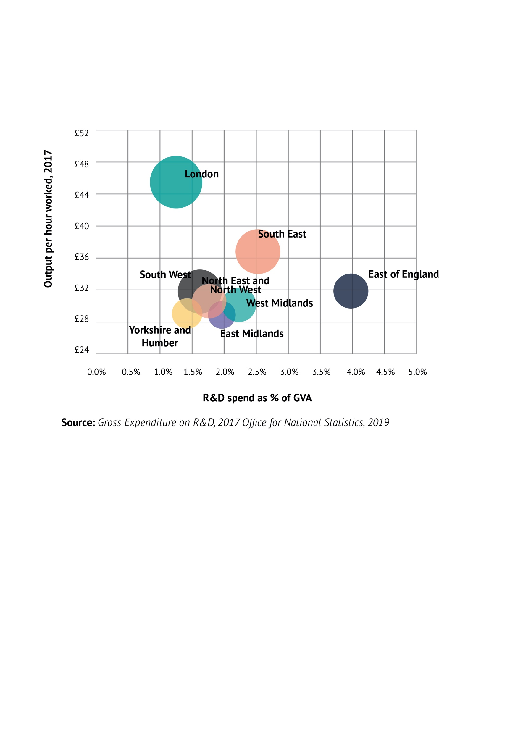

### Trade

The Yorkshire & Humber region accounts for 7.7% of UK goods exported in 2018, broadly in line with its 7% share of UK businesses. However, whilst the number of exporters has increased by 25% since 2013, it has remained relatively stable since 2016.

On average, Yorkshire & Humber goods exporters exported goods worth £1.49m in 2018, up from 1.25m in 2016. However, the value of goods exports per exporter remains lower than in other English regions other than London.

In total, West Yorkshire exported goods worth £6.17 billion in 2018. 10.6% of West Yorkshire goods went to the US compared to 15% across other core city areas and over 20% in the West Midlands. West Yorkshire is similarly underexposed to other key markets such as China, Germany and Singapore, though has a higher share of trade with Ireland and Canada.

### Place

More than one in five people living in West Yorkshire (22% or almost 517k) live in areas defined as being amongst the most deprived 10% in England, and within the region there is considerable spatial variation. Relative levels of deprivation - and wider place-based challenges - in West Yorkshire have increased in recent years, which can be characterised as follows:

* 13% of West Yorkshire households in are in fuel poverty.
* People born in Yorkshire & the Humber have significantly shorter life expectancies at birth compared to England average. The social gradient in life expectancy is steeper in Yorkshire & the Humber; people who live in more deprived neighbourhoods have shorter lives than those in less deprived areas and the difference in more pronounced here compared to the England average.
* West Yorkshire contains 162km of canals and 734km of statutory main rivers. 17k residential properties in West Yorkshire face a 1 in 100 year flood risk (Flood Zone 3) and a further 17,000 properties are in an area with a 1 in 1,000 year risk. Over 5,000 businesses are located in Flood Zone 3 with an additional 5,000 located in Flood Zone 2.
* Between 2001 and 2011, West Yorkshire (similar to national trends) has seen a decrease in the proportion of owned (outright & mortgage) and social rented properties, and near 5.2% increase in the number of privately rented properties.
* Housing sales in West Yorkshire are still recovering from the 2008/09 recession and prices in the areas lag behind the England average (£160,000 vs £240,000) - although this is skewed by the high prices in London and the South-East - and over the last 20 years the gap between house prices in Yorkshire and the Humber and England has widened. Locally there is considerable spatial variation in average house prices, and house price growth, even at sub-district level. These factors correlate with deprivation, which in turn means inequality of the wealth effect.
* Rates of active travel (walking and cycling) - important for public health, quality of life, the environment, and with implications for productivity - are lower than the England average.
* Gross median hourly pay for full-time jobs in West Yorkshire is 92% of the national average. All districts in West Yorkshire pay below the England average. The figure for Leeds is close to parity (96% of the national average) with the remaining districts occupying a fairly consistent level at 88 to 89% of the national average.
* 24% of jobs in West Yorkshire pay less than the Living Wage Foundation’s Living Wage rate, which is intended to reflect the level of pay people need to get by. In contrast, for Oxfordshire LEP it is 13%. The largest number of low-paid people is in Leeds but Kirklees and Wakefield have higher proportions of low-paid people.
* West Yorkshire has more than its fair share of skills-based deprivation. Based on the Index of Multiple Deprivation 2019, 22% of neighbourhoods in the region are among the 10% most deprived nationally in relation to skills, with Bradford (33%), and Wakefield (28%) the worst affected. However, all districts have more than their fair share of skills deprivation

### People

* West Yorkshire generally performs poorly in terms of skills supply - the proportion qualified at level 4 and above is 6 points lower than the national average – 33% of people aged 16-64 are qualified to NVQ4+ locally, compared to 39% nationally. Meanwhile the proportion qualified below level 2 is 5 points higher (27% in West Yorkshire and 22% nationally).
* The qualification profile at district level is quite disparate within West Yorkshire. For example, only 25% of the population in Wakefield is qualified to level 4. In Bradford there are significantly more people qualified below level 2 than qualified at level 4 and above. Leeds and Calderdale perform significantly better. The proportion of people qualified at level 4+ in Leeds is 13 points higher than in Wakefield. Nonetheless, all districts under-perform against the national average on higher level qualifications. This helps explain why despite the area having a large HE sector, the extent to which it currently addresses local skills needs is limited, with graduate retention rates low relative to some comparable areas.
* The area has seen a strong recent improvement in its labour market performance but still has a significant number of people who are excluded from the labour market, with disadvantaged groups most at risk: employment in manual roles (semi-skilled operatives, labourers) saw decline in recession and also shows signs of further contraction following a period of recovery.
* Although West Yorkshire has a deficit of higher skilled employment, recent employment growth has nonetheless been driven by expansion of higher skilled occupations: the number of people employed in these roles has grown by 98,000, or 28%, over the last 15 years, four times the overall rate of employment growth.
* 44% of people working in the region are employed in higher skilled roles, versus a national average of 48%. Only in Leeds is the skills profile similar to the national average. Employment in professional roles is particularly low at 20% of the total compared with national average of 23%. Employment in middle-skilled, service-intensive and manual roles are all proportionately higher in the region than nationally.

### Infrastructure

* 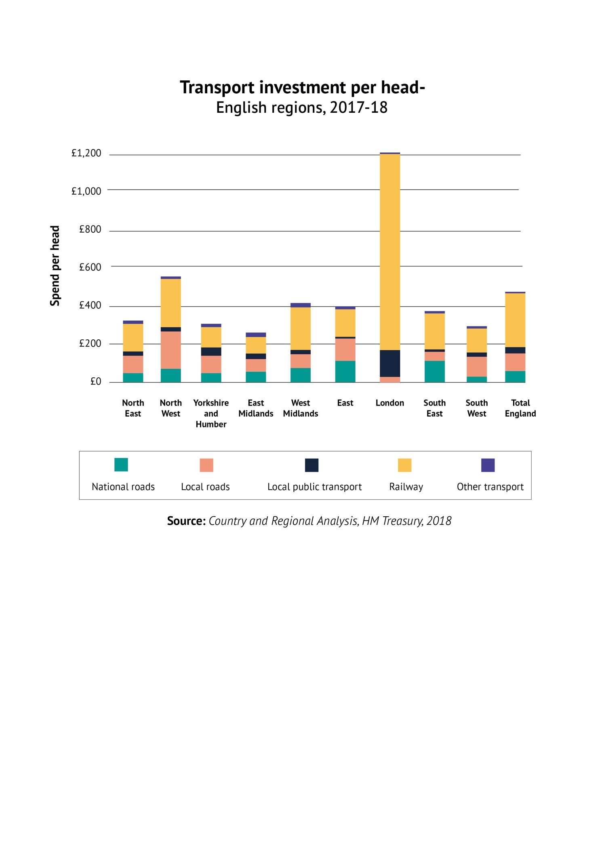Low levels of public sector investment have left the supply of infrastructure lagging behind what is needed to support a world-leading economy. For example, transport investment totalled £315 per head in Yorkshire & Humber in 2017/18, below the average for England of £475. This is skewed by London (£1,019 per head), but only the East Midlands had lower investment levels than Yorkshire & Humber.
* The volume of traffic is increasing and infrastructure improvements are not keeping pace which means congestion continues to be problem (with longer journey times and reduced averaged speeds). This has both economic and environmental impacts; it disrupts or delays the movement of people and goods, and it contributes to increased pollution and carbon emissions.
* Public transport is a key opportunity to reduce congestion, however only around 1 in 10 residents of West and North Yorkshire commute by bus, and bus passenger journeys in the area have declined by 13% since 2009/10. This trend is similar for other regions outside London, except the South East and South West. One reason for the decline in bus usage is the reduction in services. The number of bus miles operated in the Yorkshire and Humber Region has reduced by 14% between 2009/10 and 2017/18. This is one and a half times the England average.
* Almost 1 in 5 residents of West Yorkshire live within 1km of one of the area’s 69 rail stations, however data from the last census revealed that rails modal share of commuters is just 4% (less than the national average). Rail use, both nationally and locally is growing, despite recent poor performance indicators (Transport Focus survey results reveal that passengers perceptions of rail journeys, stations, and services in West Yorkshire are below average for similar metropolitan areas). Station usage data reveals that growth has been less strong in West Yorkshire compared to England overall. Leeds station accounts for 43% of all station entries and exits in West Yorkshire.
* Access to Superfast Broadband falls to 69% in the 20% most deprived areas and only 3% of properties have access to Full Fibre Broadband (FFBB). Access to FFBB improves as the deprivation decile improves with 7% of properties in the 5th decile and above being connected.

# Understanding current governance arrangements

The Combined Authority and the LEP work in partnership with one another - and with local councils and business - to seek to ensure everyone in our region benefits from a strong, successful economy and a modern accessible transport network. These ambitions will be driven by a forthcoming Local Industrial Strategy and Strategic Economic Framework which will capture and align economic policy making across the city region.

## Combined Authorities, LEPs and PCCs

### Combined Authorities

Because the geographic areas covered by functional economic market areas (illustrated by, for example, travel to work areas) are typically significantly larger than the areas of individual local authorities, there is considered likely to be scope for improvements to be made to the exercise of some statutory functions and economic outcomes through joint decision making and close co-ordination of delivery activity across these economic areas.

All combined authorities are statutory ‘bodies corporate’ with legal personality and exercise functions as set out in orders and primary legislation. CAs may be made as either non-mayoral or mayoral – the mayoral variant has a directly elected mayor that personally exercises and/or delegates specific (”mayoral”) functions, in addition to being a voting member, and Chair, of the Combined Authority.

The constituent district authorities need not cede any of their functions to their combined authority, although they may choose to do so, or to share appropriate functions with the combined authority, where this would demonstrably improve the exercise of those functions. The combined authority model provides a way to take on powers and funding which would otherwise be managed from Whitehall.

The combined authority model therefore allows groups of relevant authorities to work closely together on a voluntary basis to create a strategic economic framework and policies to deliver, for example, improvements in transport and other infrastructure across their sub-regions and economic investment activity. It is intended to support improved strategic decision making and leadership on these and other issues.

As a combined authority has a separate legal identity from its constituent authorities it is able to hold budgets, employ staff and enter into contracts (e.g. to act as accountable body for funding distributed by government) and, in the case of West Yorkshire Combined Authority, to collaborate with local authorities within the wider Leeds City Region functional economy. The activities of a combined authority are governed by its members, a majority of whom must be elected members of the constituent local authorities, ensuring its local democratic mandate. A combined authority makes the delivery of strategic decisions more streamlined and efficient, e.g. by removing the requirement for each district authority to ratify the same decision separately.

### LEPs

From 2011, local enterprise partnerships (LEPs) were established as a public-private sector partnership. There are 38 LEPs across England. They are business led partnerships between local authorities and local private sector businesses. Each is tasked to play a central role in determining local economic priorities and undertaking activities to drive economic growth and job creation, improve infrastructure and raise workforce skills within the local area. LEP boards are led by a business Chair and board members are local leaders of industry, educational institutions and the public and third sectors.

### (c) Police and Crime Commissioners

PCCs were elected for the second time in May 2016 in 40 force areas across England and Wales. Every force area, including West Yorkshire, is represented by a PCC, except Greater Manchester and London, where PCC responsibilities lie with the Mayor.

The PCC does not run operational policing, that is the role of the Chief Constable; the role of the Commissioner is to be the voice of the people for the area, hold the police to account, set the policing budget and produce a Police and Crime Plan for the area.

Under the terms of the Police Reform and Social Responsibility Act 2011, PCCs will:

* appoint (and will be able to dismiss) the Chief Constable. The Chief Constable will appoint all other officers within the Force;
* set out a five-year police and crime plan (the Plan), although it may be refreshed each year and may be fully revised at the Commissioner's discretion;
* determine local policing priorities, publish the plan, set a local precept and set the annual Force budget (including contingency reserves) in consultation with the Chief Constable. The Plan will need to take account of national policing challenges, set out in the national 'Strategic Policing Requirement';
* receive the policing grant from the Home Office, various grants from the Ministry for Housing Communities and Local Government and the local precept (as well as any other funding streams);
* commission policing services from the Chief Constable (or other providers - in consultation with the Chief Constable). These services shall be set out in the Plan where the Commissioner's objectives and funding will be publicly disclosed;
* publish the Plan, which will remain a public document, including any updates or amendments made, during the five-year period;
* publish an annual report at the end of the financial year, which will set out progress made by the Commissioner against the objectives set out in the Plan;
* publish annual financial accounts alongside the annual report, including showing how resources were used to address priorities and how value for money was secured;
* have a general duty to regularly consult and involve the public and have regard to the local authority priorities; and
* be able to require a report from the Chief Constable at any time about the execution of their functions

### West Yorkshire Combined Authority

The 2013 Review of West Yorkshire governance arrangements relating to transport, economic development and regeneration concluded that West Yorkshire Integrated Transport Authority and West Yorkshire Passenger Transport Executive should be abolished and a combined authority for the area created, both as the best option for the area going forward in terms of delivering the 2012 City Deal, and because it would be likely to improve:

* the exercise of statutory functions relating to economic development, regeneration and transport in the area;
* the effectiveness and efficiency of transport; and
* the economic conditions in the area.

In making the order to create the Combined Authority, the Secretary of State also had regard to the need to: secure more effective and convenient local government for the area; and to reflect the identities and interests of the area’s local communities. On that basis,West Yorkshire Combined Authority was created in April 2014. Membership is comprised of elected members of the West Yorkshire partner councils of Bradford, Calderdale, Kirklees, Leeds and Wakefield, plus York and the Chair of the LEP. Voting members are: five elected members, one appointed by each of the five constituent West Yorkshire councils, and three elected members agreed by the constituent councils to reflect the balance of political parties across the Combined Authority area.

In addition there is: an elected member appointed by City of York Council (which is a non-constituent member of the Combined Authority) and the Chair of the LEP (these members are non-voting except where the Combined Authority has resolved to give them a vote on any issues).

Currently, West Yorkshire has a non-mayoral combined authority. The West Yorkshire Devolution Deal commits, subject to a statutory review, to the Combined Authority being made Mayoral with a directly elected Mayor to be elected by the voters of West Yorkshire by May 2021.

### *Supporting structures*

The work of the Combined Authority (and the LEP) is supported through an integrated officer body and various Committees and advisory panels (comprising council members and private, other public, and third sector representation) including:

* Transport Committee, with supporting joint and district consultation sub-committees;
* West Yorkshire and York Investment Committee;
* Overview and Scrutiny and Governance and Audit Committees; and
* Advisory Panels: Business, Innovation and Growth; Employment and Skills; Green Economy; Inclusive Growth and Public Policy; and Place.

### *Functions*

The Combined Authority exercises a combined range of specific statutory duties, powers and functions for economic development & regeneration and transport.

It works closely with the LEP to develop, shape and deliver policies that meet the needs of employers in the region, and this is enabled through the General Power of Competence which the Combined Authority exercises in respect of promoting economic development and regeneration.

The Combined Authority is the statutory body created under the Transport Act 1968 to secure public transport services and facilities required for the sub region. The five District authorities currently exercise local highways functions, including highways maintenance and traffic management. Under the Transport Act 1985, the Combined Authority is also responsible for procuring public passenger transport services following the de-regulation of the bus market. The Combined Authority has a duty as the Local Transport Authority to ‘secure or promote the provision of a system of public transport which meets the needs of the area’ and delivers public services to the people of West Yorkshire via the Metro branded network of bus stations, travel centres and public transport information.

Amongst its other transport duties, the Combined Authority also:

* prepares the Statutory Local Transport Plan for the area, and other related plans and strategies (including for bus, rail and freight) and manages the local transport allocation from Department for Transport
* is responsible for administering the English National Concessionary Travel Scheme for subsidising public transport;
* is party to rail franchise agreements;
* is responsible for reviewing rail passenger services and advising Department for Transport under the Railways Acts.

Combined Authority transport functions are funded by:

* the transport levy placed on the District Authorities
* Department for Transport rail and other grants
* Devolved funds, e.g. Department for Transport major scheme grant funds, Growth Deal funding (until 2021), West Yorkshire+ Transport Fund gainshare funding (post 2021), enabling significant delivery including:
  + an additional 2,000 park and ride spaces at 14 West Yorkshire rail stations bringing the total to around 7,000, encouraging rail use and reducing car journeys into our town and city centres
  + rail stations at Apperley Bridge, Kirkstall Forge and Low Moor, opened with almost £27 million of investment from the Combined Authority, and which people used to make almost ¾ million journeys in 2018/19.
  + £60 million of investment in cycling and walking schemes across the region over the past five years. 67km of new and improved cycling and walking with more than 2.3 million trips made on the infrastructure to date.
  + £79 million invested in building eight new college facilities and refurbishing two further facilities, expected to deliver a £600m impact over the next five years
  + £45 million from the Growth Deal invested into creating ten Enterprise Zone sites across the Leeds City Region deliver over 1.5 million square feet of new commercial space
  + £4 million invested into creating a district heat network in Leeds City Centre providing low cost, low carbon heating to almost 2,000 homes as well as a number of businesses

### Leeds City Region LEP

In 2011, the LEP was established as one of the first in the country as a public-private sector partnership.

The LEP brings together business and council leaders to ensure that services and investment are well co-ordinated across the City Region and support businesses to grow, eg through the Growing Places Fund, Inward Investment, Skills, Low Carbon and Inclusive Growth.

From March 2020, in order to comply with Government’s requirement that LEP areas can no longer be partly overlapping, the geography of the LEP was changed to cover the West Yorkshire district areas of Bradford, Calderdale, Kirklees, Leeds and Wakefield only and membership of the LEP Board now reflects that change whilst continuing to be known as Leeds City Region LEP.

### West Yorkshire PCC

The West Yorkshire PCC was first elected in 2012 and again 2016 and his term of office is now due to end in May 2021 following the cancellation of the May 2020 elections. The PCC is supported by a Deputy PCC and an Office of the PCC (OPCC). The OPCC employs a number of statutory and core staff in addition to other staff that support wider service provision under the direction and control of the PCC.

The West Yorkshire Police and Crime Plan 2016-21 is built around delivering the following four key outcomes:

* tackle crime and anti-social behaviour;
* safeguard vulnerable people;
* make sure criminal justice works for communities; and
* support victims and witnesses.

The Plan also sets out 16 priorities for the OPCC, West Yorkshire Police and partners, identified by people and partners from across West Yorkshire through the consultation exercise 'Your Plan, Your Priorities'. The Plan priorities are shown in the following table:

## Case for change

The Combined Authority arrangements within West Yorkshire provide a framework for collaboration that is currently limited to economic development and transport, and available funding streams which are similarly constrained. West Yorkshire authorities have undertaken an assessment of the opportunities and challenges existing across the region demonstrating that access to a broader range of powers and devolved funding is needed to achieve the area’s full growth potential.

### The ’minded-to’ West Yorkshire devolution deal

Government and West Yorkshire authorities have agreed an ambitious ‘minded-to’ devolution deal that will provide the area with significant new powers and funding to increase opportunities and living standards through inclusive growth and productivity improvements. The content of this deal expands on the model seen in other areas with a clear focus on clean and inclusive growth and driving increased productivity.

The deal is described as ‘minded-to’ as the proposals are subject to formal consent by the individual councils and parliamentary approval of the relevant legislation to implement the proposals over the coming months.

### Governance

The economic and social challenges facing the region need to be addressed and opportunities maximised if the area is to grow and prosper. The powers and funding available through existing membership of the Combined Authority do not provide sufficient scope to tackle the key long-term, entrenched issues facing the West Yorkshire identified above in relation to growth, productivity, diversity and inclusion, innovation, trade, place, people and infrastructure. There is strong evidence that strengthened governance arrangements in the West Yorkshire area, with additional powers and funding, will deliver significant economic outcomes locally and improve the contribution of the area to the Northern Powerhouse and national economy.

For example, a compelling headline case for governance reform in the City Region has been made by the OECD[3] which recognises that: “Institutional factors are crucial in ensuring successful consultation and co-ordinating among stakeholders within regions, with other regions and central government…thus, governance matters.”

The OECD further concluded that in Leeds City Region - which was seen to be particularly affected by its polycentricity, geographic dispersion, and institutional complexity - it was challenging to generate effective communication, strong co-ordination and a shared sense of purpose in response to the challenges it then faced. Therefore, it was recommended that the City Region would benefit from strengthened and more established regional governance arrangements.

Moreover, the West Yorkshire authorities have an opportunity through the ‘minded-to’ devolution deal to take on a greater level of local control and responsibility for a number of key drivers of economic growth with an unprecedented range of additional powers and funding. This opportunity does not exist within the existing the Combined Authority arrangements as Government has been clear that strong, accountable governance exercised through a mayoral combined authority is an essential prerequisite of any further devolution of powers and functions to a city region.

Under the terms of the deal a Mayoral West Yorkshire Combined Authority with a new directly elected mayor for the area will provide a stable and directly accountable platform for devolution of resources and a wider range of powers from central government. The MCA will exercise a broader range of functions as detailed below, with the Mayor exercising certain powers with personal accountability to the electorate, devolved from central Government and set out in legislation. The Mayor may choose to delegate function(s) to members of the Combined Authority. No constituent council functions will be removed from those councils.

The Mayor will chair Combined Authority meetings within which each of the five constituent authorities will appoint one member. Three elected members will continue to be agreed by the constituent councils to reflect the balance of political parties across the Combined Authority area.

The MCA will be able to explore opportunities for further collaboration with its neighbouring councils, including Harrogate, Craven, Selby, York and North Yorkshire County Council, and across the whole of Yorkshire through the Yorkshire Leaders Board. York will remain as a non-constituent member and the Mayoral Combined Authority may invite representatives from other partner councils to attend (and speak) at any Mayoral Combined Authority meeting

The relationship with business is integral to the proposed arrangements, with the LEP represented on the Combined Authority through a non-voting member, and the Mayor represented on the LEP Board.

It is anticipated that decision making will generally be by way of consensus and with clear voting arrangements set out in the constitution for the occasions where it is not possible for all constituent members to agree.

In addition, for the following decisions, the majority of members must include the consent of three of the five members for the constituent councils (but not that of the three additional constituent council members appointed for political balance):

* Approving the Combined Authority’s budget (excluding decisions which relate to the Mayor’s budget); and
* Setting a levy.

The Mayor will be required to consult the Combined Authority on Mayoral strategies, and this will be subject to the following specific conditions:

* The spatial development strategy will require the consent of the members of each of the five constituent councils (but not that of the three additional constituent council members appointed for political balance);
* The Combined Authority will be able to amend the Mayor’s budget if five eighths of the members agree to do so; and
* The Combined Authority will be able to amend the Mayor’s transport strategy if a majority of members agree to do so.

The following decisions by the Mayor will require the consent of the Combined Authority member (but not the member appointed for political balance), or substitute member acting in that member’s place, appointed by the constituent council in whose area the decision will apply:

* the designation of any area of land as a Mayoral development area leading to the establishment, by order, of a Corporation (the consent of the relevant national park authority is also required if the land falls within the designated national park area);
* the compulsory purchase of land or buildings by the Mayor;
* any decision that could lead to a financial liability falling directly upon that constituent council; and
* such other matters as may be contained in the Combined Authority constitution and agreed with the Mayor.

The Mayor and the Combined Authority will be scrutinised and held to account by the Combined Authority’s Overview and Scrutiny and Governance and Audit Committees. The arrangements currently established for the Combined Authority will be retained, subject to any amendments required to reflect the introduction of the Mayor and any new statutory provisions. The Mayor and the Combined Authority may also seek to enhance scrutiny and develop wider conference with all elected members in the Combined Authority’s area to engage on key issues.

### Functions

The deal specifies that the new MCA would continue to exercise the range of current Combined Authority functions in relation to economic development regeneration and transport - outlined elsewhere in this review (save for the Mayor taking responsibility for preparing the transport plan and strategies).

The new MCA and Mayor would exercise distinct new functions. These would be devolved from central Government and set out in legislation and draw down from Whitehall significant new funding streams. No transfer would be required of statutory responsibility from local authorities to the MCA or Mayor as a result of the deal.

The various powers in scope, and their rationale, are considered in the grid below and encompass a broad set of ambitions covering:

* Finance and Investment
* Transport
* Skills and Employment
* Innovation
* Trade and Regional Business Support
* Housing and Planning
* Culture Heritage and Digital
* Climate, flooding and the environment
* Public Service Reform

|  |  |  |
| --- | --- | --- |
| **Functions – Finance and Investment** | **Economic Challenge Addressed** | **Rationale** |
| Power for the Mayor to:   * charge business rate supplement (subject to ballot); and * set a precept on council tax to fund Mayoral functions   Power for the Combined Authority to borrow up to an agreed cap for non-transport functions | 1,2,3,4,5, 6,7,8 | The Mayoral Combined Authority will be able to utilise the new functions (and existing Combined Authority powers and devolved funding, eg borrowing for transport functions) in relation to charging a business rates supplement and borrowing powers to create a fully devolved, flexible single pot to be named the West Yorkshire Investment Fund (WYIF), covering all devolved budgets, and in line with an agreed assurance framework to ensure that all funded interventions are aligned to the balanced economic outcomes for the area. This will transform the region’s capacity to drive its ambitions of faster, more inclusive and greener growth and delivery of a 21st century transport system. The WYIF would comprise a number of devolved income streams, including from the following funds agreed in the deal:   * £38m per annum to the Combined Authority for 30 years (25% capital and 75% revenue), to capitalise the WYIF, subject to five-yearly gateway assessments to confirm that the investment has contributed to economic growth; * The Combined Authority will be able to use capital receipts from asset sales as revenue funding for public service transformational initiatives; * Combined Authority powers to borrow (within limits agreed with HMT) for its new functions will allow the Combined Authority to invest in economically productive infrastructure; * Powers to raise a Strategic Infrastructure Tariff would enable the Combined Authority to raise funding for strategic infrastructure and would operate alongside any local forms of developer contributions; and * Mayoral power to introduce a supplement on business rates for expenditure on a project or projects that will promote economic development in the area, subject to a ballot of affected businesses. * Flood risk management schemes worth at least £101m will be taken forward in West Yorkshire over the course of the six-year programme, as a result of the announcement by the Chancellor at Budget of a £5.2bn envelope; and * A £25 million Heritage Fund to support the British Library in establishing a potential ‘British Library North’. * In addition, the Mayoral power to set a precept on local council tax bills would help pay for the Mayor’s work (and no other Combined Authority functions). A precept would offer greater transparency to West Yorkshire residents in relation to the funding of Mayoral functions. |
| **Functions - Transport** | **Economic Challenge Addressed** | **Rationale** |
| Power for the Mayor to:   * draw up a local transport plan and strategies * request local regulations requiring large fuel retailers to provide Electric Vehicle charging points * implement bus franchising in the area; and * pay grants to bus service operators   Combined Authority transport powers to set up and coordinate a Key Route Network (KRN) on behalf of the Mayor, along with:   * powers to collect contributions from utility companies for diversionary works needed as a result of highways works carried out on the Key Route Network; and * powers to operate a permit scheme designed to control the carrying out of works on the Key Route Network | 2,6,8 | * The additional powers devolved to the Mayoral Combined Authority will unlock the devolution of the following transport related funds and funding flexibilities: * A consolidated local transport budget, devolved to the Mayor, including all relevant devolved highways funding, starting with a five-year, integrated transport settlement beginning in 2022/23 from a wider £4.2bn envelope. * £317m to the Combined Authority from the Transforming Cities Fund to deliver the projects included in the Leeds City Region bid; * to take forward the next stage of development of the Outline Business Case for the redevelopment of Leeds station, subject to endorsement of the current business case, which will deliver improvements both in track and services and in the station’s accessibility and environment; and * up to £500,000 to support Bradford’s master planning work to explore the regeneration opportunities of potential NPR services.   In addition to the ability to pay grants to bus service operators, access to franchising powers under the Bus Services Act 2017 will provide the opportunity for the Mayor to specify bus services in West Yorkshire as part of an integrated local transport system and help to facilitate the delivery of smart, simple integrated ticketing across the city region.  Through the Automated and Electric Vehicles Act, the Mayor’s power to request from the Secretary of State local regulations requiring large fuel retailers to provide Electric Vehicle charging points within the Combined Authority area will be beneficial in terms of promoting lower carbon transport modes.  The establishment of a statutory Key Route Network (KRN) would build on existing local arrangements to enable better collaborative decision-making on major strategic transport issues. The identified KRN will be collaboratively managed at the West Yorkshire level by the respective local highway authorities in partnership with the Combined Authority on behalf of the Mayor (who would be responsible for the overall coordination of the collaborative arrangements). There will be no transfer of statutory responsibility for such roads from the existing highway authorities. Responsibility for resourcing maintenance and operational management of the network would remain the responsibility of the respective local highway authorities. |
| **Functions - Economic development and Skills** | **Economic Challenge Addressed** | **Rationale** |
| * Mayor to have the functional power of competence * Combined Authority duty to prepare an assessment of economic conditions * Combined Authority adult education and skills functions | 2,3,7 | The Mayor will not have the general power of competence, however the Mayor will have, as an ancillary power, a functional power of competence which complements the Combined Authority’s existing powers and enables the Mayoral CA to do things appropriate or incidental to, or connected with, the Mayor’s and Combined Authority’s functions. It will also aid the delivery of the comprehensive programme of collaboration with Government departments and national agencies which is envisaged in the deal, in order to build on West Yorkshire’s economic strengths and assets and address its weaknesses, including in relation to: transport; skills and employment; innovation; trade and regional business support; housing and planning; culture, heritage and digital; climate, flooding and the environment; and public service reform (for example to explore the feasibility and opportunities around an ‘Act Early' Health Institute).  The Combined Authority’s powers to prepare an assessment of economic conditions will underpin the pending Local Industrial Strategy and ensure that regional policy making is evidence based and takes account of current and emerging economic conditions, including for example in respect of providing business support.  By devolving the annual Adult Education Budget and conferring the relevant powers on the Combined Authority, the provision of adult skills in West Yorkshire will be better aligned with locally determined priorities to ensure the skills system is demand led so that all our residents have the skills required to help businesses to grow, innovate and diversify. A workforce that has transferable and relevant skills is a prerequisite to delivering inclusive growth within the region. |
| **Functions - Housing and planning and regeneration** | **Economic Challenge Addressed** | **Rationale** |
| Mayoral powers:   * statutory spatial planning powers to produce a West Yorkshire Spatial Development Strategy (SDS) - exercisable with the unanimous consent of the constituent authorities * power to designate a Mayoral Development Area and then set up a Mayoral Development Corporation (subject to the consent of the constituent council affected by the exercise of the function) * housing and land acquisition powers to support housing, regeneration, infrastructure and community development and wellbeing.   Combined Authority housing and regeneration powers in relation to:   * compulsory purchase (subject to the consent of the constituent council affected by the exercise of the function), plus provision of housing and land, land acquisition and disposal, and development and regeneration of land * seeking consent to raise a Strategic Infrastructure Tariff | 6,7,8 | An SDS for West Yorkshire (supported by the proposed additional Mayoral and Combined Authority housing and development powers) would enable a common strategic vision for spatial planning across the area to be agreed and implemented, ensuring policy decisions are made more effective by reducing the impact of administrative boundaries. This enhanced coordination would also allow the individual local planning authorities to develop their individual local plans with a common base in evidence and strategy.  SDSs in particular are considered effective in cementing this joint-working as the local plans of constituent members have to be in general conformity with them, whilst democratically accountable governance arrangements (such as requiring unanimous agreement from districts) can help ensure that the SDS is truly a common vision.  The scope and preferred approach to developing any West Yorkshire SDS is a matter for local agreement, in line with the National Planning Policy Framework. Because the MCA would be given powers over other areas of strategic policy, such as strategic transport powers, an SDS could help ensure that there is a corresponding land-use policy tool to prevent coordination failure between land-use policy and these other policy areas.  In the context of climate crisis, it is a regional SDS‘s ability to coordinate key strategic policies to tackle the pressing issues in a cross-boundary way that provides significant value added when compared to a local plan, including by providing strategic co-ordination on: energy policy; regeneration; renewal and retrofitting; modal shift; utilising broadband infrastructure; strategic waste management; flood risk management; developing and enhancing blue and green infrastructure; and ensuring policies deliver biodiversity net gains.  In addition, £3.2m will be devolved to the MCA to support development of a pipeline of strategic housing sites across the region. Government will explore the potential for investment into housing propositions that emerge from development of this pipeline, including through the Brownfield Housing Fund, with a national £400m envelope, and future funding streams. If successful, this funding will support the Combined Authority in bringing more land into development for delivery of housing on brownfield sites beyond existing local plans. |
| **Functions – Police and Crime Commissioner (PCC)** | **Economic Challenge Addressed** | **Rationale** |
| PCC functions to be exercised by the Mayor or the Mayor’s appointed Deputy Mayor for Policing | 3,6,7 | Would enable opportunities to be explored for efficiencies through wider strategic public service integration.  Improved functional effectiveness by strengthening links such as between inclusive growth and community safety and cohesion, eg by diverting vulnerable people (for example care-leavers) away from the criminal justice system by ensuring they have a structured pathway towards personal wellbeing, relevant and transferable skills, and access to good work and building on West Yorkshire OPCC stratetgies around reducing reoffending and victims already developed and in place. |

## Criteria

This section sets out the local and legislative criteria against which possible regional governance options are then considered.

### Local requirements

* Add value to West Yorkshire’s delivery of outcomes **through clear, transparent and accountable regional decision making;**
* **Enable control over additional funding and powers** which would otherwise be managed from Whitehall (such as in the current Devolution Deal, and future Deals);
* **Work more effectively in partnership** with others, such as:
  + with local authorities at West Yorkshire / Leeds City Region and Yorkshire level, e.g. in delivering a comprehensive approach to delivering faster, greener and more inclusive growth; and
  + across the North of England, for example on the Transport for the North agenda, including HS2, Northern Powerhouse Rail and rail franchising.
* Ensure strategic decisions eg on economic investment, planning and transport are made at the **most appropriate administrative level, and as locally as possible;** and
* **Enable efficiency savings to be realised**, either financial savings from devolved project and programme delivery, also co-ordination, time and transaction cost savings through reduced fragmentation of decision making and strategic planning.

### Statutory tests

Section 112 of the 2009 Act provides that where one or more of the authorities which undertook the review conclude that the exercise of the power to make an order under S104 or 105 would be likely to improve the exercise of statutory functions in West Yorkshire, they may prepare and publish a scheme relating to the exercise of those functions. The Secretary of State may only make an order (under S104 or S105) if they also consider that to do so is likely to **improve the** **exercise of statutory functions** in the Combined Authority’s area. In making any such order, the Secretary of State must have regard to the need:

* To secure **more effective and convenient local government** for the area; and
* To reflect the **identities and interests of our local communities**

## Governance options

This Section examines the effectiveness of existing governance structures at the West Yorkshire level and considers their appropriateness against that of other possible governance models. An assessment of the following three options is provided below:

* Option 1 - Do nothing / business as usual
* Option 2 - Strengthen existing arrangements
* Option 3 – An MCA

### Option 1 - Do nothing / business as usual

The (non-mayoral) combined authority model in West Yorkshire has demonstrated several strengths:

* Enabled the historic fragmentation of previous regional governance arrangements to be addressed by establishing a single, integrated regional authority bringing together statutory economic development and transport functions;
* Created the opportunity for various types of collaborative effort, including a stronger shared sense of strategic purpose between partners on the challenges of promoting faster, cleaner and more inclusive growth and the delivery of a 21st century transport system;
* Been able to effectively and efficiently discharge significant devolved powers and funding, including those agreed the 2012 City Deal, and to fulfil ambitions set out in the Leeds City Region Strategic Economic Plan (SEP) , such as proposals for a £1 billion West Yorkshire Plus Transport Fund; and has
* Provided a visible, stable and streamlined body corporate to which Government has been demonstrably confident in devolving significant further powers and funding, such as via the £1 billion 2014 Growth Deal, which would otherwise have been controlled by Whitehall.

The PCC model and West Yorkshire PCC have delivered various benefits:

* Provided stronger and more transparent local accountability of the police, e.g., the West Yorkshire PCC has been directly elected by the public to hold the Chief Constable to account, making the police answerable to the communities they serve.
* Ensuring community needs are met as effectively as possible and improving local relationships through building confidence and restoring trust, which is a key aspect of promoting social cohesion and maintaining public order.
* Working in partnership across a range of agencies at local and national level to ensure there is a unified approach to preventing and reducing crime, including sharing learning and best practice.

The following are however considered to be drawbacks of maintaining the status quo / business as usual:

* Foregoes co-ordination benefits of having strategic powers on skills, planning, housing, economic development transport within a single streamlined authority, and in some instances West Yorkshire may not be able to take forward strategic infrastructure schemes;
* Retaining existing separate Combined Authority and PCC governance arrangements potentially hinders further exploring opportunities for efficiencies and collaboration through more alignment and integration, e.g. in terms of links between inclusive growth and community cohesion.
* The powers and funding on offer through the West Yorkshire Devolution Deal are conditional upon the adoption of a directly elected Mayor.

### Option 2 – Strengthen existing arrangements

Under this option, the existing non-mayoral Combined Authority would be further strengthened through the exercise of additional powers, duties and functions, including for example the following:

* Power to borrow up to an agreed cap for non-transport functions;
* Adult education and skills functions;
* Duty to prepare an assessment of economic conditions;
* Housing functions relating to compulsory purchase, plus provision of housing and land, land acquisition and disposal, and development and regeneration of land; and
* Ability to seek consent to raise a Strategic Infrastructure Tariff.

The above functions would need to be devolved to the Combined Authority via secondary legislation, and therefore would require Government (and local) approvals to make the relevant order. Moreover, a number of the functions are only meaningful if accompanied by devolved funds, for example the Adult Education Budget needs in practice to be devolved to the area to give effect to the related functions. There is however currently no evidence that Government is either likely to consent to the transfer of these additional functions to the Combined Authority or provide additional devolved funding in order to make these functions meaningful, outside of a Mayoral devolution deal.

Under this option, the benefits of promoting collaboration with - and potentially integrating the Combined Authority and PCC staffing structures - could be also explored, e.g., in order to seek to secure some overall efficiency savings. However, the main governance reform driver in terms of streamlining public decision-making arrangements would not be deliverable because the Combined Authority would first need to have in place a directly elected Mayor in order to take on and exercise PCC powers on an ex officio basis.

### Option 3 - A Mayoral Combined Authority

This option would require the existing Combined Authority to become an MCA.

The adoption of an MCA model of governance with an elected Mayor for West Yorkshire will enable the area to unlock the additional benefits of the ‘minded-to' devolution deal through the additional powers and funding from government, as described above. An MCA is the government’s preferred governance mechanism for the greater transfer of powers and funding, and in line with other devolution deals the West Yorkshire deal is dependent on adopting an MCA model of governance.

In addition to the Combined Authority’s existing joint governance arrangements for key growth levers such as transport, skills, economic development and regeneration - which allow for strategic prioritisation across its area and integrated policy development - the following value is added from West Yorkshire moving to a mayoral combined authority model:

* the 30-year gainshare funding mechanism agreed in the deal provides the basis for the long term approach needed to address the long standing economic challenges facing the region, as well as building on the area’s significant assets and strengths;
* an opportunity to draw together a range of devolved and other funding sources into a flexible West Yorkshire Investment Fund programme to enable a holistic approach to tackling shared priorities and driving growth;
* greater local accountability and decision-making power, working in partnership with the Government, constituent councils and the LEP;
* a unified and influential voice to strengthen conversations with government, national agencies and business leaders in the development of local growth policy, strategic interventions, securing a greater share of national resources and influencing national decision making;
* greater visibility and influence as part of the group of mayoral combined authorities with an increasing level of national influence and access to important initiatives only available to these authorities;
* alignment of decision-making at a strategic level across a broader range of statutory functions, including skills, planning, housing, economic development transport and under a coherent strategy, appraisal framework and investment programme;
* consistency in the governance arrangements for strategic transport and other infrastructure assets that span across a wider geography;
* an important role and voice across the Northern Powerhouse, by working with partners across the North of England to promote opportunities for pan-Northern collaboration, including the Yorkshire Leaders Board, Transport for the North and the NP11, to drive productivity and build the Northern Powerhouse;
* closer working across the wider public sector on integrating functions and services, including PCC powers, and providing innovative solutions to the challenges of reducing financial resources and new and improved ways of working; and
* a stable and accountable platform underpinned by statutory powers to access greater devolved powers and funding delegated from government as part of future deals to enable locally devised interventions.

# Conclusions

To ensure the effective exercise of statutory functions across the area of West Yorkshire, adopting an MCA model of governance for the area (Option 3) is considered optimal. An MCA for the area offers greater flexibility and accountability, and moreover devolved powers and funding, than can be provided through either continuing with the existing arrangements (Option 1) or strengthening existing arrangements (Option 2).

The new MCA governance model, along with the additional devolved powers and funding resulting from the 'minded-to' deal, would better enable the area to pursue its objectives of promoting faster, more inclusive and cleaner growth and delivering a 21st century transport system.

It is therefore concluded that:

* current regional governance arrangements - based on a non-mayoral Combined Authority for West Yorkshire - do not represent the best model in terms of delivering the long-term ambitions of the authorities within the area for economic growth and delivery of public services;
* there is limited practical scope for the existing governance arrangements to be meaningfully strengthened, short of adopting a mayoral combined authority model;
* a change is required to enable the West Yorkshire authorities to pursue their economic policy agenda at greater pace, while continuing to collaborate with the wider Leeds City Region, Yorkshire and the North in pursuit of shared economic objectives;
* the statutory criteria for preparing and publishing a scheme are met, i.e., the making of an order under S104 and S105 to enable the adoption of an MCA model of governance for the area of West Yorkshire is the best option and will be likely to **improve the exercise of statutory functions in that area**;
* in addition, establishing an MCA model for West Yorkshire will:
  + **have a positive impact on the interests and identities of local communities** – these proposals build on established regional governance arrangements which cover a coherent functional economic area and which represent the views and interests of local communities ; and
  + **secure more effective and convenient local government** by reducing complexity and streamlining the delivery of public services within the area.

It is therefore proposed that a governance scheme is published (a draft scheme is included at Appendix A) that confirms:

* A mayoral combined authority should cover area of West Yorkshire;
* A West Yorkshire Mayor would be elected in May 2021;
* The Mayor would become a member of the Combined Authority, and chair meetings of the authority;
* Each constituent council will continue to appoint a member to the new mayoral combined authority, along with political representatives from opposition groups, and non-constituent members from the LEP and City of York Council would be appointed; and
* the Mayor and MCA will exercise specific statutory functions, and hold some powers concurrently with West Yorkshire local authorities. No functions are being removed from those councils. Where existing functions currently held by West Yorkshire local authorities are to be shared with the Mayor or the MCA, this must be agreed by the constituent councils.



## Find out more

westyorks-ca.gov.uk

**West Yorkshire Combined Authority**

40-50 Wellington House,

Wellington Street,

Leeds,

LS1 2DE

All information correct at time of writing (May 20)

1. EU DG for Regional Policy (2012). Also SERC for the Northern Way (2009) found that a 20 minute reduction in journey times between Leeds and Manchester would generate productivity benefits (using wages as a proxy) in the region of 1.5% for West Yorkshire districts, after controlling for the skill, age, gender, and occupational mix of places.
2. . *PTEG (2013). The Case for the Urban Bus. The Economic and Social Value of Bus Networks in Metropolitan Areas*: “…around £1.3bn reflect user benefits from access to jobs, training, shopping and leisure opportunities. The remaining benefits accrue to other transport users and society at large, through decongestion, reduced pollution, lower accident rates, improved productivity and the stand-by value of bus
3. Promoting Growth in All Regions, OECD, 2012