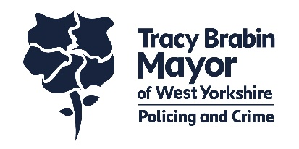
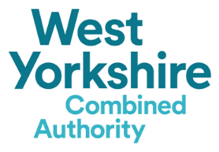
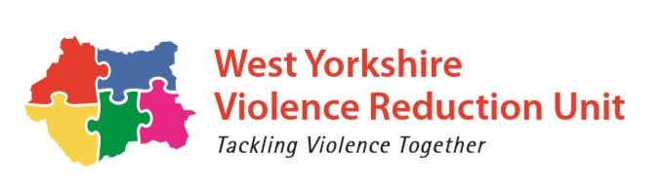

HMYOI Wetherby intervention
Expression of Interest
Please return to VRU@westyorks-ca.gov.uk
By 5PM, MONDAY 21st JUNE 2021

The West Yorkshire Violence Reduction Unit (VRU) has been awarded funding from the Home Office for 2021/22 to support interventions that will prevent young people from entering the criminal justice system and reduce reoffending.
The impact of these interventions is to achieve a reduction in first time offenders, reoffending and weapon related crime, particularly amongst those victims aged under 25.
The VRU is seeking an Expression of Interest from experienced providers for the HMYOI Wetherby intervention, with a total of £40,000 available committed until 31 March 2022.
Details / Overview
The VRU’s criminal justice thematic work stream aims to establish interventions in a range of community and secure settings, designed to divert young people from custody and reduce reoffending on release. Whilst the number of reoffenders and reoffences have continuously dropped from 2008 to 2018 for all young people, the trends suggest that young reoffenders aged between 10 and 17 are continuing to become increasingly prolific.

This intervention will specifically look at addressing violence in a custodial environment, including those whose offence is for serious violence, and reduce reoffending on release. There are significant numbers of people in prison due to violent offences, demonstrating a need for intervention.

In conjunction with the IOM 6th Hub and working closely with OMU, this intervention will be designed to offer support to those young people in HMYOI Wetherby. We are seeking an intervention that will be able to deliver structured one-to-one and group work. The provider will also work closely with the Prison and partner agencies in the estate, providing up to date information to help address levels of violence and weapon related offences.
To support this intervention, you need to agree to work closely with the Knowledge Hub in the VRU to engage in evaluations and research where required to tailor the needs to the right interventions. Experience of working in a Prison environment is desirable and experience of working with young people is essential.
As the funding is until 31 March 2022, you will need to demonstrate the ability to mobilise quickly.

Intended Outcomes
This intervention will contribute to the overarching VRU deliverables:
- A reduction in hospital admissions for assaults with a knife or sharp object and especially among those victims aged under 25
- A reduction in knife-enabled serious violence and especially amongst those victims aged under 25
- A reduction in all non-domestic homicides and especially amongst those victims aged under 25 involving knifes
Project specific outcomes include:
- Reduction in reoffending and repeat offences
- Established a positive partnership with the Prison and associated partners
- Established positive relationships with the young people
- Evidence of structured one-to-one and group work
- Gathering evidence and sharing learning with partners to gain a greater understanding of what support and intervention is effective
- Other intended outcomes as agreed with the successful provider

Evaluation
All Expressions of Interest received by the required deadline will be evaluated by the VRU in conjunction with HMYOI Wetherby w/c 21st JUNE 2021.
Applicants will receive notification w/c 28th JUNE 2021.

Answer all the questions below.
All answers must be within the required wordcount.

Applicant details
Name |  | Role
Organisation
Registered charity / company no
Email
Telephone |  | Mobile

Please tick the following if you:
☐ Agree to work closely with the VRU Knowledge Hub to engage in evaluations and research
☐ Have experience of working with young people (essential)
☐ Have experience of working in a Prison environment (desirable)
- Provide an overview of your intended intervention at HMYOI Wetherby. Please include your outcomes, pathways with partner agencies in the Prison, how many young people will your intervention reach and how this will support in release planning.
Maximum word count: 500

- How will you measure the effectiveness and impact of this intervention working with the VRU Knowledge Hub?

Maximum word count: 250

- How will you ensure that the service provided reflects best practice and is of the highest quality possible?
Maximum word count: 250

- How will the service ensure the safeguarding of young people engaged in the intervention? Vetting will also be completed under Standard Plus and at the discretion of the Prison
Maximum word count: 250

- Taking into account the funding period, please provide an overview of how the intervention will be mobilised including the timeframes.
Maximum word count: 300
Due the current COVID-19 restrictions and the challenges this is causing to service delivery. Please ensure you explain your mobilisation in both planning and delivery that takes the National Roadmap Stages into consideration. You may attach an optional timeline to your EOI.

- Please tell us about your specialism and deeper understanding to deliver the intervention to young people in a custodial setting.
Maximum word count: 250

- The VRU will be working closely with the provider and HMYOI Wetherby to plan for sustainability of successful interventions. How will you support the evaluation and sustainability planning throughout the funding timeframe?
Maximum word count: 250

- Budget
Cost Breakdown | Any further cost breakdown detail | Total Cost £
Service management / Administration
Intervention staff
Training
Travel
Any Consumables
Subsistence
Recruitment / Training
Set up costs
Other Costs
Total |  | £

