Youth Competition Submission and Consent Form

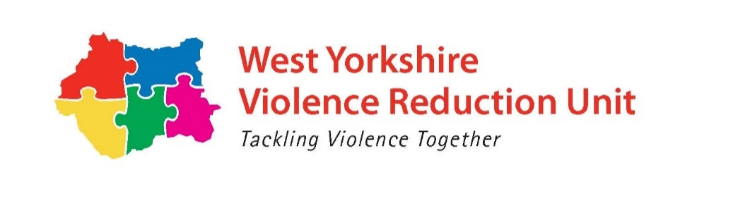
EVENT: Violence Reduction Unit Creative Art Competition

Name
Age
District within West Yorkshire:
(Bradford, Calderdale, Kirklees, Leeds or Wakefield)
In the event of your entry being chosen as the competition winner, the West Yorkshire Violence Reduction Unit (VRU) would like to use your competition entry, alongside your first name, age and district that you live in to publicise and promote the work and role of the VRU as well as to promote and raise awareness about policing and community safety across West Yorkshire. To comply with the UK General Data Protection Regulation, we can only use your personal Information if you consent to us doing so. This data will be kept on record for a 2-year period. For further information on how your data will be handled please take a look at our privacy statement: https://www.westyorks-ca.gov.uk/policing-and-crime/privacy-policy/

Consent information
To be completed by parent, guardian, or carer if you are under the age of 16

To be completed by parent/guardian/carer:
- I give permission for the young person’s entry, first name, age and district to be released on the website as part of this competition
- I give permission for the young person’s entry, first name, age and district to be released on the West Yorkshire Violence Reduction Unit social media pages as part of this competition (Twitter/ Facebook)
- I can confirm that I have read (or been made aware of) how this entry and identifying information about this young person will be stored within the organisation
- I give permission for material produced by the young person named to be used beyond the competition but for other marketing materials prepared by the VRU, including promotion of the VRU and engagement with young people
- Copyright in the work remains the copyright of the creator of the young person as the creator of the work. You hereby grant both the West Yorkshire Violence Reduction Unit and the Royal Armouries a non-exclusive and non-commercial licence to reproduce the work in connection with the project in all media and display worldwide in perpetuity.

If you are under the age of 16, please get the consent of your parent, guardian, or carer before proceeding and tick the boxes above.

Signature: | Print name:
Date:

