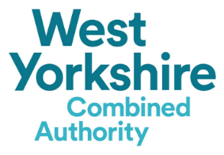
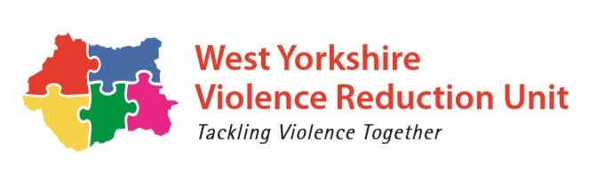

Answer all the questions below.
All answers must be within the required wordcount.

Applicant details
Name |  | Role
Organisation
Registered charity / company no
Email
Telephone |  | Mobile

Please tick the following if you:
☐ Agree to work closely with the VRU Knowledge Hub to engage in evaluations and research
☐ Have experience of working with young people (essential)
☐ Have experience of working in an education environment (desirable)
- Provide an overview of your intended sports and creative arts intervention. Please include your outcomes, pathways with identified education partners, how many young people will your intervention reach and how this will support in aspiration raising,
Maximum word count: 500

- How will you ensure that your intervention is inclusive for those young people with additional needs and barriers? (For example language, transport, learning difficulties etc. )
Maximum word count: 250

- Please indicate which district you are applying for and your existing delivery within that area (if any).
Maximum word count: 500
☐ Bradford
☐ Calderdale
☐ Kirklees
☐ Leeds

Existing Delivery:

- How will you measure the effectiveness and impact of this intervention working with the VRU Knowledge Hub?

Maximum word count: 250

- How will you ensure that the service provided reflects best practice and is of the highest quality possible?
Maximum word count: 250

- How will the service ensure the safeguarding of young people engaged in the intervention?
Maximum word count: 250

- Taking into account the funding period, please provide an overview of how the intervention will be mobilised including the timeframes.
Maximum word count: 300

- Please tell us about your specialism and deeper understanding to deliver the intervention to young people in an education and community setting.
Maximum word count: 250

- The VRU will be working closely with the provider and the identified high school to plan for sustainability of successful interventions. How will you support the sustainability planning throughout the funding timeframe?
Maximum word count: 250

- Budget

