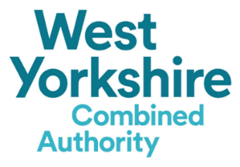
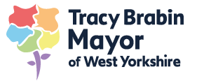
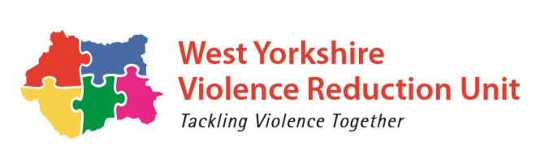

Answer all the questions below.
All answers must be within the required wordcount.

Applicant details
Name |  | Role
Organisation
Registered charity / company no
Email
Telephone |  | Mobile

Please tick the following if you:
☐ Agree to work closely with the VRU Knowledge Hub to engage in evaluations and research
☐ Have experience of working with young people (essential)
☐ Have experience of working in an education environment (desirable)
- Provide an overview of your intended mentoring and support intervention including both a targeted and universal offer. Please include your intended outcomes, how many young people will your intervention reach and how this will support in improving attendance and behaviour as well as raising aspirations.
Maximum word count: 1000

- Does your proposed intervention have a Theory of Change?

☐ Yes ☐ No

If yes please include a copy with the application.

- How will you ensure that your intervention is inclusive for those young people with additional needs and barriers? (For example language, learning difficulties etc.)
Maximum word count: 500

- How will you ensure that your intervention involves the whole family, community providers and other professionals to provide a positive pathway for the young person being supported.
Maximum word count: 500

- Please indicate which district you are applying for and your existing delivery within that area (if any).
Maximum word count: 500
☐ Leeds
☐ Kirklees
☐ Bradford
☐ Calderdale

Existing Delivery:

- How will you measure the effectiveness and impact of this intervention working with the VRU Knowledge Hub?

Maximum word count: 500

- How will you ensure that the service provided reflects best practice and is of the highest quality possible?
Maximum word count: 250

- How will the service ensure the safeguarding of young people engaged in the intervention?
Maximum word count: 250

- Taking into account the funding period, please provide an overview of how the intervention will be mobilised including the timeframes.
Maximum word count: 500

- Please tell us about your specialism and deeper understanding to deliver the intervention to young people in an education and community setting.
Maximum word count: 500

- The VRU will be working closely with the provider and the identified high school to plan for sustainability of successful interventions. How will you support the sustainability planning throughout the funding timeframe?
Maximum word count: 250

- Budget

- Added Value – Please tell us about any experience or additional value your organisation can offer that will enhance the proposed intervention and young people benefitting from it.
Maximum word count: 500

